重点项目执行期内发表的学术论文

|  |  |  |  |  |  |
| --- | --- | --- | --- | --- | --- |
| 序号 | 论文类型 | 年份 | 论文名称 | 主要完成者 | 期刊/会议 |
| 1 | 期刊 | 2024 | [Dual Branch Multi-Level Semantic Learning for Few-Shot Segmentation](javascript:void(0)) | Chen Yadang,  Jiang Ren,  **Zheng Yuhui,**  Sheng Bin,  Yang ZhiXin,  Wu Enhua | IEEE Transactions on Image Processing |
| 2 | 期刊 | 2023 | Multi-biometric Unified Network for Cloth-changing Person Re-Identification | Zhang Guoqing,  Liu Jie,  Chen Yuhao,  **Zheng Yuhui,**  Zhang Hongwei | IEEE Transactions on Image Processing |
| 3 | 期刊 | 2023 | Contrastive Transformer Hashing for Compact Video Representation | Shen Xiaobo,  Zhou Yue,  Yuan Yunhao,  Yang xichen,  Lan kong,  **Zheng Yuhui** | IEEE Transactions on Image Processing |
| 4 | 期刊 | 2021 | [Deep High-Resolution Representation Learning for Cross-Resolution Person Re-Identification](javascript:void(0)) | Zhang Guoqing,  Ge Yu,  Dong Zhicheng,  Wang Hao,  **Zheng, Yuhui,**  Chen Shengyong | IEEE Transactions on Image Processing |
| 5 | 期刊 | 2024 | [Dual-Stream Complex-Valued Convolutional Network for Authentic Dehazed Image Quality Assessment](javascript:void(0)) | Guan Tuxin,  Li Chaofeng,  **Zheng Yuhui**,  Wu Xiaojun,  Bovik Alan C | IEEE Transactions on Image Processing |
| 6 | 期刊 | 2024 | [Multiple Riemannian Kernel Hashing for Large-Scale Image Set Classification and Retrieval](javascript:void(0)) | Shen Xiaobo,  Wu Wei,  Wang Xiaxin,  **Zheng Yuhui** | IEEE Transactions on Image Processing |
| 7 | 期刊 | 2023 | [Tensor Cascaded-Rank Minimization in Subspace: A Unified Regime for Hyperspectral Image Low-Level Vision](javascript:void(0)) | Sun Le,  He Chengxun,  **Zheng Yuhui**,  Wu Zebin,  Jeon Byeungwoo | IEEE Transactions on Image Processing |
| 8 | 期刊 | 2021 | [Consistency Graph Modeling for Semantic Correspondence](javascript:void(0)) | He Jianfeng,  Zhang Tianzhu,  **Zheng Yuhui**,  Xu Mingliang,  Zhang Yongdong,  Wu Feng | IEEE Transactions on Image Processing |
| 9 | 期刊 | 2023 | [Domain Adaptive Transformer Tracking Under Occlusions](javascript:void(0)) | Yu Qianqian,  Fan Keqi,  **Zheng Yuhui**; | IEEE Transactions on Multimedia |
| 10 | 期刊 | 2023 | Target-Aware Transformer Tracking | **Zheng Yuhui**,  Zhang Yan,  Xiao Bin | IEEE Transactions on Circuits and Systems for Video Technology |
| 11 | 期刊 | 2024 | DCL: Dipolar Confidence Learning for Source-Free Unsupervised Domain Adaptation | Tian Qing,  Sun Heyang,  Peng Shun,  **Zheng Yuhui**,  Wan Jun,  Zhang Lei | IEEE Transactions on Circuits and Systems for Video Technology |
| 12 | 期刊 | 2022 | [Unsupervised Multiview Distributed Hashing for Large-Scale Retrieval](javascript:void(0)) | Shen Xiaobo,  Tang Yunpeng,  **Zheng Yuhui**,  Yuan YunHao,  Sun Quan-Sen | IEEE Transactions on Circuits and Systems for Video Technology |
| 13 | 期刊 | 2021 | [Hybrid-attention guided network with multiple resolution features for person re-identification](javascript:void(0)) | Zhang Guoqing,  Yang Junchuan,  **Zheng Yuhui**,  Wang Ye,  Wu Yi,  Chen, Shengyong | Information Sciences |
| 14 | 期刊 | 2024 | [Boosting Video Object Segmentation via Robust and Efficient Memory Network](javascript:void(0)) | Chen Yadang,  Zhang Dingwei,  **Zheng Yuhui**,  Yang Zhi-Xin,  Wu Enhua,  Zhao Haixing | IEEE Transactions on Circuits and Systems for Video Technology |
| 15 | 期刊 | 2023 | [Compact network embedding for fast node classification](javascript:void(0)) | Shen Xiaobo,  Ong Yew-Soon,  Mao Zheng,  Pan Shirui,  Liu Weiwei,  **Zheng, Yuhui**; | Pattern Recognition |
| 16 | 期刊 | 2021 | [TSLRLN: Tensor subspace low-rank learning with non-local prior for hyperspectral image mixed denoising](javascript:void(0)) | He Chengxun,  Sun Le,  Huang Wei,  Zhang Jianwei,  **Zheng Yuhui**,  Jeon Byeungwoo | Signal Processing |
| 17 | 期刊 | 2022 | [SmsNet: A New Deep Convolutional Neural Network Model for Adversarial Example Detection](javascript:void(0)) | Wang Jinwei,  Zhao Junjie,  Yin Qilin,  Luo Xiangyang,  **Zheng Yuhui**,  Shi YunQing,  Jha Sunil Kr | IEEE Transactions on Multimedia |
| 18 | 期刊 | 2022 | [Illumination Unification for Person Re-Identification](javascript:void(0)) | Zhang Guoqing,  Luo Zhiyuan,  Chen Yuhao,  **Zheng Yuhui**,  Lin Weisi | IEEE Transactions on Circuits and Systems for Video Technology |
| 19 | 期刊 | 2022 | [Multi-Task Convolution Operators with Object Detection for Visual Tracking](javascript:void(0)) | **Zheng Yuhui**,  Liu Xinyan,  Xiao Bin,  Cheng Xu,  Wu Yi,  Chen Shengyong | IEEE Transactions on Circuits and Systems for Video Technology |
| 20 | 期刊 | 2024 | One-click-based Perception for Interactive Image Segmentation | Wang Tao,  Li Haochen,  **Zheng Yuhui**,  Sun Quan-sen; | IEEE Transactions on Neural Networks and Learning Systems |
| 21 | 期刊 | 2022 | [Multiview Learning With Robust Double-Sided Twin SVM](javascript:void(0)) | Ye, Qiaolin,  Huang, Peng,  Zhang, Zhao,  **Zheng, Yuhui**,  Fu, Liyong,  Yang, Wankou | IEEE Transactions on Cybernetics |
| 22 | 期刊 | 2023 | [Visibility and Distortion Measurement for No-Reference Dehazed Image Quality Assessment via Complex Contourlet Transform](javascript:void(0)) | Guan Tuxin,  Li Chaofeng,  Gu Ke,  Liu Hantao,  **Zheng Yuhui**,  Wu Xiao-jun | IEEE Transactions on Multimedia |
| 23 | 期刊 | 2023 | [Mixed Noise Removal for Hyperspectral Images Based on Global Tensor Low-Rankness and Nonlocal SVD-Aided Group Sparsity](javascript:void(0)) | Sun Le,  Cao Qiujie,  Chen Yuwen,  **Zheng Yuhui**,  Wu Zebin | IEEE Transactions on Geoscience and Remote Sensing |
| 24 | 期刊 | 2022 | [SpectralSpatial Feature Tokenization Transformer for Hyperspectral Image Classification](javascript:void(0)) | Sun Le,  Zhao Guangrui,  **Zheng Yuhui**,  Wu Zebin | IEEE Transactions on Geoscience and Remote Sensing |
| 25 | 期刊 | 2024 | [SDBAD-Net: A Spatial Dual-Branch Attention Dehazing Network Based on Meta-Former Paradigm](javascript:void(0)) | Zhang Guoqing,  Fang Wenxuan,  **Zheng Yuhui**,  Wang Ruili | IEEE Transactions on Circuits and Systems for Video Technology |
| 26 | 期刊 | 2022 | [Deep Co-Image-Label Hashing for Multi-Label Image Retrieval](javascript:void(0)), | Shen Xiaobo,  Dong Guohua,  **Zheng Yuhui**,  Lan Long,  Tsang Ivor,  Sun Quan-Sen | IEEE Transactions on Multimedia |
| 27 | 期刊 | 2022 | [TIPCB: A simple but effective part-based convolutional baseline for text-based person search](javascript:void(0)) | Chen Yuhao,  Zhang Guoqing,  Lu Yujiang,  Wang Zhenxing,  **Zheng Yuhui** | Neurocomputing |
| 28 | 期刊 | 2023 | [Multiattention Joint Convolution Feature Representation With Lightweight Transformer for Hyperspectral Image Classification](javascript:void(0)) | Fang Yu,  Ye Qiaolin,  Sun Le,  **Zheng Yuhui**,  Wu Zebin | IEEE Transactions on Geoscience and Remote Sensing |
| 29 | 期刊 | 2022 | [A Robust GAN-Generated Face Detection Method Based on Dual-Color Spaces and an Improved Xception](javascript:void(0)) | Chen Beijing,  Liu Xin,  **Zheng Yuhui**,  Zhao Guoying,  Shi Yun-Qing | IEEE Transactions on Circuits and Systems for Video Technology |
| 30 | 期刊 | 2022 | [Detecting Aligned Double JPEG Compressed Color Image With Same Quantization Matrix Based on the Stability of Image](javascript:void(0)) | Wang Hao,  Wang Jinwei,  Luo Xiangyang,  **Zheng Yuhui**,  Ma Bin,  Sun Jinsheng,  Jha Sunil Kr | IEEE Transactions on Circuits and Systems for Video Technology |
| 31 | 期刊 | 2023 | [CRNet: Channel-Enhanced Remodeling-Based Network for Salient Object Detection in Optical Remote Sensing Images](javascript:void(0)) | Sun Le,  Wang Qing,  Chen Yuwen,  **Zheng Yuhui**,  Wu Zebin,  Fu Liyong,  Jeon Byeungwoo | IEEE Transactions on Geoscience and Remote Sensing |
| 32 | 期刊 | 2023 | [Joint Classification of Hyperspectral and LiDAR Data Using a Hierarchical CNN and Transformer](javascript:void(0)), | Zhao Guangrui,  Ye Qiaolin,  Sun Le,  Wu Zebin,  Pan Chengsheng,  Jeon Byeungwoo | IEEE Transactions on Geoscience and Remote Sensing |
| 33 | 期刊 | 2023 | [Object Tracking in UAV Videos by Multifeature Correlation Filters With Saliency Proposals](javascript:void(0)) | Zhang Yan,  **Zheng Yuhui** | Journal of Selected Topics in Applied Earth Observations and Remote Sensing |
| 34 | 期刊 | 2022 | [SPANet: Successive Pooling Attention Network for Semantic Segmentation of Remote Sensing Images](javascript:void(0)) | Sun Le,  Cheng Shiwei,  **Zheng Yuhui**,  Wu Zebin,  Zhang Jianwei | IEEE Journal of Selected Topics in Applied Earth Observations and Remote Sensing |
| 35 | 期刊 | 2023 | [Multi-granularity feature utilization network for cross-modality visible-infrared person re-identification](javascript:void(0)) | Zhang Guoqing,  Zhang Yinyin,  Chen Yuhao,  Zhang Hongwei,  **Zheng Yuhui** | Soft Computing |
| 36 | 期刊 | 2021 | [Pansharpening via Subpixel Convolutional Residual Network](javascript:void(0)) | Li Chunyu,  **Zheng Yuhui**,  Jeon Byeungwoo | IEEE Journal of Selected Topics in Applied Earth Observations and Remote Sensing |
| 37 | 期刊 | 2023 | [Transformer-based global-local feature learning model for occluded person re-identification1](javascript:void(0)) | Zhang Guoqing,  Chen Chao,  Chen Yuhao,  Zhang Hongwei,  **Zheng Yuhui** | Journal of Visual Communication and Image Representation |
| 38 | 期刊 | 2023 | [BSFCDet: Bidirectional Spatial-Semantic Fusion Network Coupled with Channel Attention for Object Detection in Satellite Images](javascript:void(0)) | Wei Xinchi,  Zhang Yan,  **Zheng Yuhui** | Remote Sensing |
| 39 | 期刊 | 2022 | [Close-set camera style distribution alignment for single camera person re-identification](javascript:void(0)) | Zhang Guoqing,  Zhang Hongwei,  Chen Yuhao,  **Zheng Yuhui** | Neurocomputing |
| 40 | 期刊 | 2024 | [Graph Convolutional Multi-Label Hashing for Cross-Modal Retrieval](javascript:void(0)) | Shen Xiaobo,  Chen Yinfan,  Liu Weiwei,  **Zheng Yuhui**,  Sun Quan-Sen | IEEE Transactions on Neural Networks and Learning Systems |
| 41 | 期刊 | 2024 | [Progressive discrepancy elimination for visible-infrared person re-identification](javascript:void(0)) | Zhang Guoqing,  Wang Zhun Zhun,  Wang Hairui,  Zhou Jieqiong,  **Zheng Yuhui** | Neurocomputing |
| 42 | 期刊 | 2024 | InfinitePerson: Innovating Synthetic Data Creation for Generalization Person Re-Identification | Zhang Guoqing,  Li Jin,  **Zheng Yuhui**,  Wang Ruili | IEEE Transactions on Circuits and Systems for Video Technology |
| 43 | 期刊 | 2024 | [Learning dual attention enhancement feature for visible-infrared person re-identification](javascript:void(0)) | Zhang, Guoqing,  Zhang, Yinyin,  Zhang, Hongwei,  Chen, Yuhao,  **Zheng, Yuhui** | Journal of Visual Communication and Image Representation |
| 44 | 期刊 | 2024 | [Local-enhanced representation for text-based person search](javascript:void(0)) | Zhang Guoqing,  Chen Yuhao,  **Zheng Yuhui**,  Martin Gaven,  Wang Ruili | Pattern Recognition |
| 45 | 期刊 | 2025 | Adaptive transformer with Pyramid Fusion for cloth-changing Person Re-Identiffcation | Zhang Guoqing,  Zhou Jieqiong,  **Zheng Yuhui**,  Martin Gaven,  Wang Ruili | Pattern Recognition |
| 46 | 期刊 | 2022 | [Global Relation-Aware Contrast Learning for Unsupervised Person Re-Identification](javascript:void(0)) | Zhang, Hongwei,  Zhang, Guoqing,  Chen, Yuhao,  **Zheng, Yuhui** | IEEE Transactions on Circuits and Systems for Video Technology |
| 47 | 期刊 | 2023 | [Motion Stimulation for Compositional Action Recognition](javascript:void(0)) | Ma Lei,  **Zheng Yuhui**,  Zhang Zhao,  Yao Yazhou,  Fan Xijian,  Ye Qiaolin | IEEE Transactions on Circuits and Systems for Video Technology |
| 48 | 会议 | 2024 | Graph Convolutional Semi-supervised Cross-modal Hashing | Shen Xiaobo,  Yu Gaoyao,  Chen Yinfan,  Yang Xichen,  **Zheng Yuhui** | The 32nd ACM International Conference on Multimedia |
| 49 | 会议 | 2024 | A Transformer-Based Adaptive Prototype Matching Network for Few-Shot Semantic Segmentation | Chen Sihan,  Chen Yadang,  **ZhengYuhui**,  Yang Zhi-Xin,  Wu Enhua | The 33rd International Joint Conference on Artificial Intelligence |
| 50 | 会议 | 2023 | [Graph Convolutional Incomplete Multi-modal Hashing](javascript:void(0)) | Shen Xiaobo,  Chen Yinfan,  Pan Shirui,  Liu Weiwei,  **Zheng Yuhui** | The 31st ACM International Conference on Multimedia |
| 51 | 会议 | 2024 | Generalizable Fourier Augmentation for Unsupervised Video Object Segmentation | Song Huihui,  Su Tiankang,  **Zheng Yuhui**,  Zhang Kaihua,  Liu Bo,  Liu Dong | The 38th Annual AAAI Conference on Artificial Intelligence |
| 52 | 会议 | 2024 | Contrastive Transformer Cross-Modal Hashing for Video-Text Retrieval | Shen Xiaobo,  Huang Qianxin,  Lan long,  **ZhengYuhui** | The 33rd International Joint Conference on Artificial Intelligence |
| 53 | 会议 | 2024 | Contrastive Transformer Masked Image Hashing for Degraded Image Retrieval | Shen Xiaobo,  Cai Haoyu,  Gong Xiuwen,  **ZhengYuhui** | The 33rd International Joint Conference on Artificial Intelligence |
| 54 | 会议 | 2024 | Distributed Manifold Hashing for Image Set Classification and Retrieval | Shen Xiaobo,  Song Peizhuo,  Yuan Yunhao,  **Zheng Yuhui** | The 38th Annual AAAI Conference on Artificial Intelligence |
| 55 | 会议 | 2021 | [Reference-Aided Part-Aligned Feature Disentangling for Video Person Re-Identification](javascript:void(0)), | Zhang Guoqing,  Chen Yuhao,  Dai Yang,  **Zheng Yuhui**,  Wu Yi | 2021 IEEE International Conference on Multimedia and Expo |
| 56 | 会议 | 2023 | [Multi-level Part-aware Feature Disentangling for Text-based Person Search](javascript:void(0)) | Chen Yuhao,  Zhang Guoqing,  Zhang Hongwei,  **Zheng Yuhui**,  Lin Weisi | IEEE International Conference on Multimedia and Expo (ICME) |
| 57 | 会议 | 2022 | [Multi-Biometric Unified Network for Cloth-Changing Person Re-Identification](javascript:void(0)) | Zhang Guoqing,  Liu Jie,  Chen Yuhao,  Zheng Yuhui,  Zhang Hongwei | 2022 IEEE International Conference on Multimedia and Expo |
| 58 | 会议 | 2021 | [Domain Adaptive Visual Tracking with Mullti-Scale Feature Fusion](javascript:void(0)) | Zhang Guoqing,  Liu Jie,  Chen Yuhao,  Zheng Yuhui,  Zhang Hongwei | IEEE International Conference on Progress in Informatics and Computing |

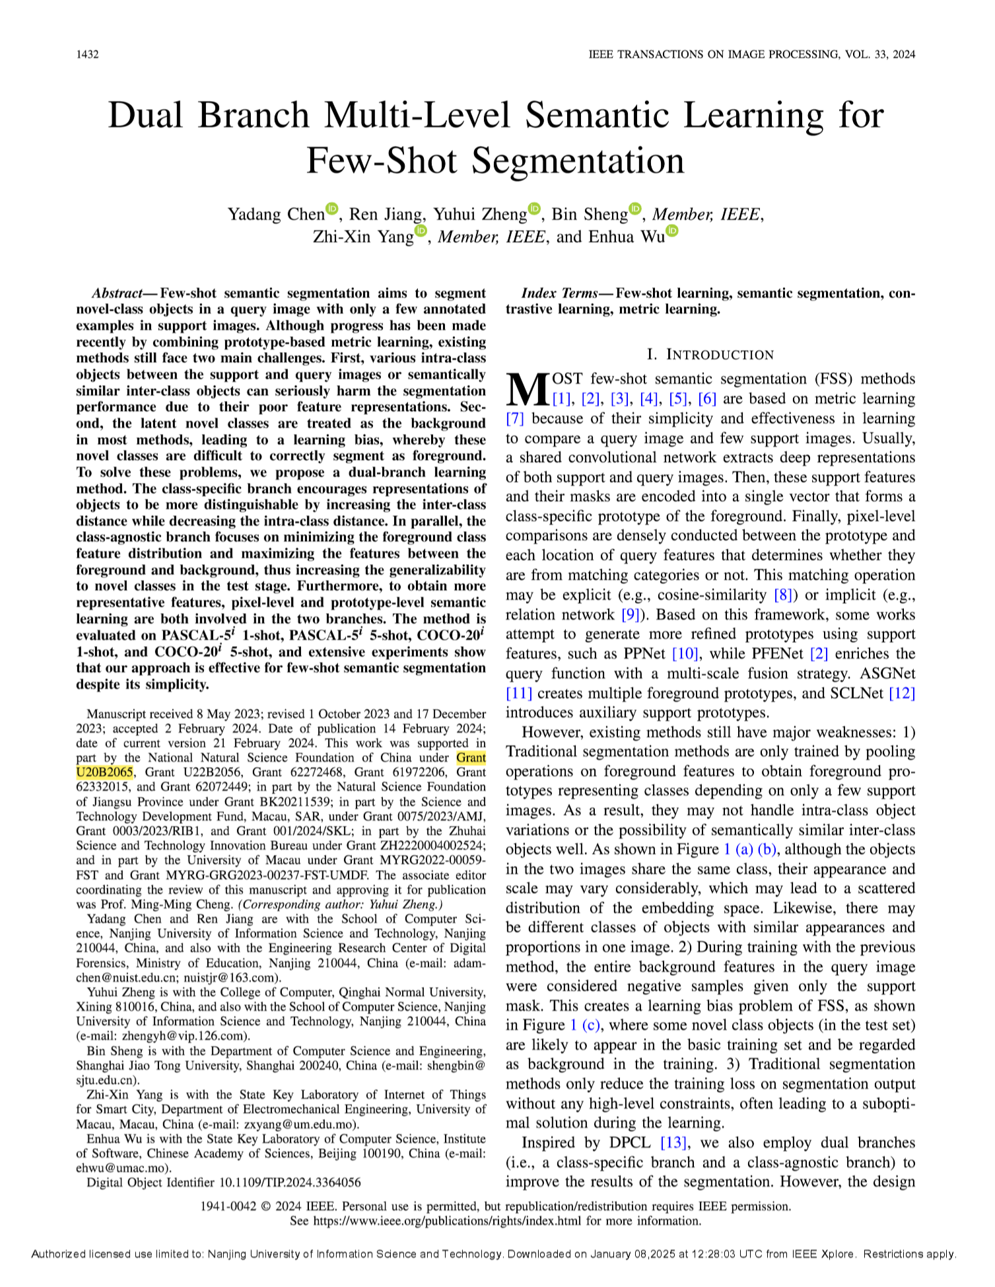

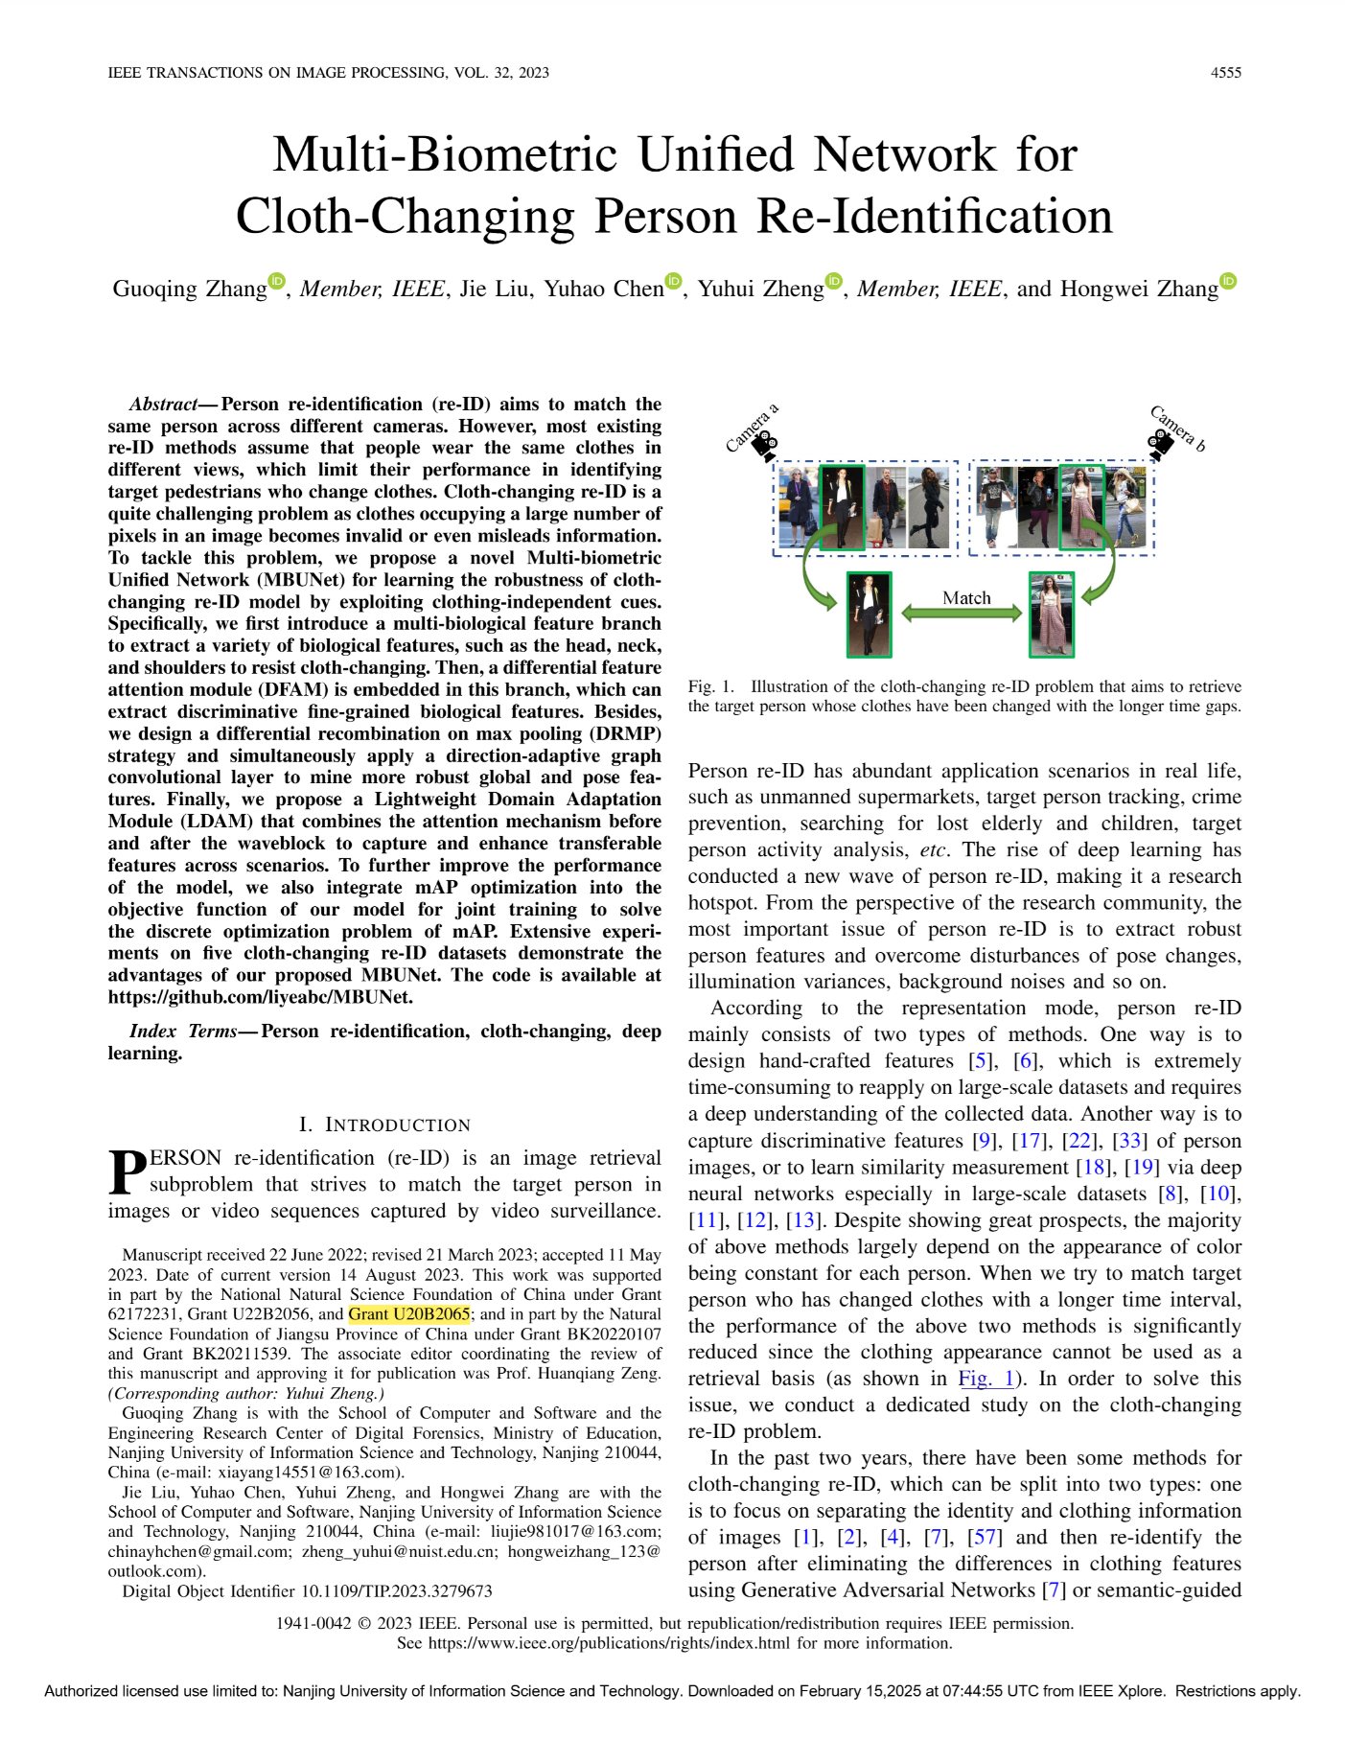

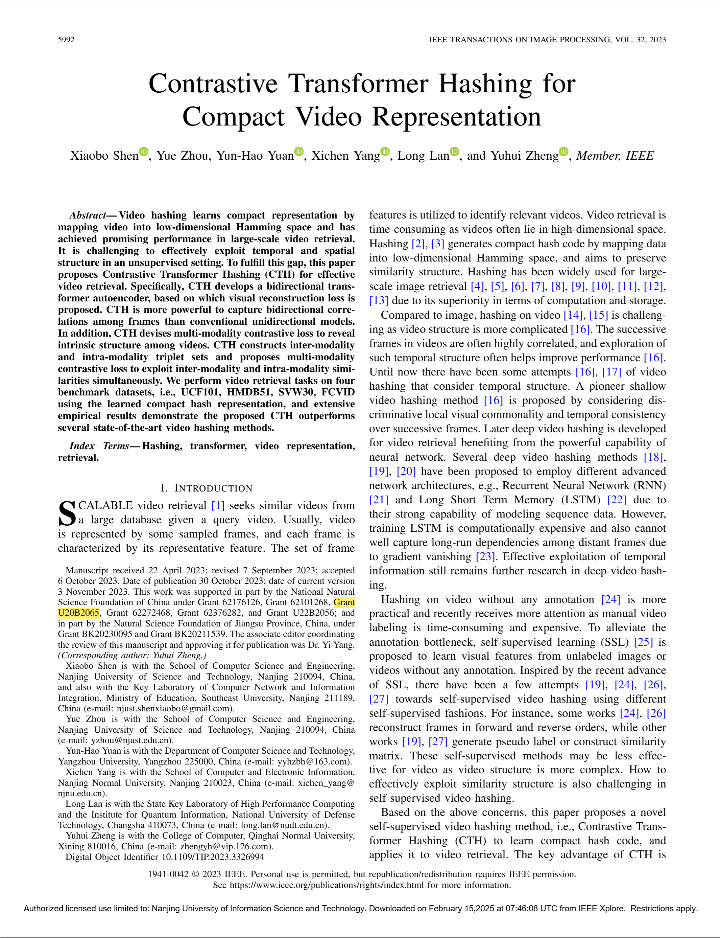

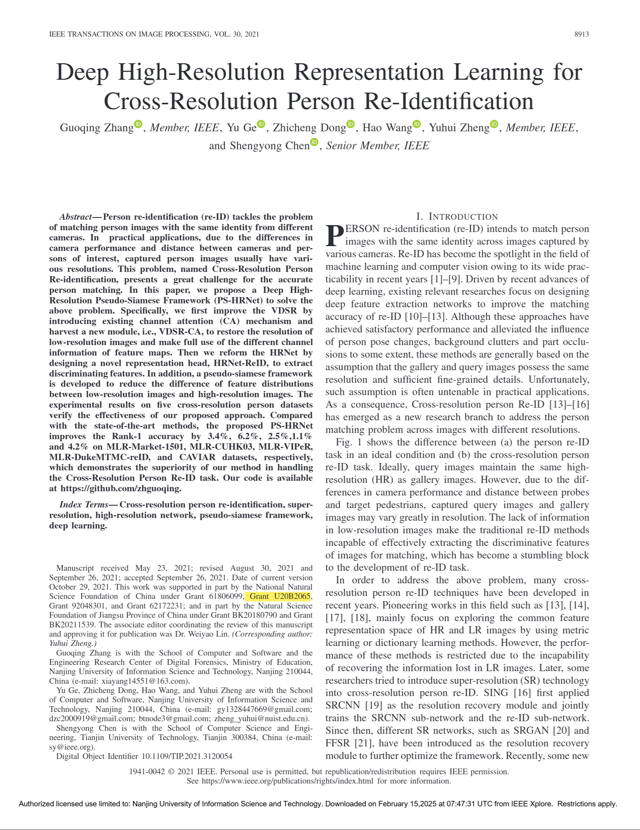

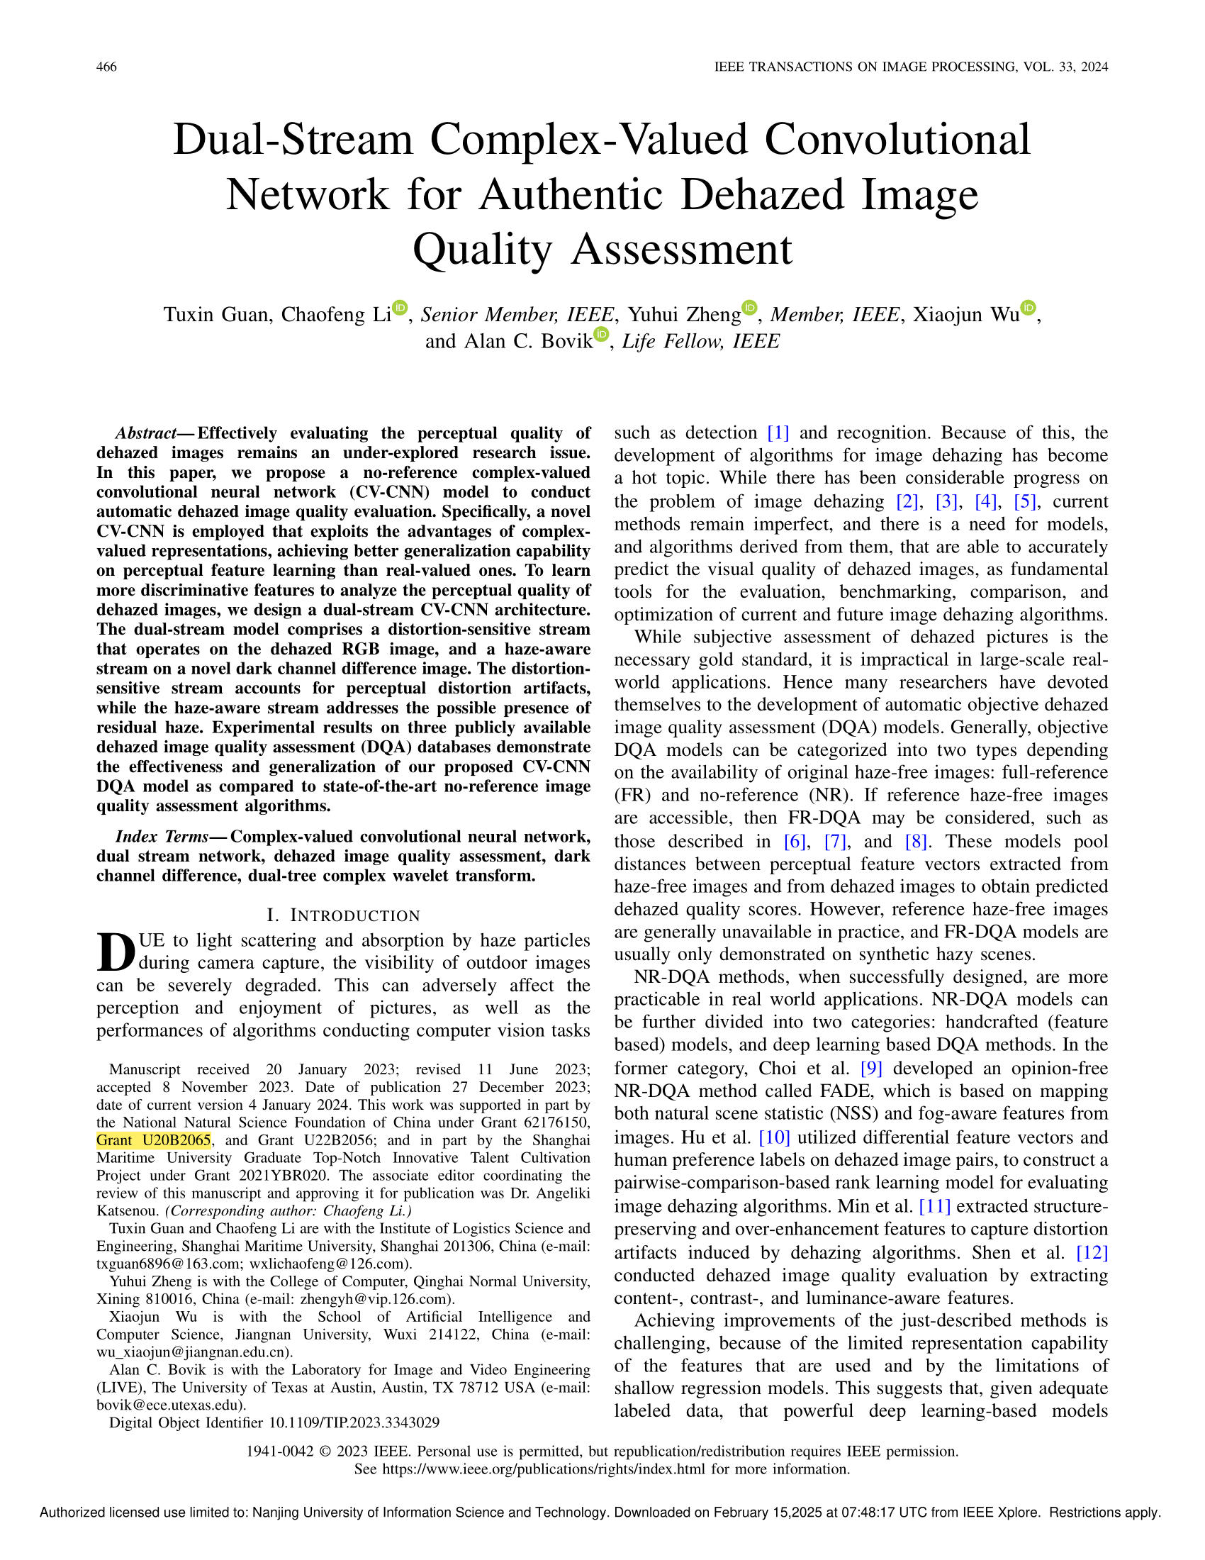

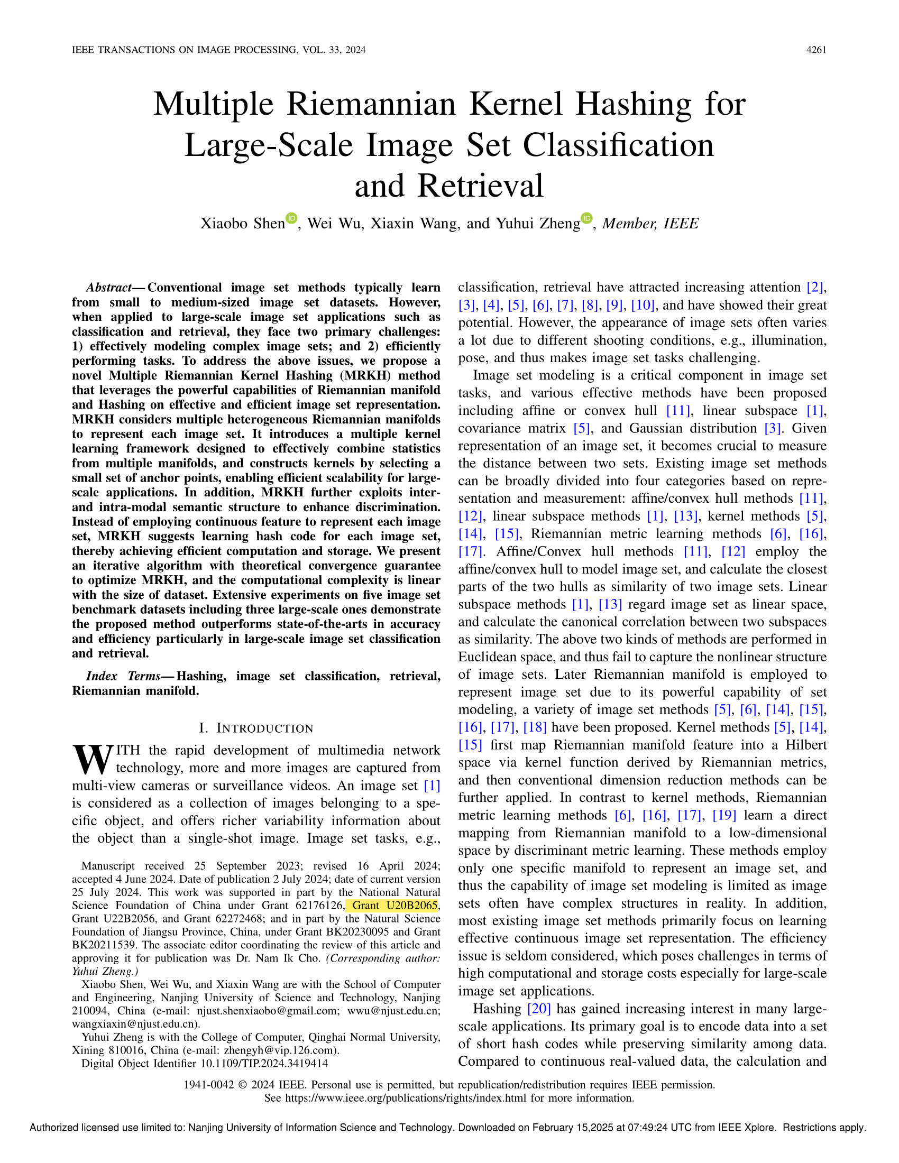

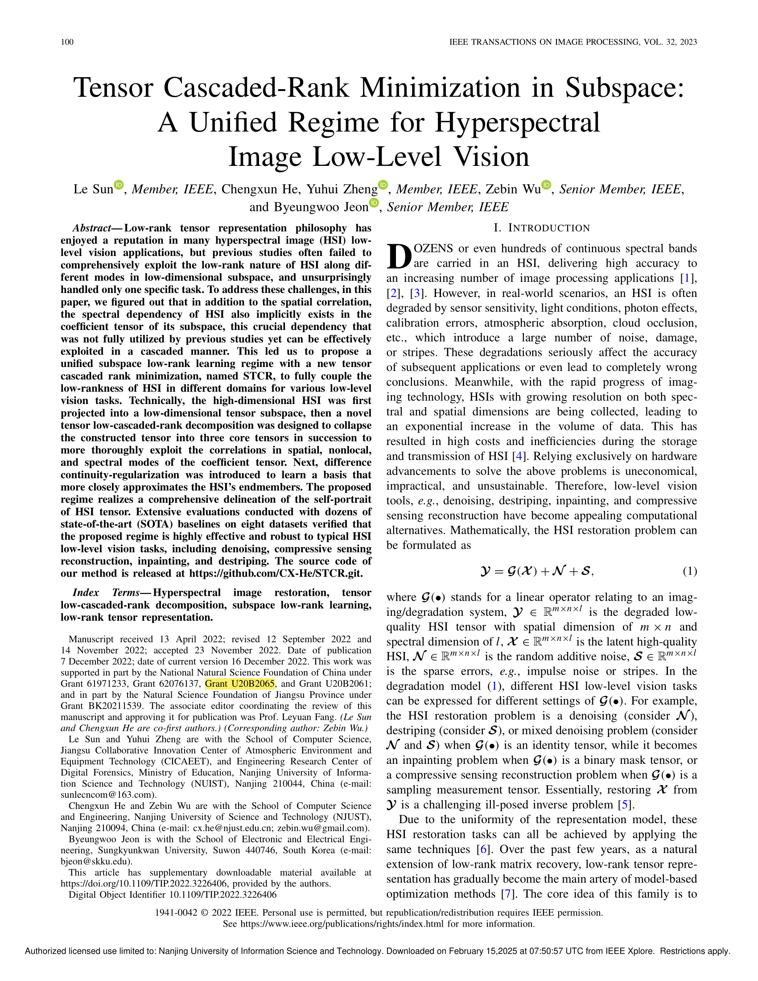

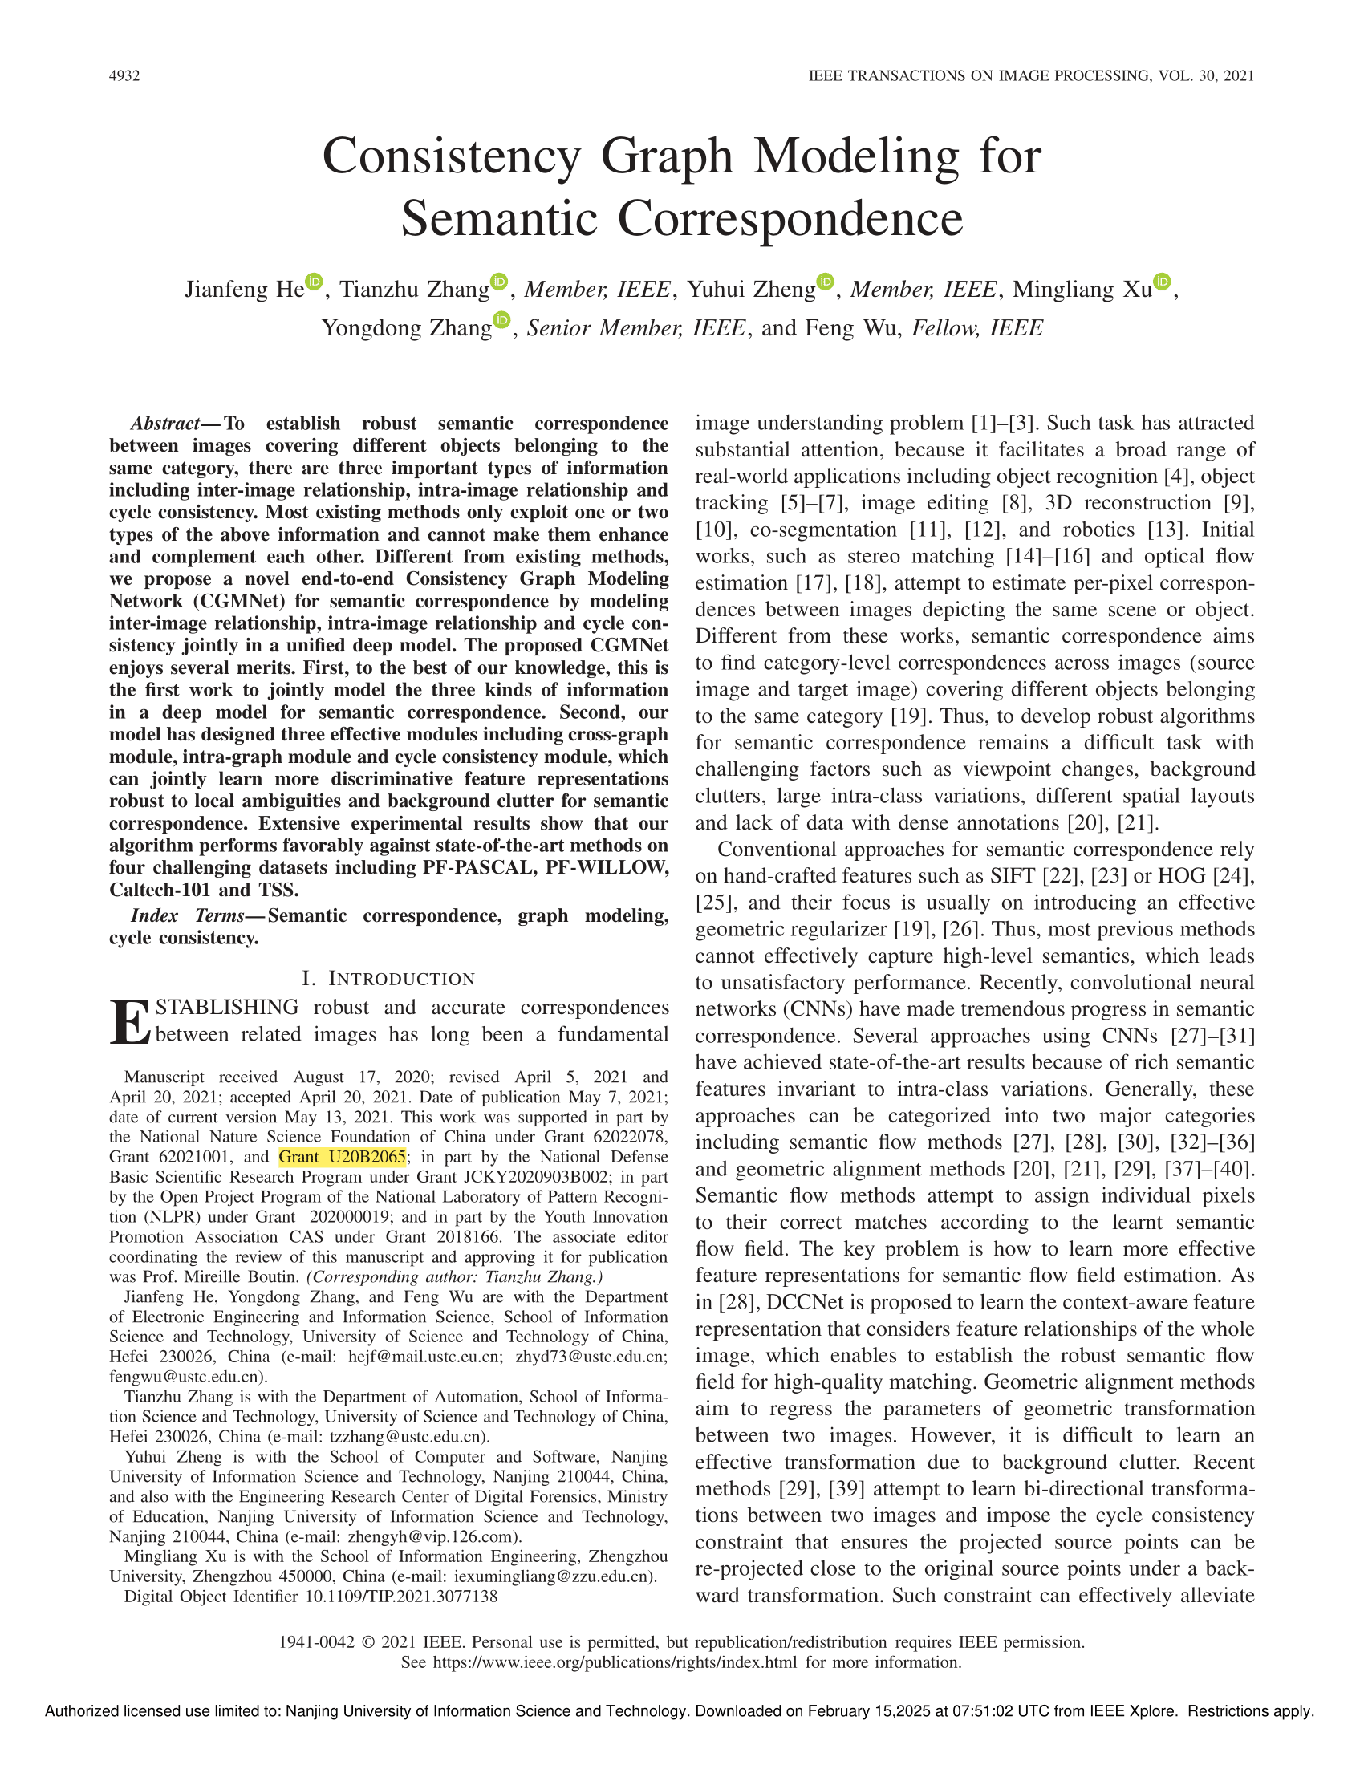

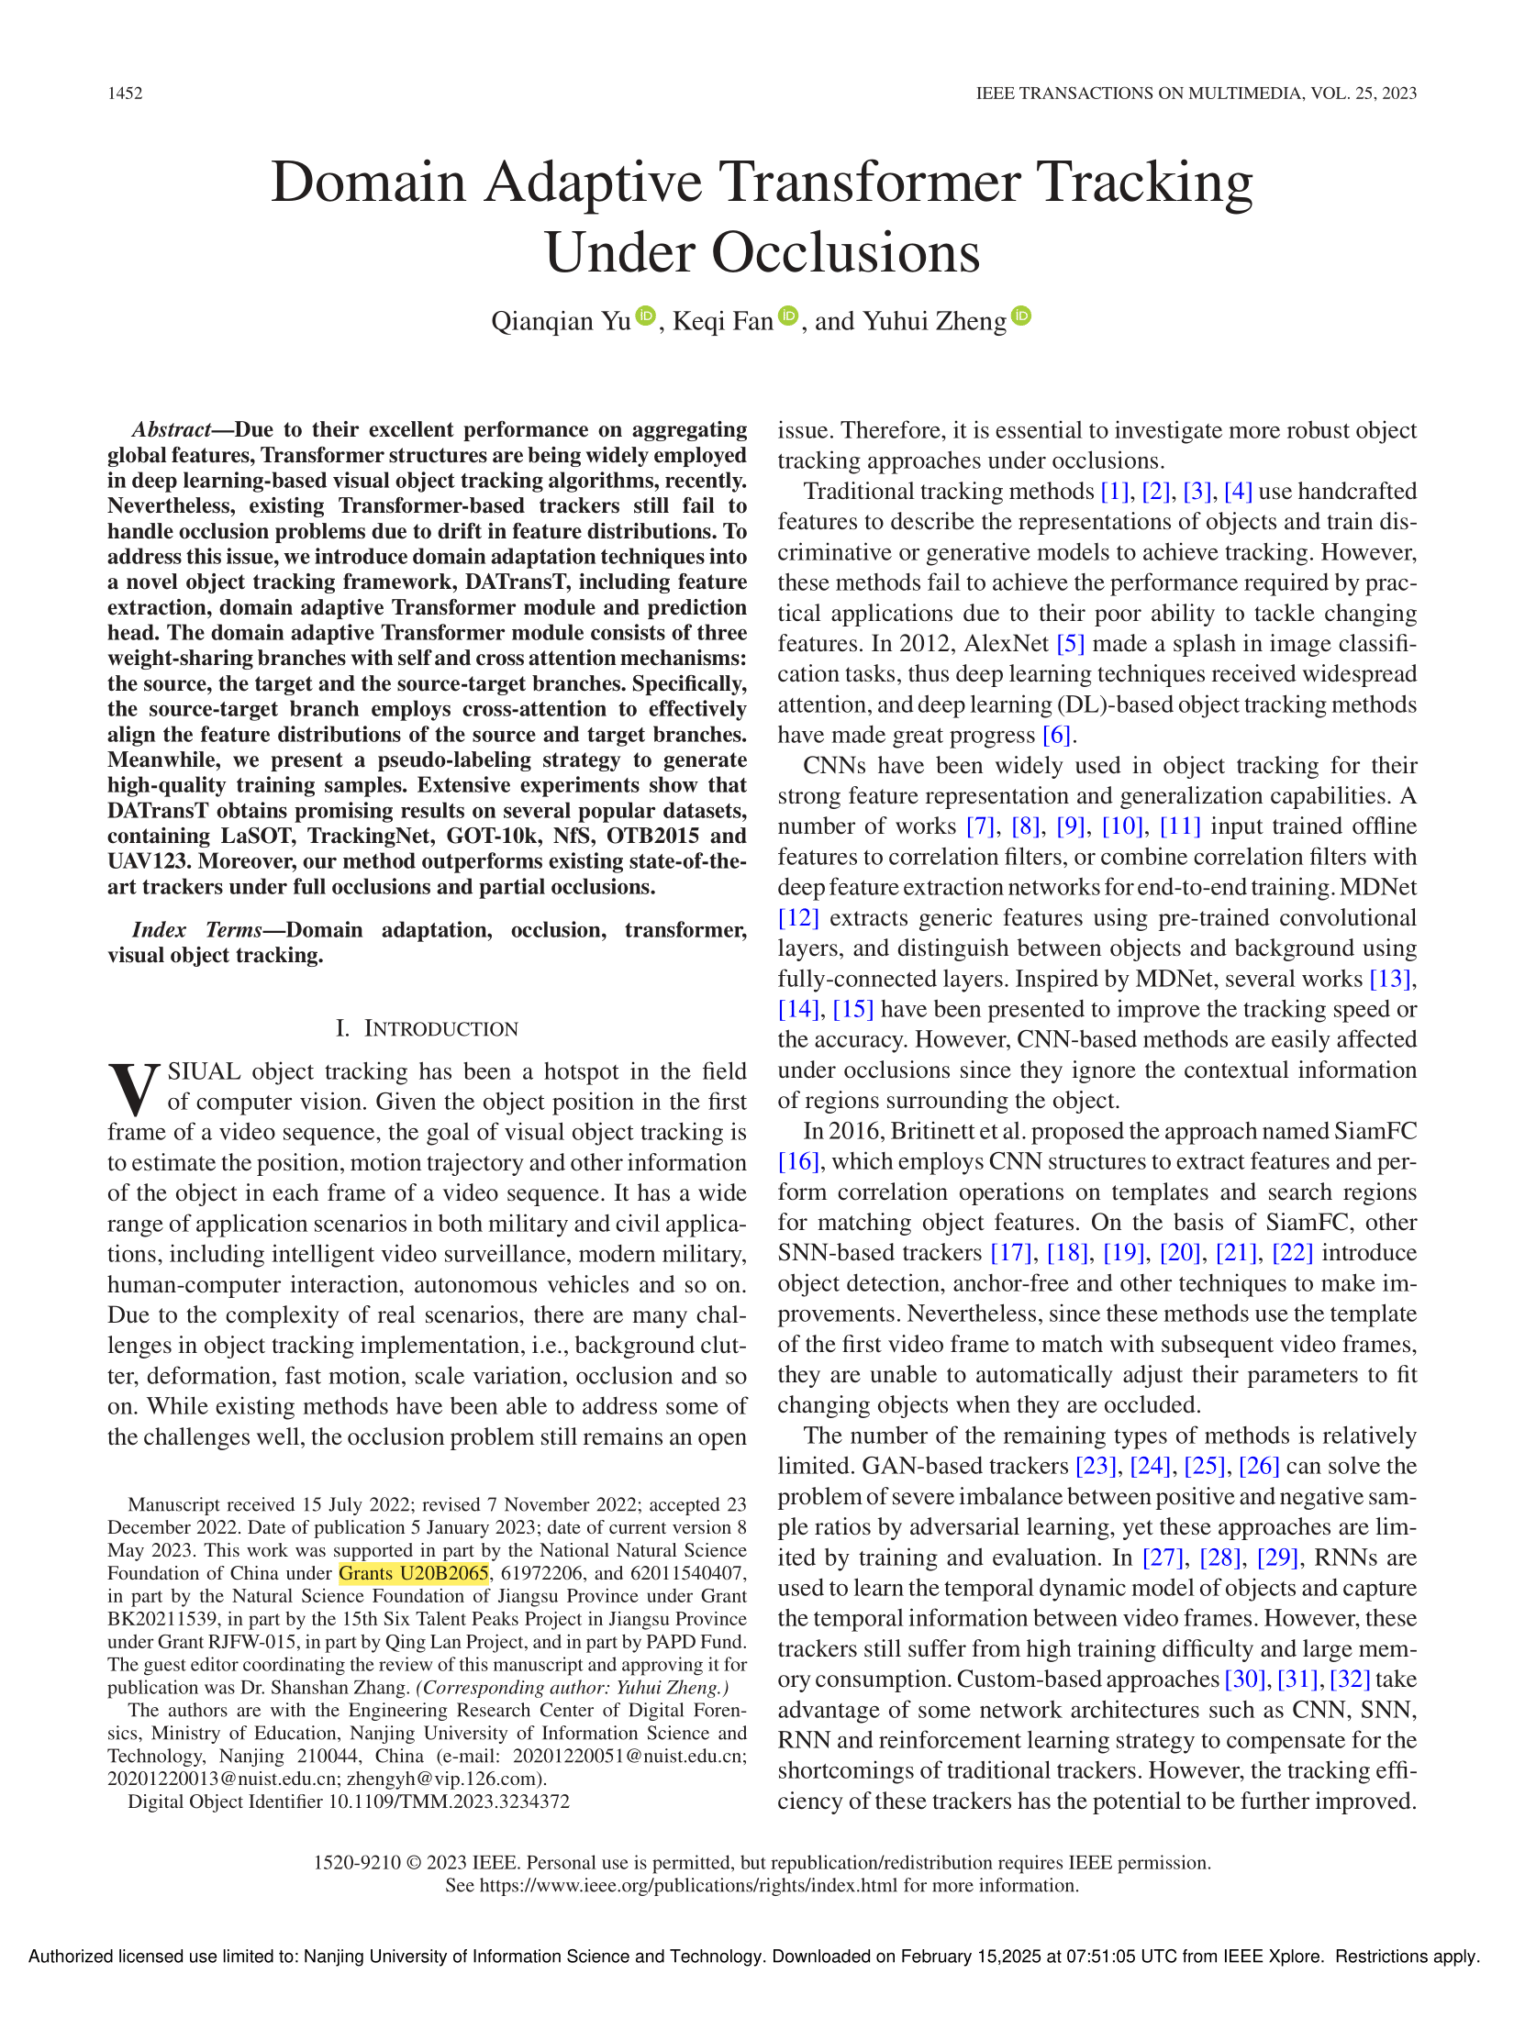

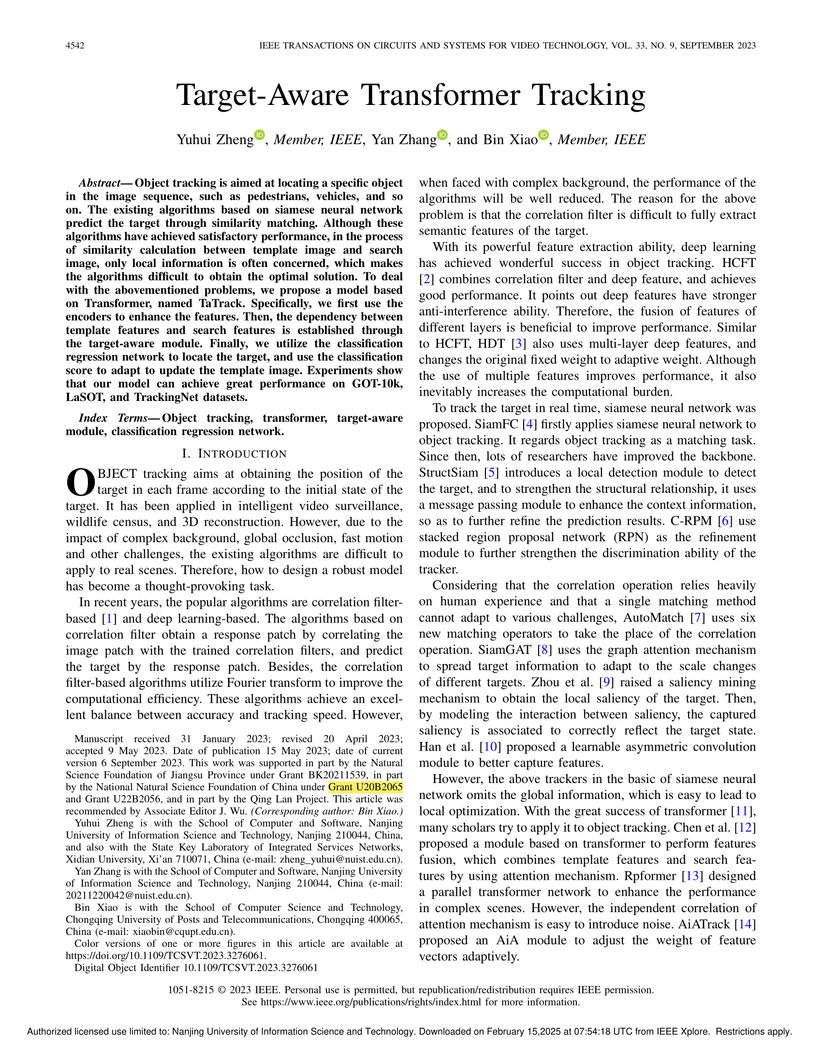

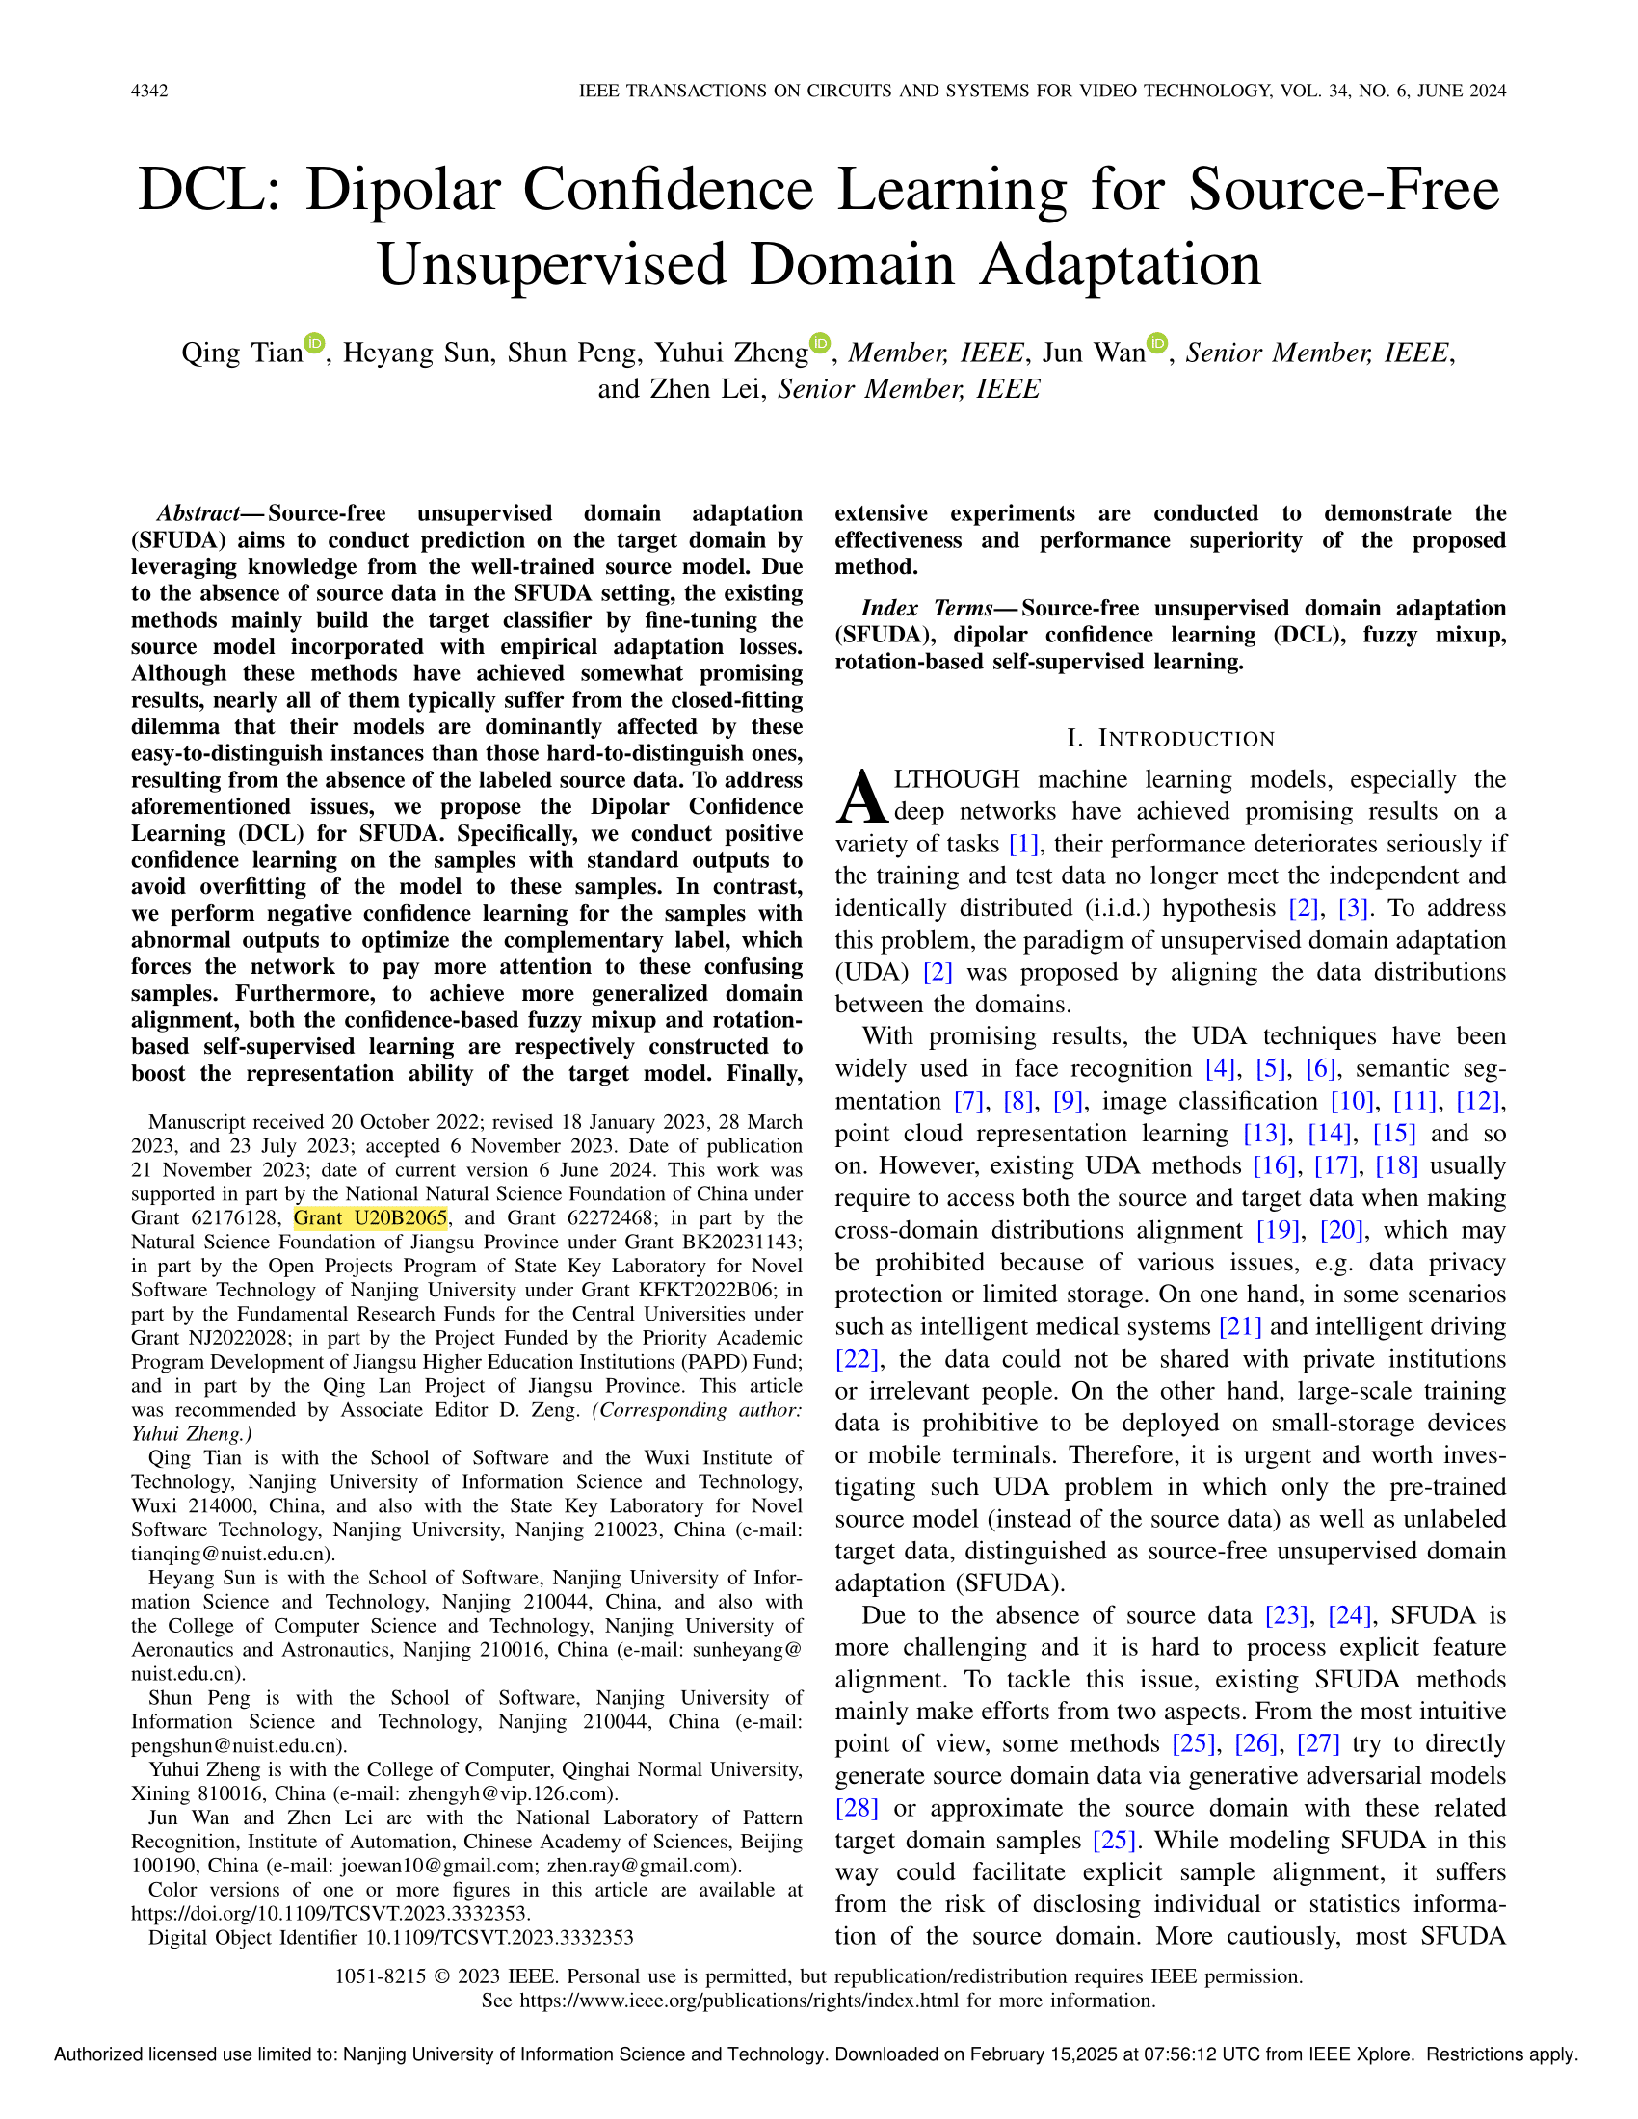

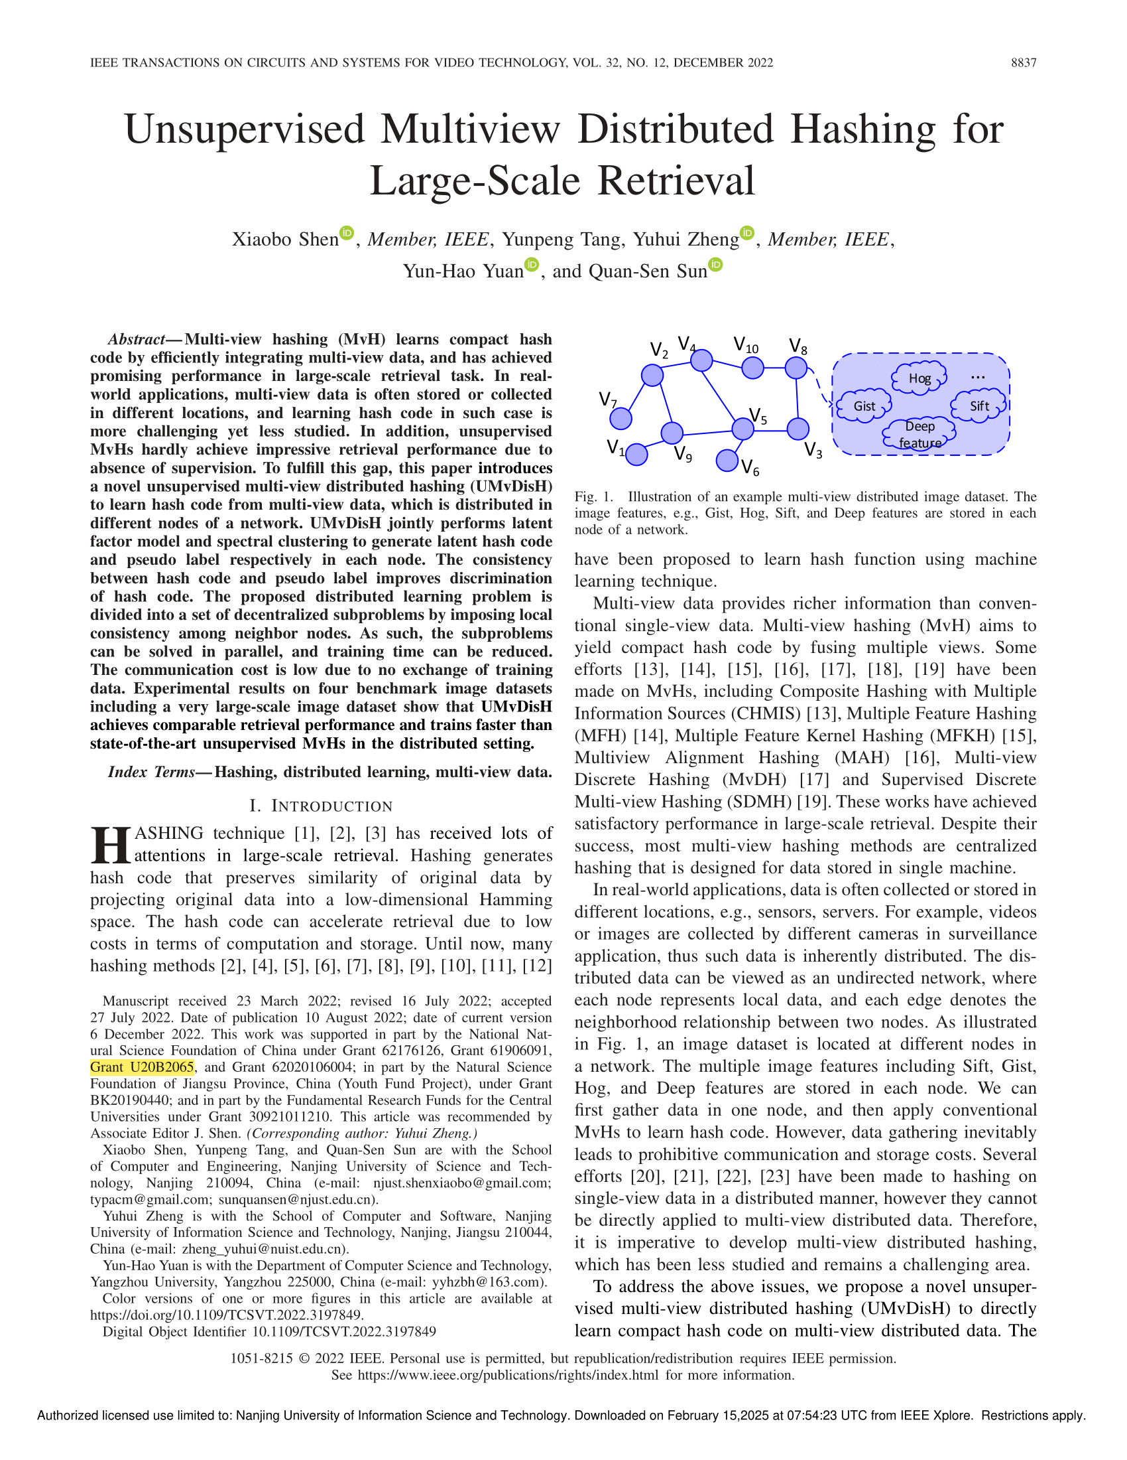

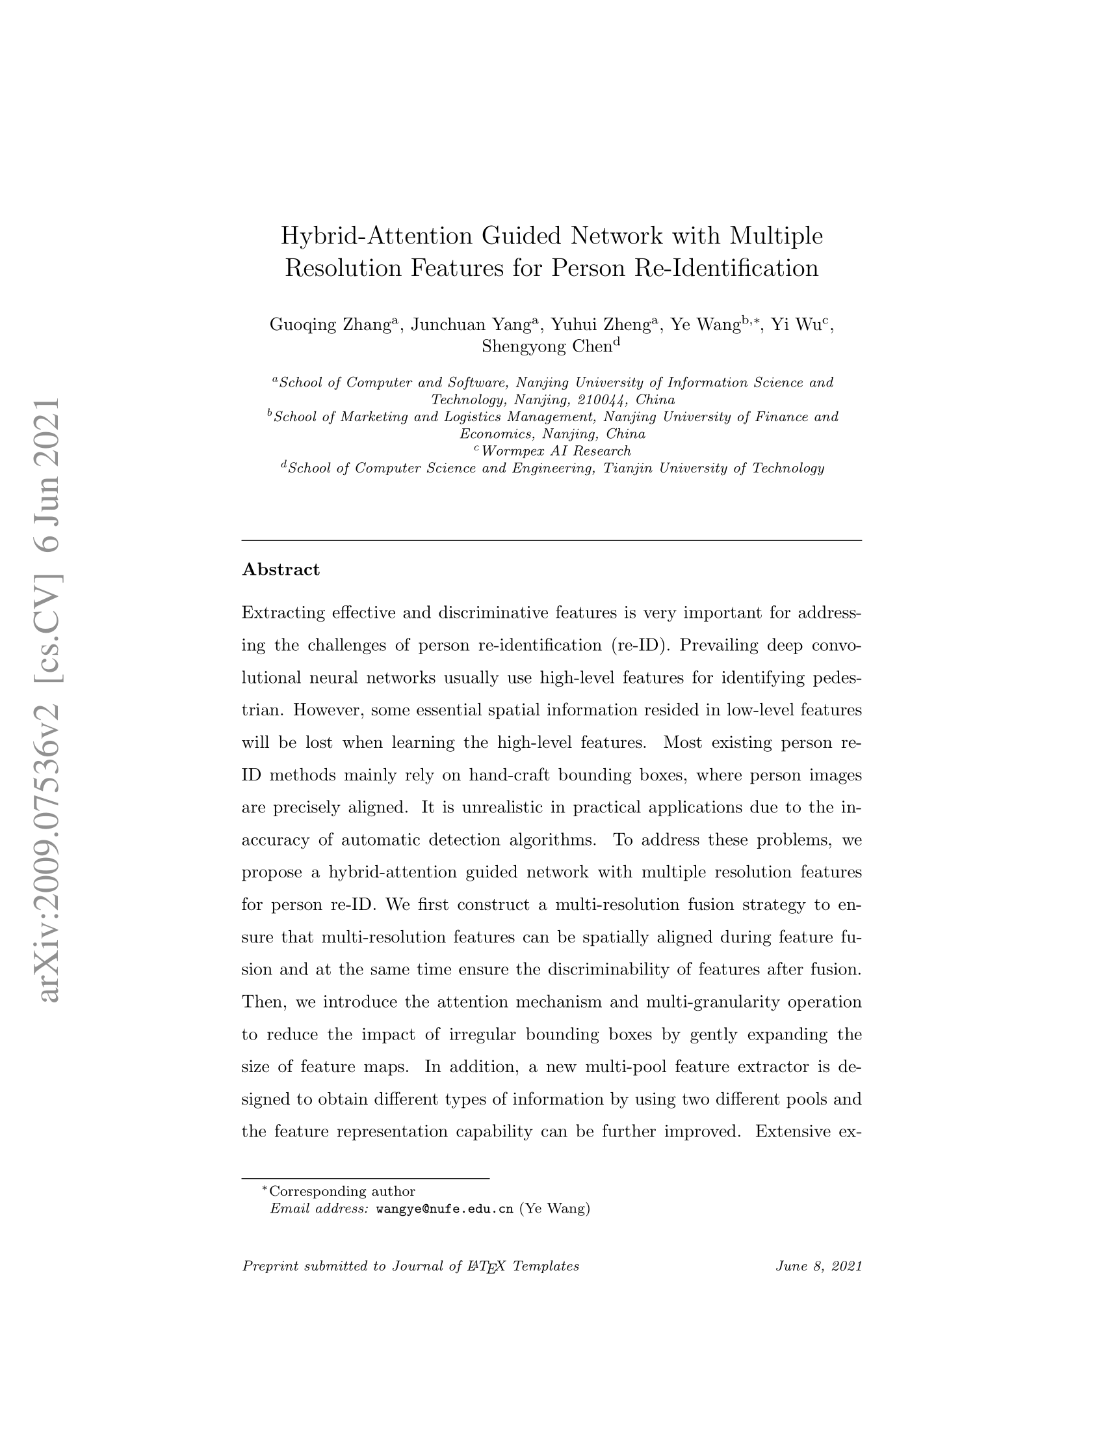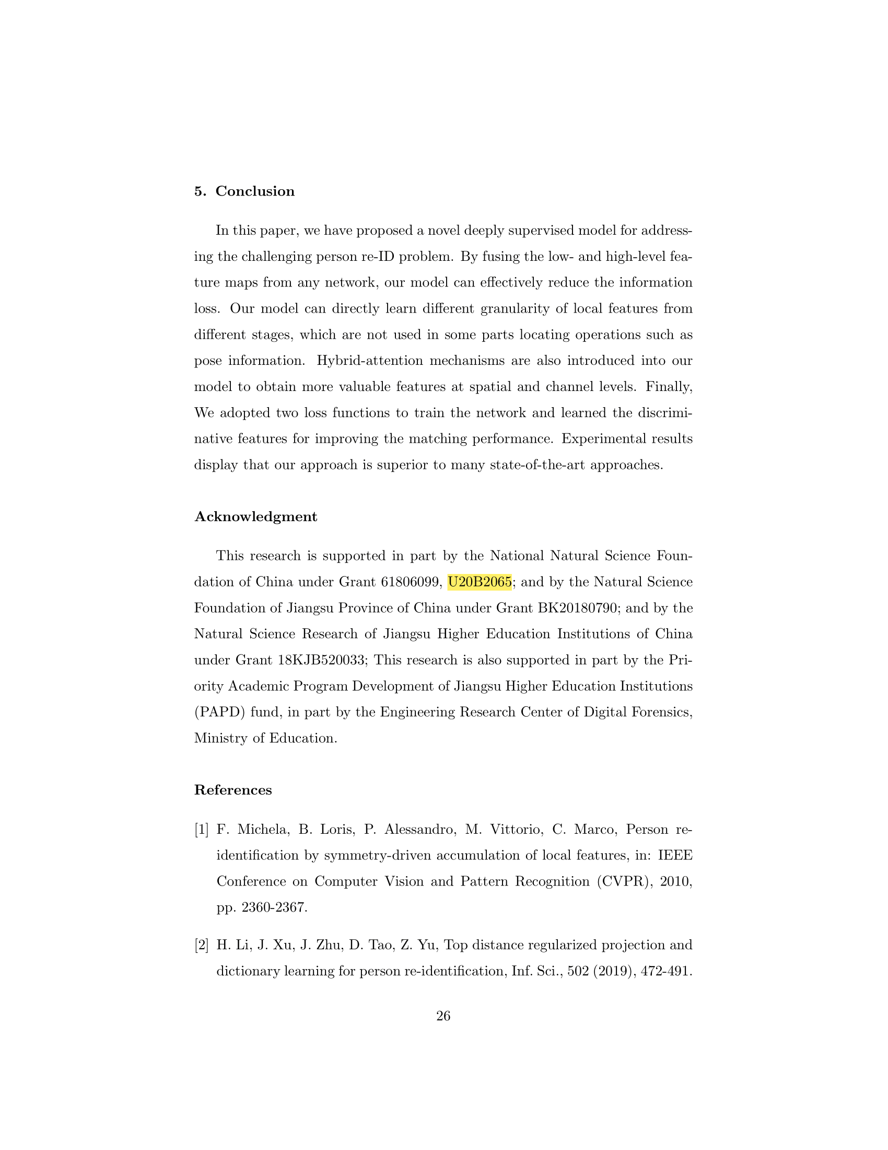

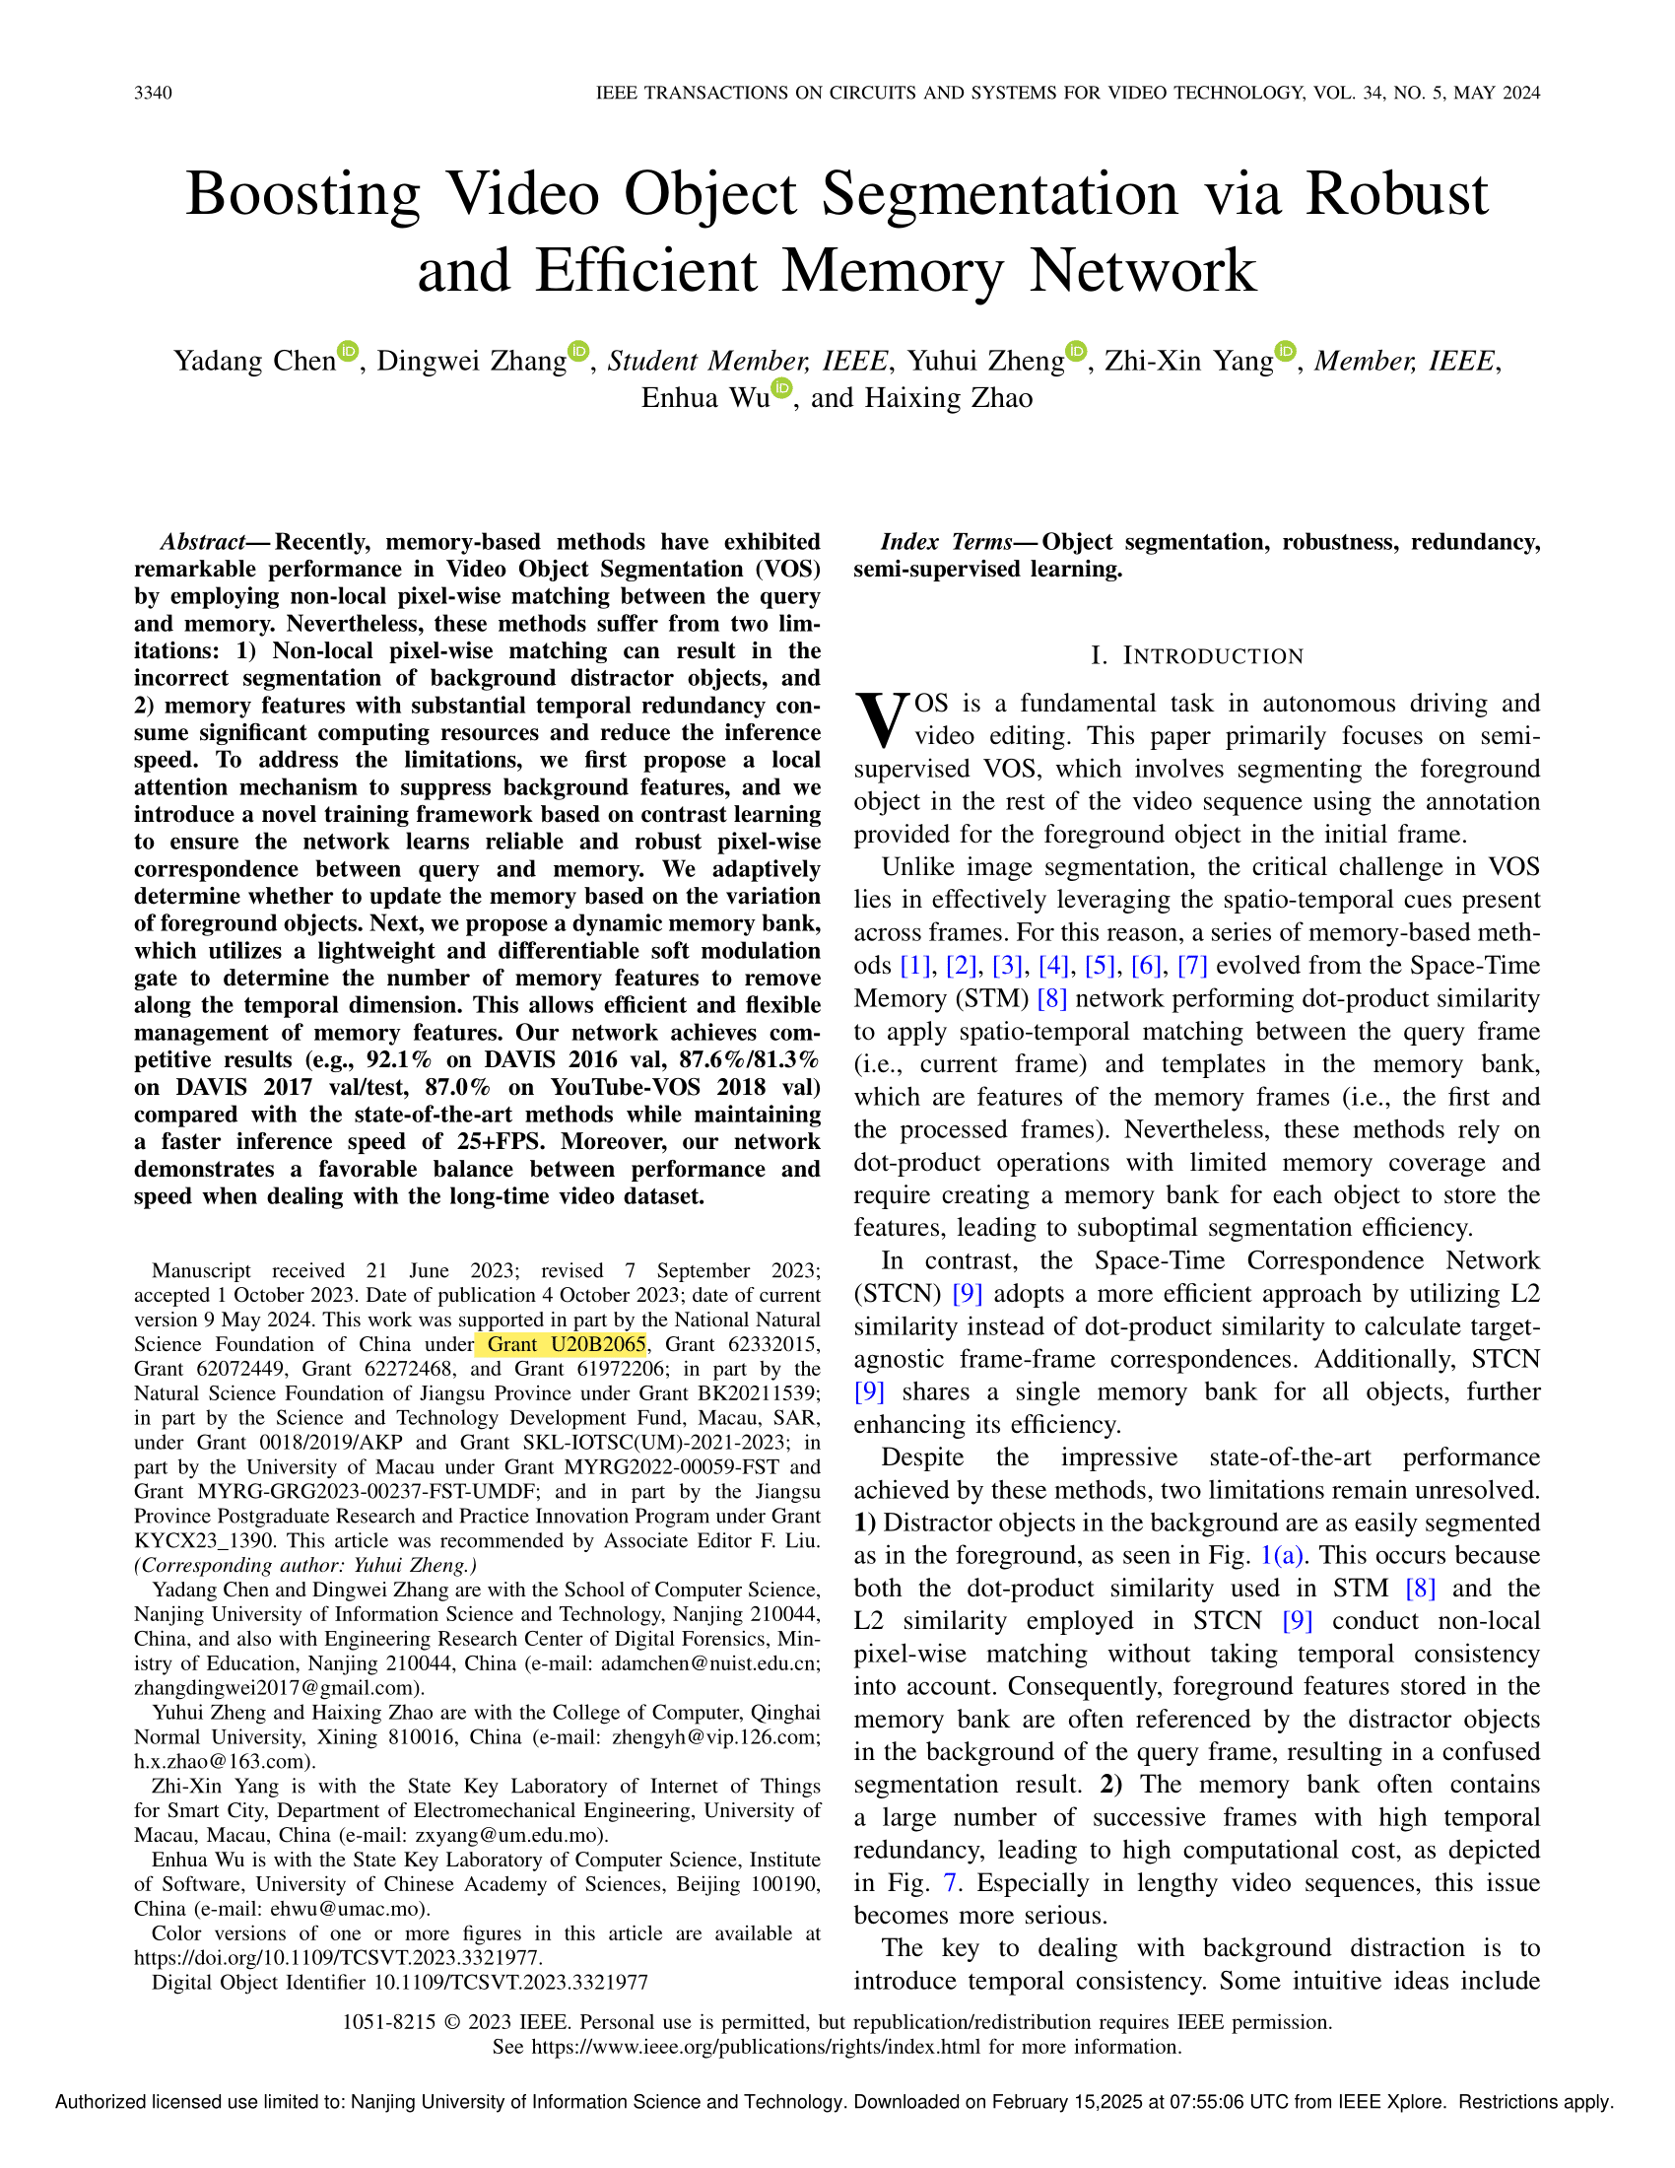

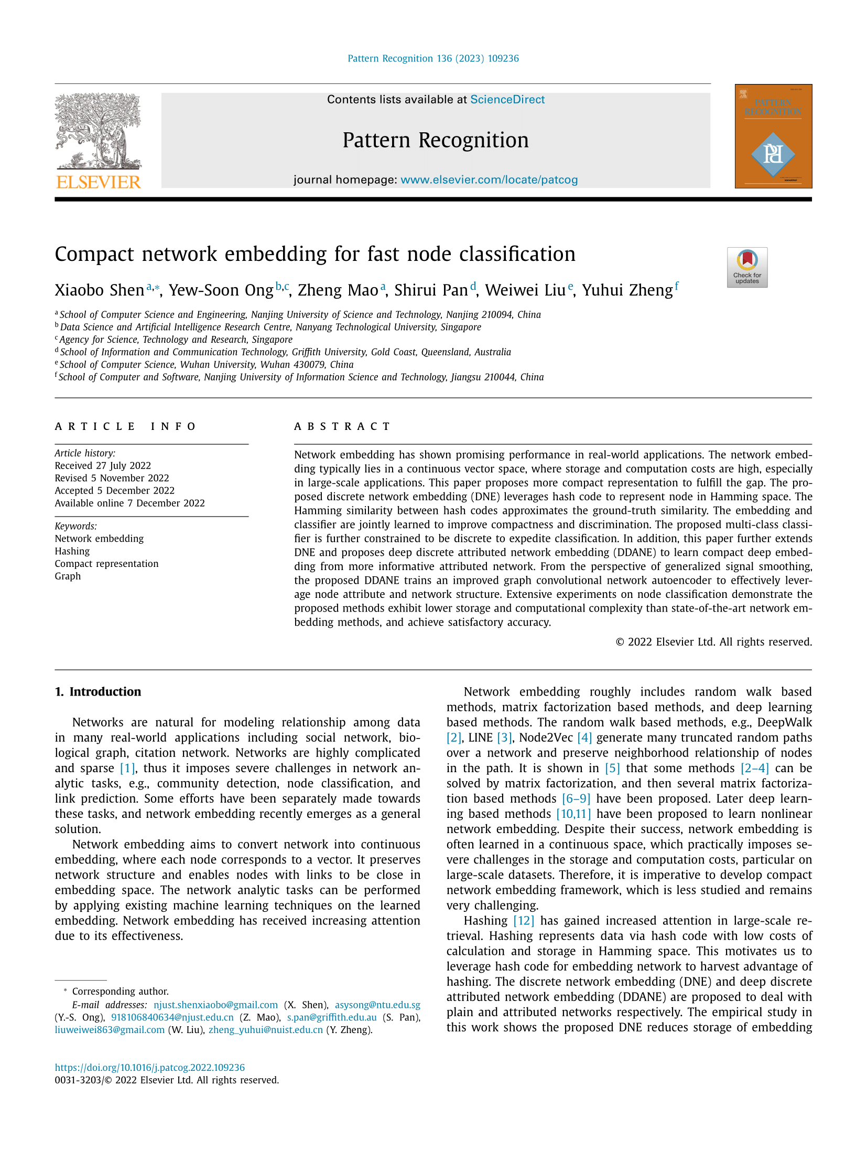 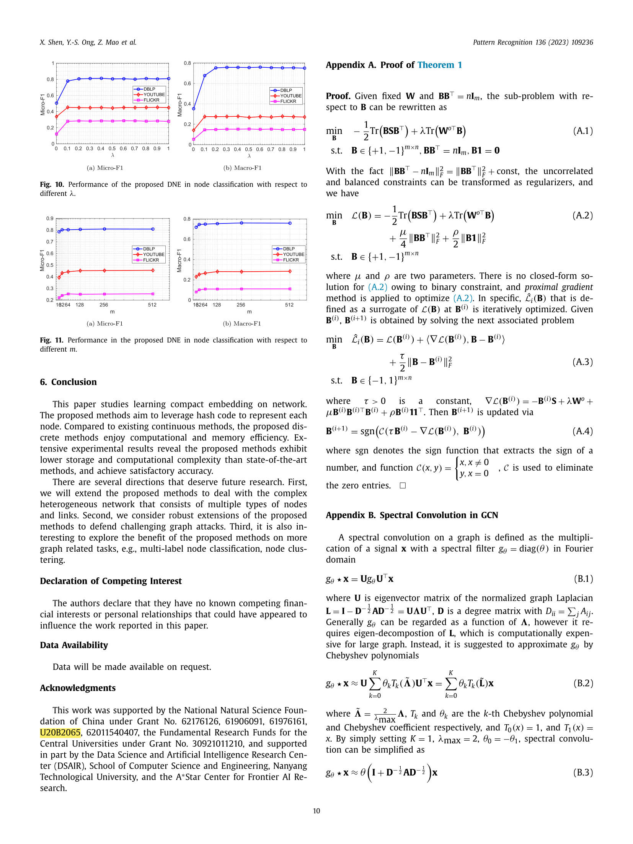

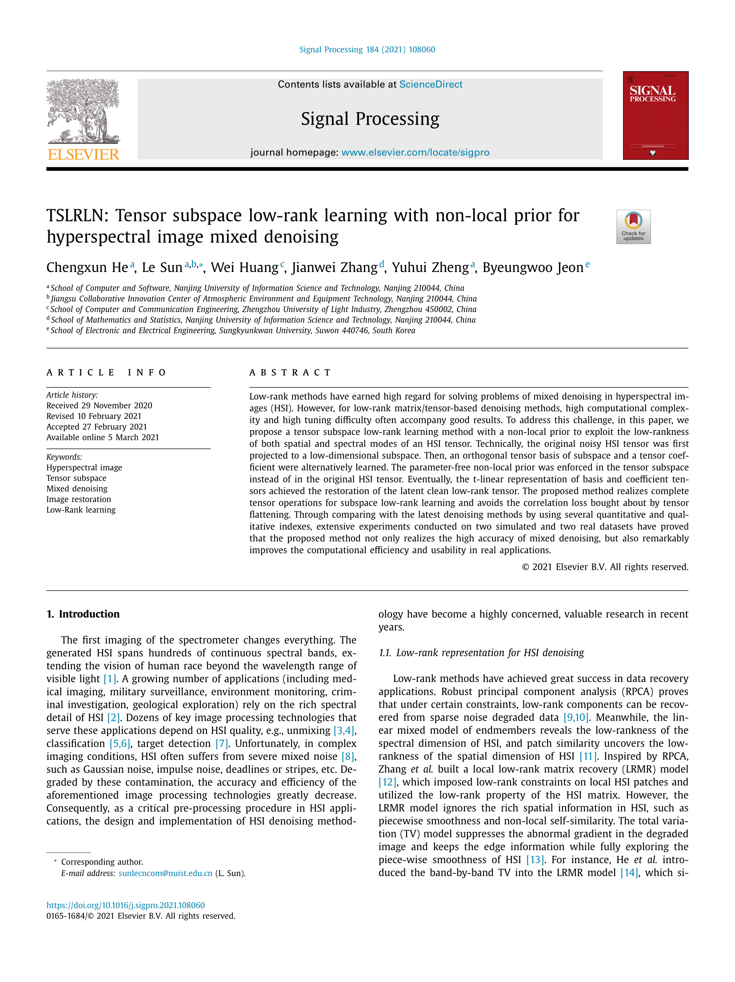 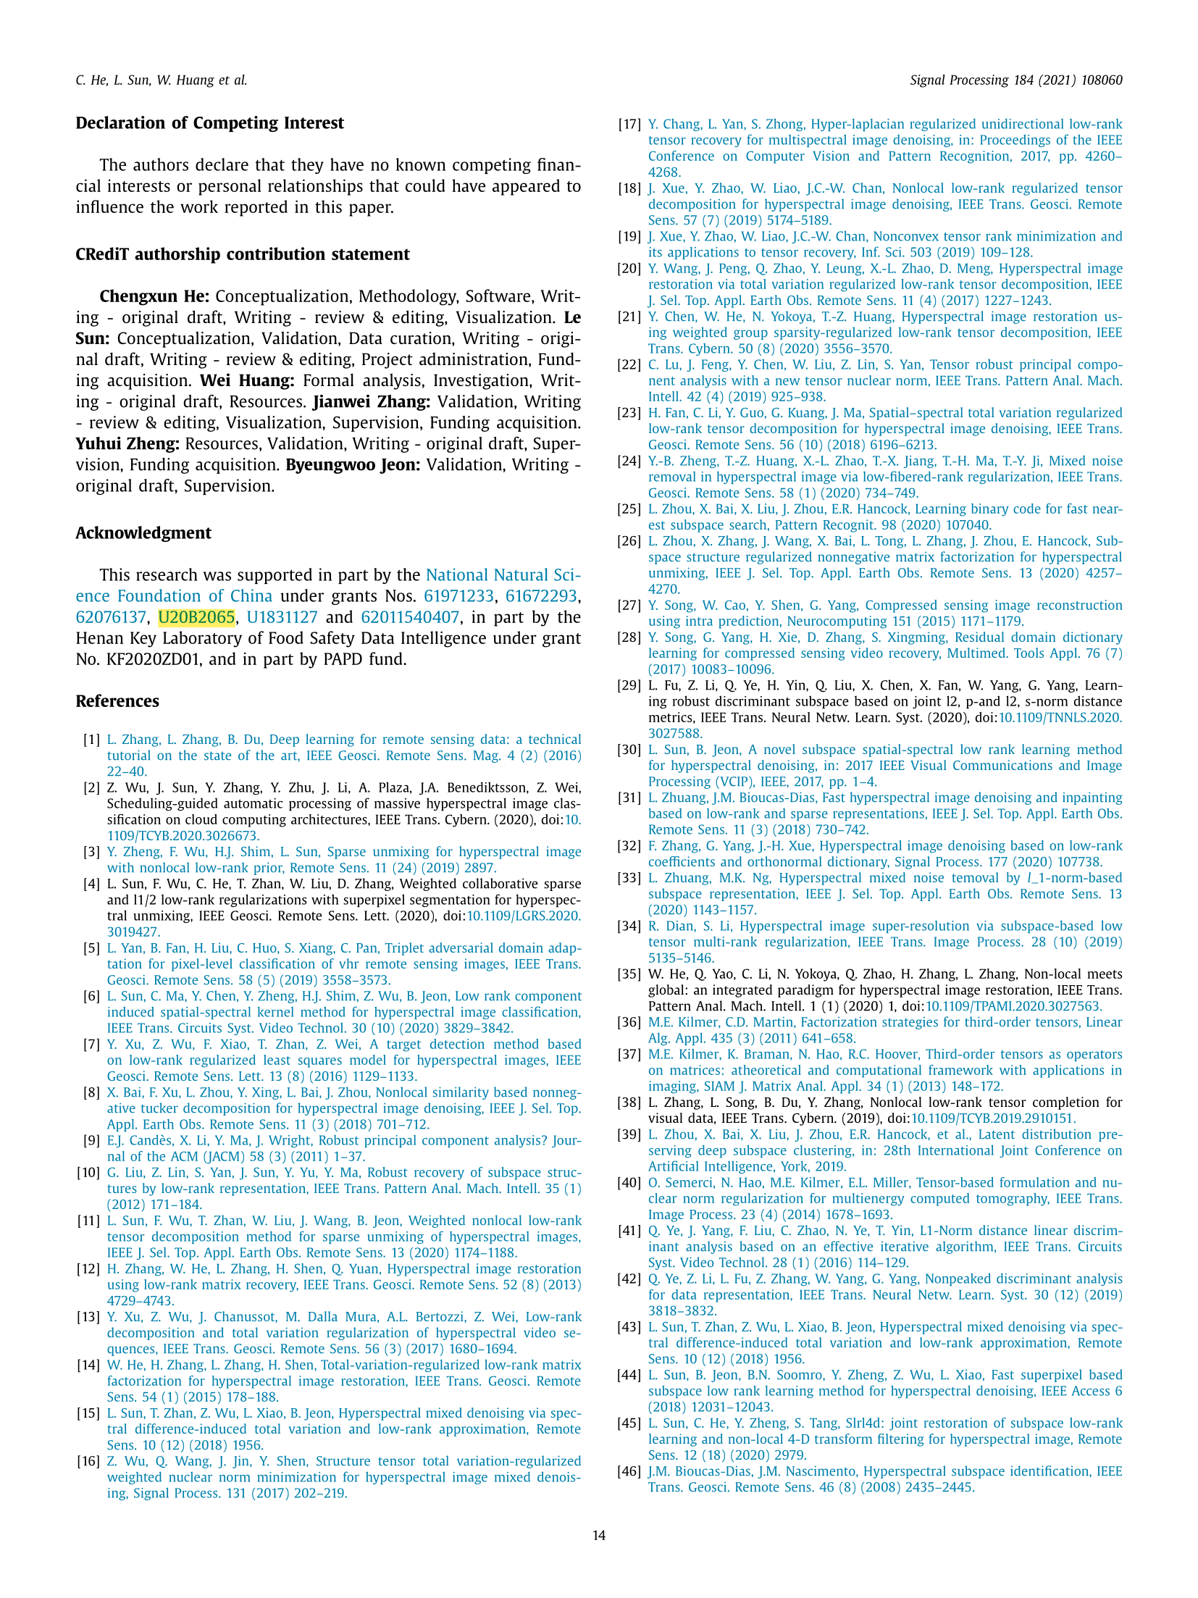

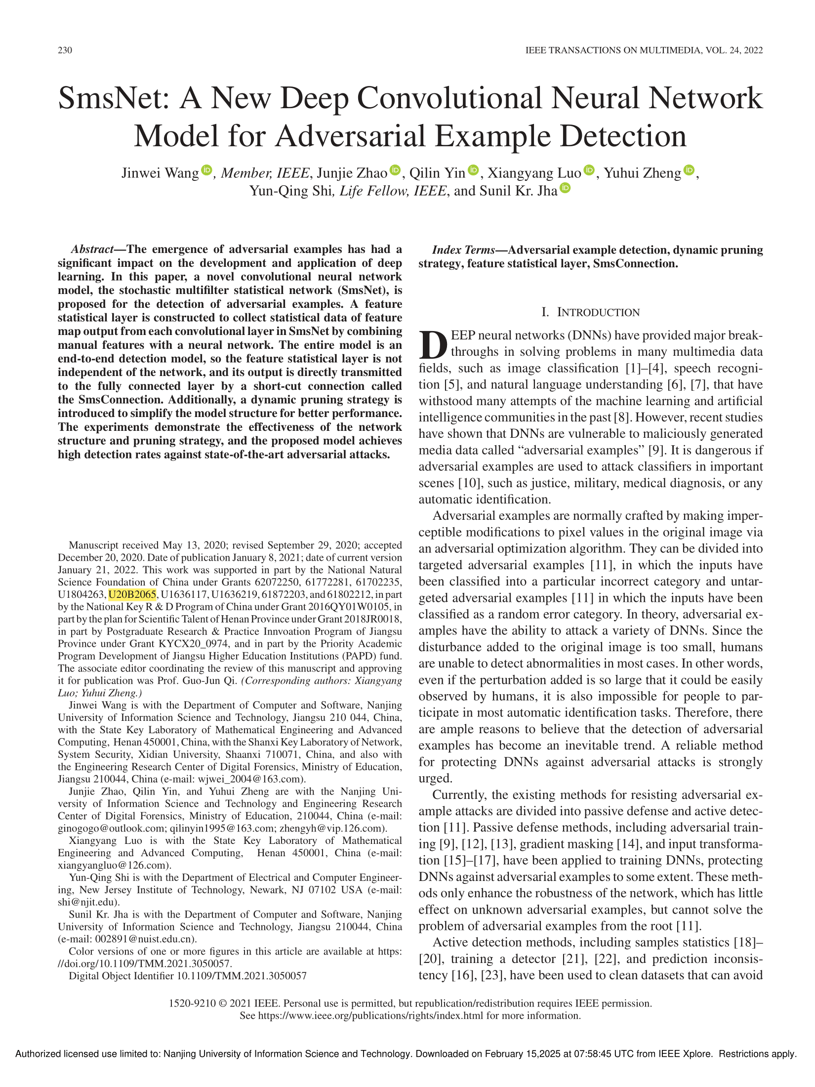

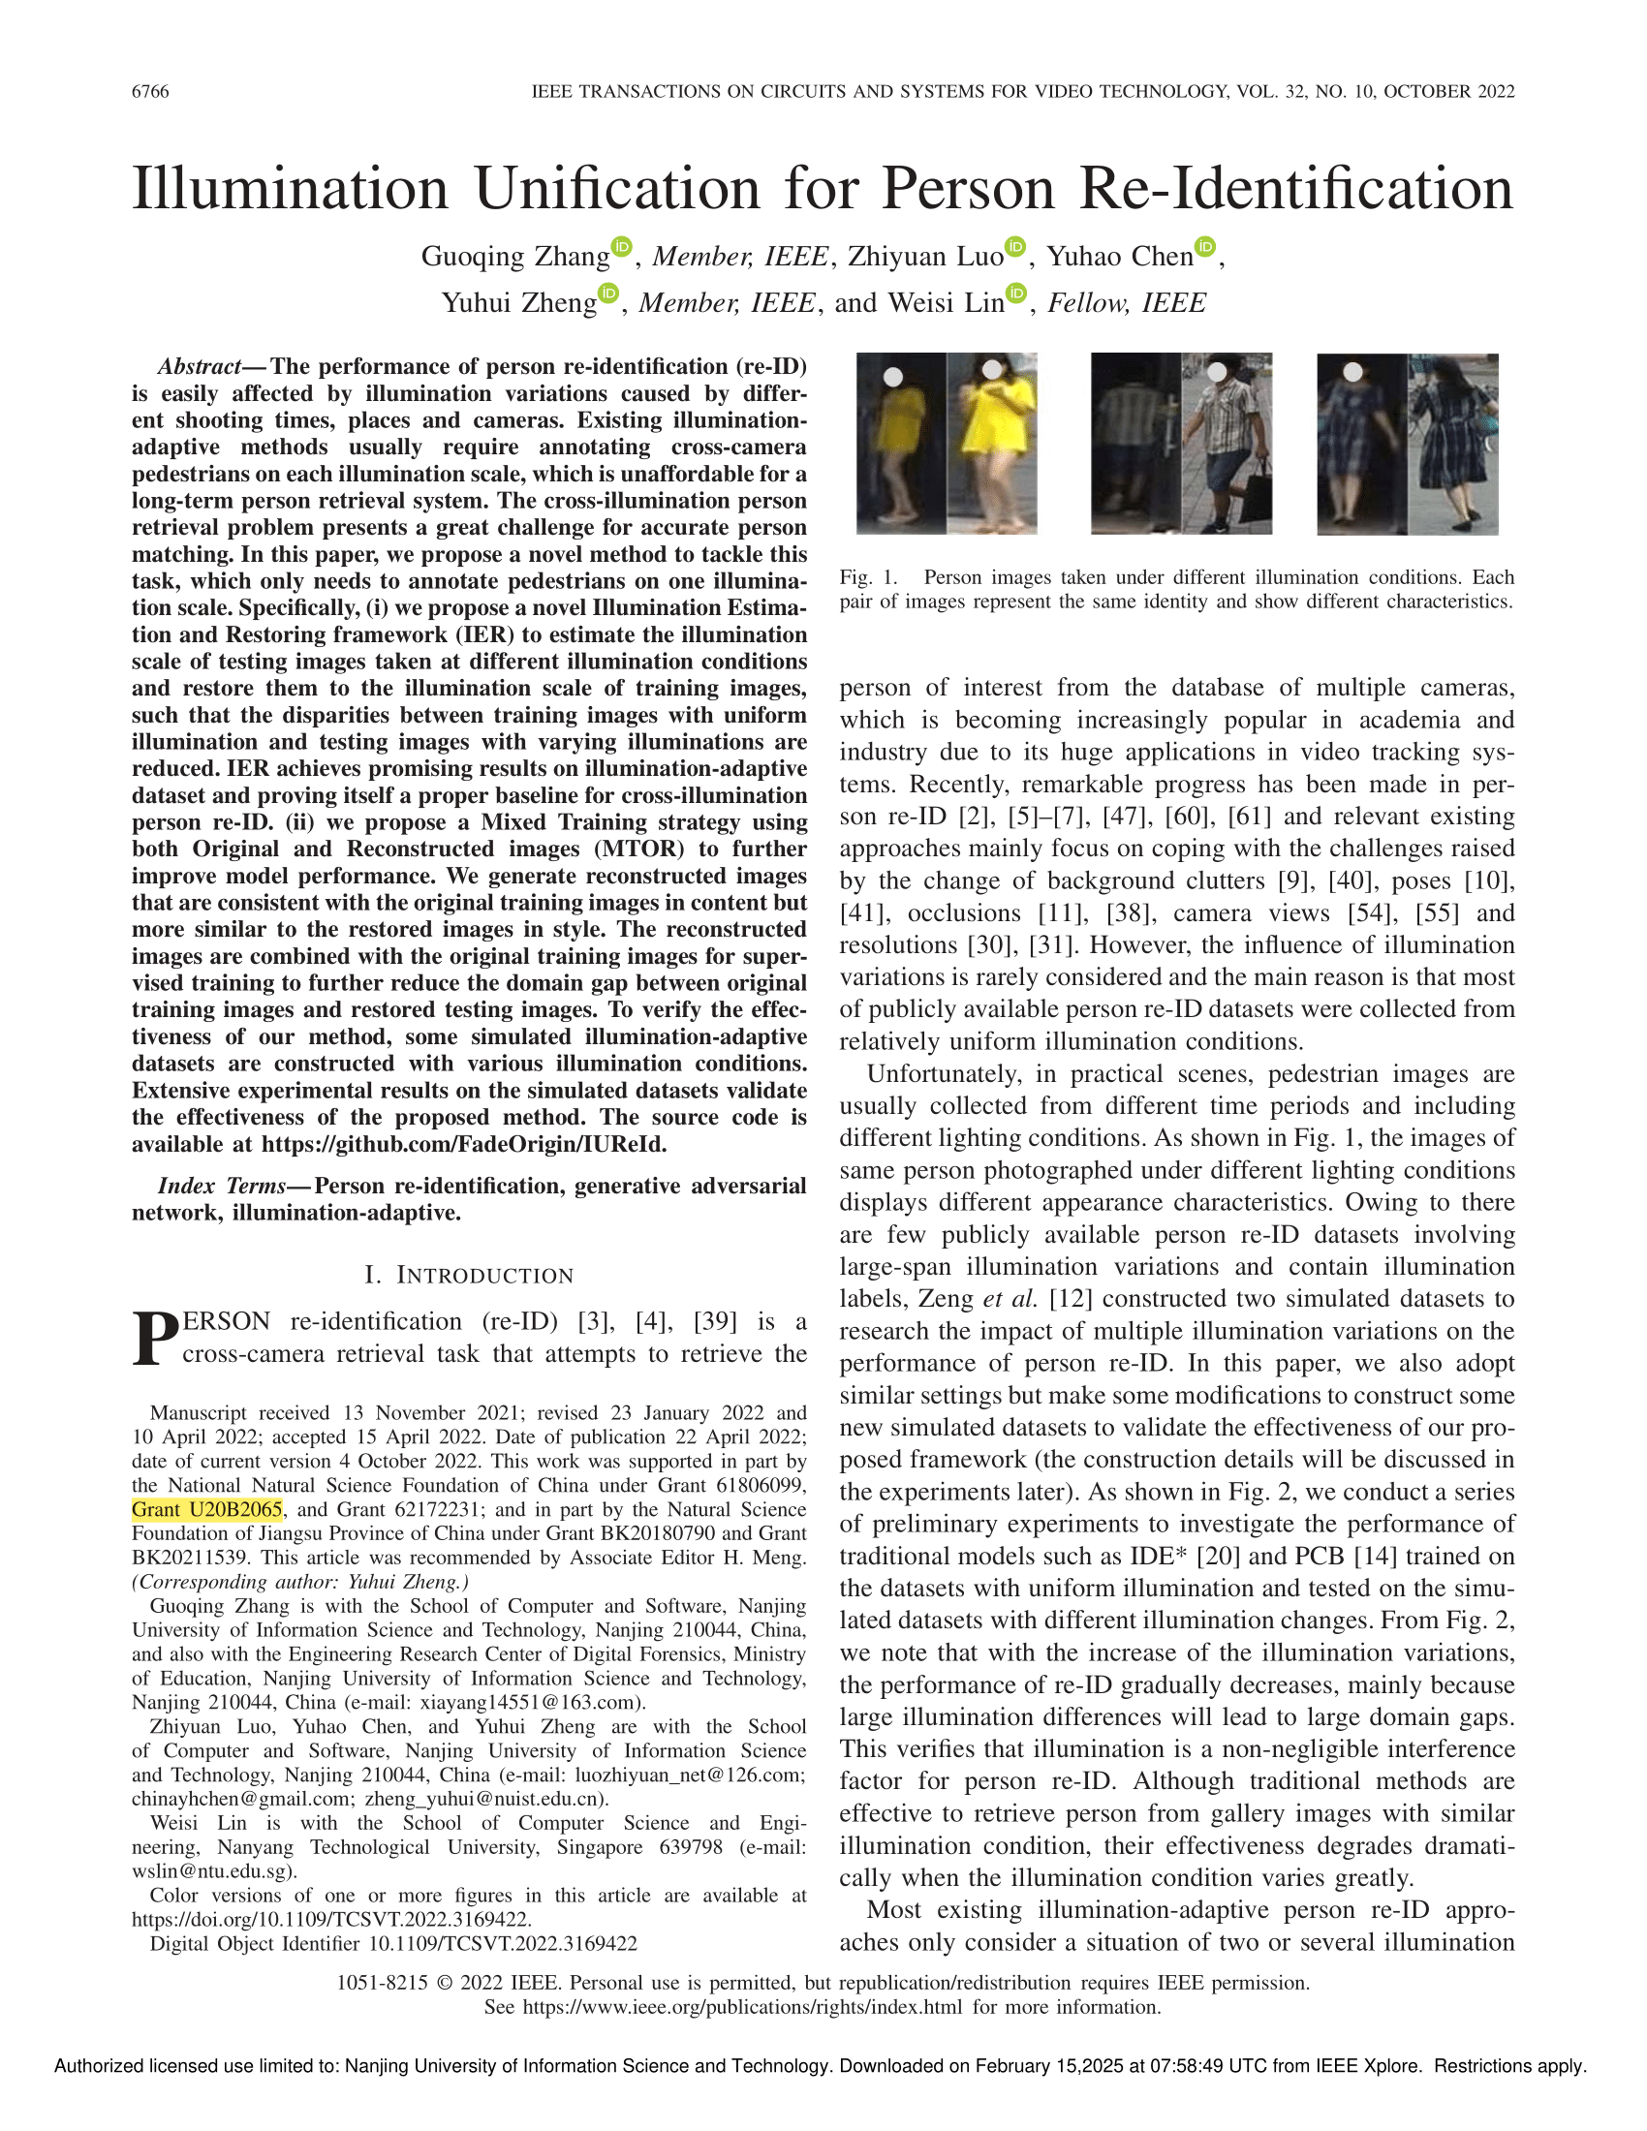

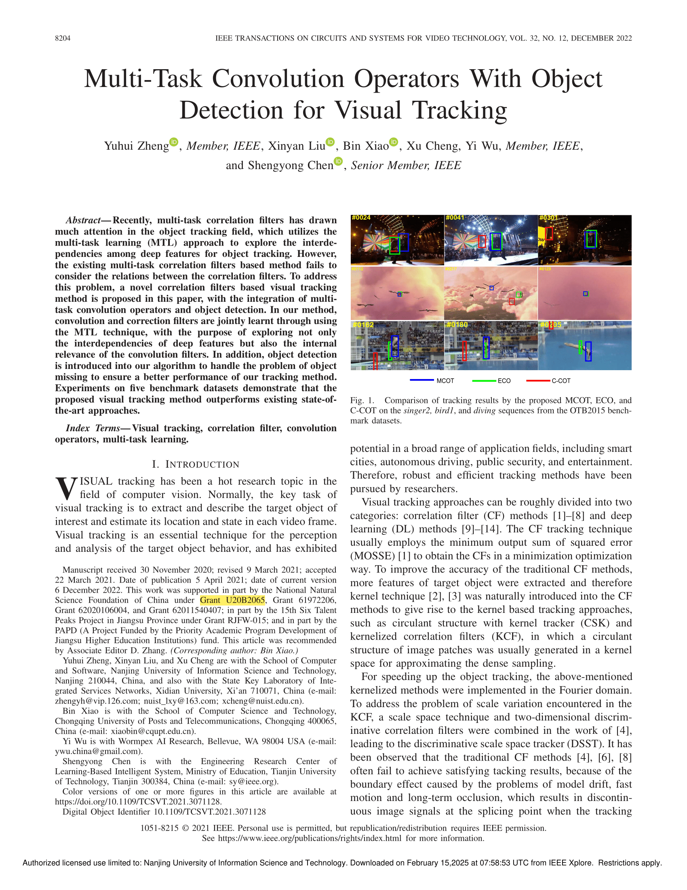

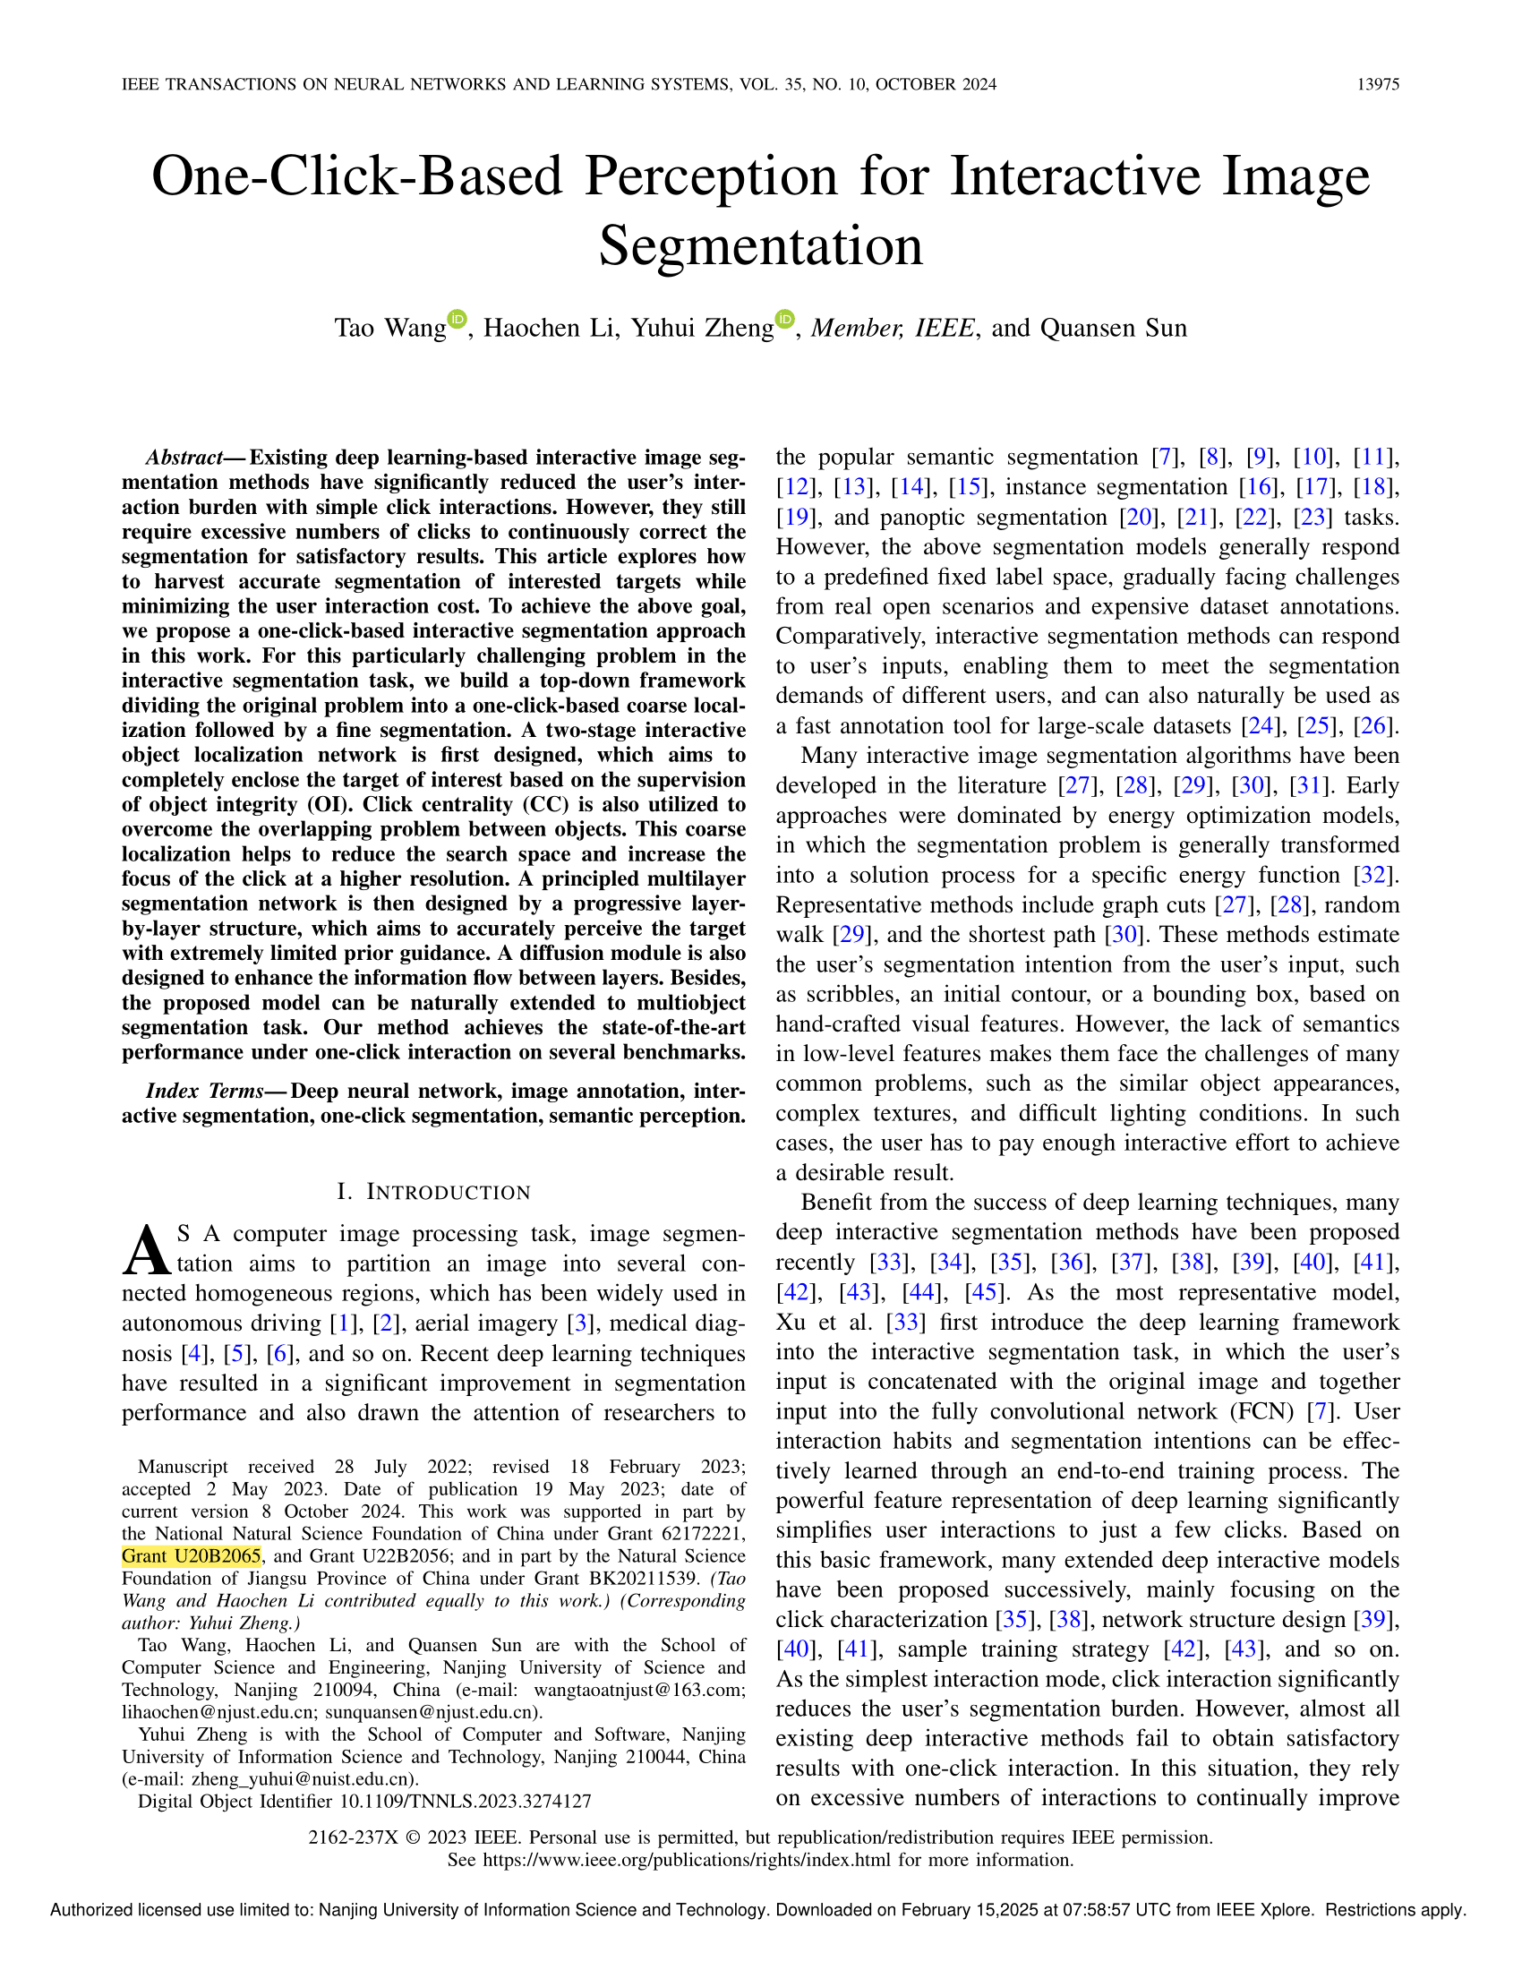

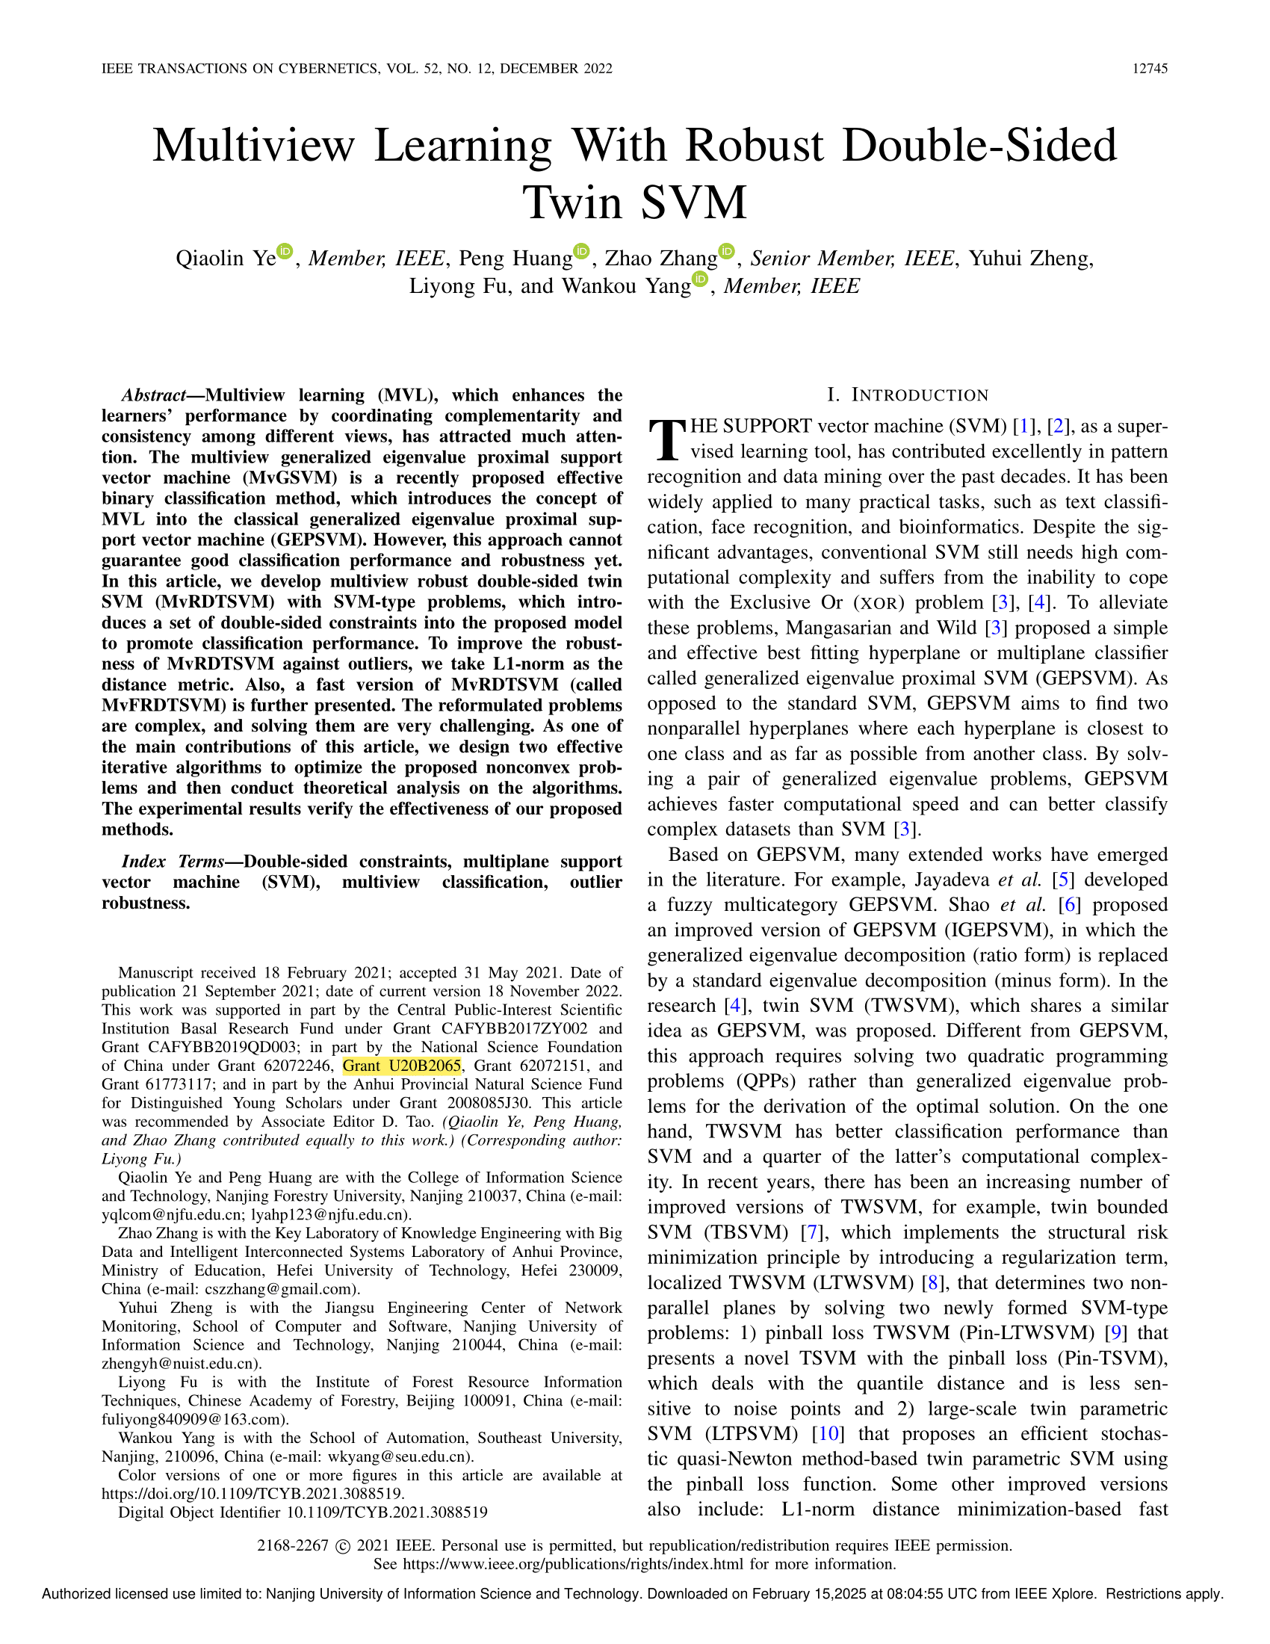

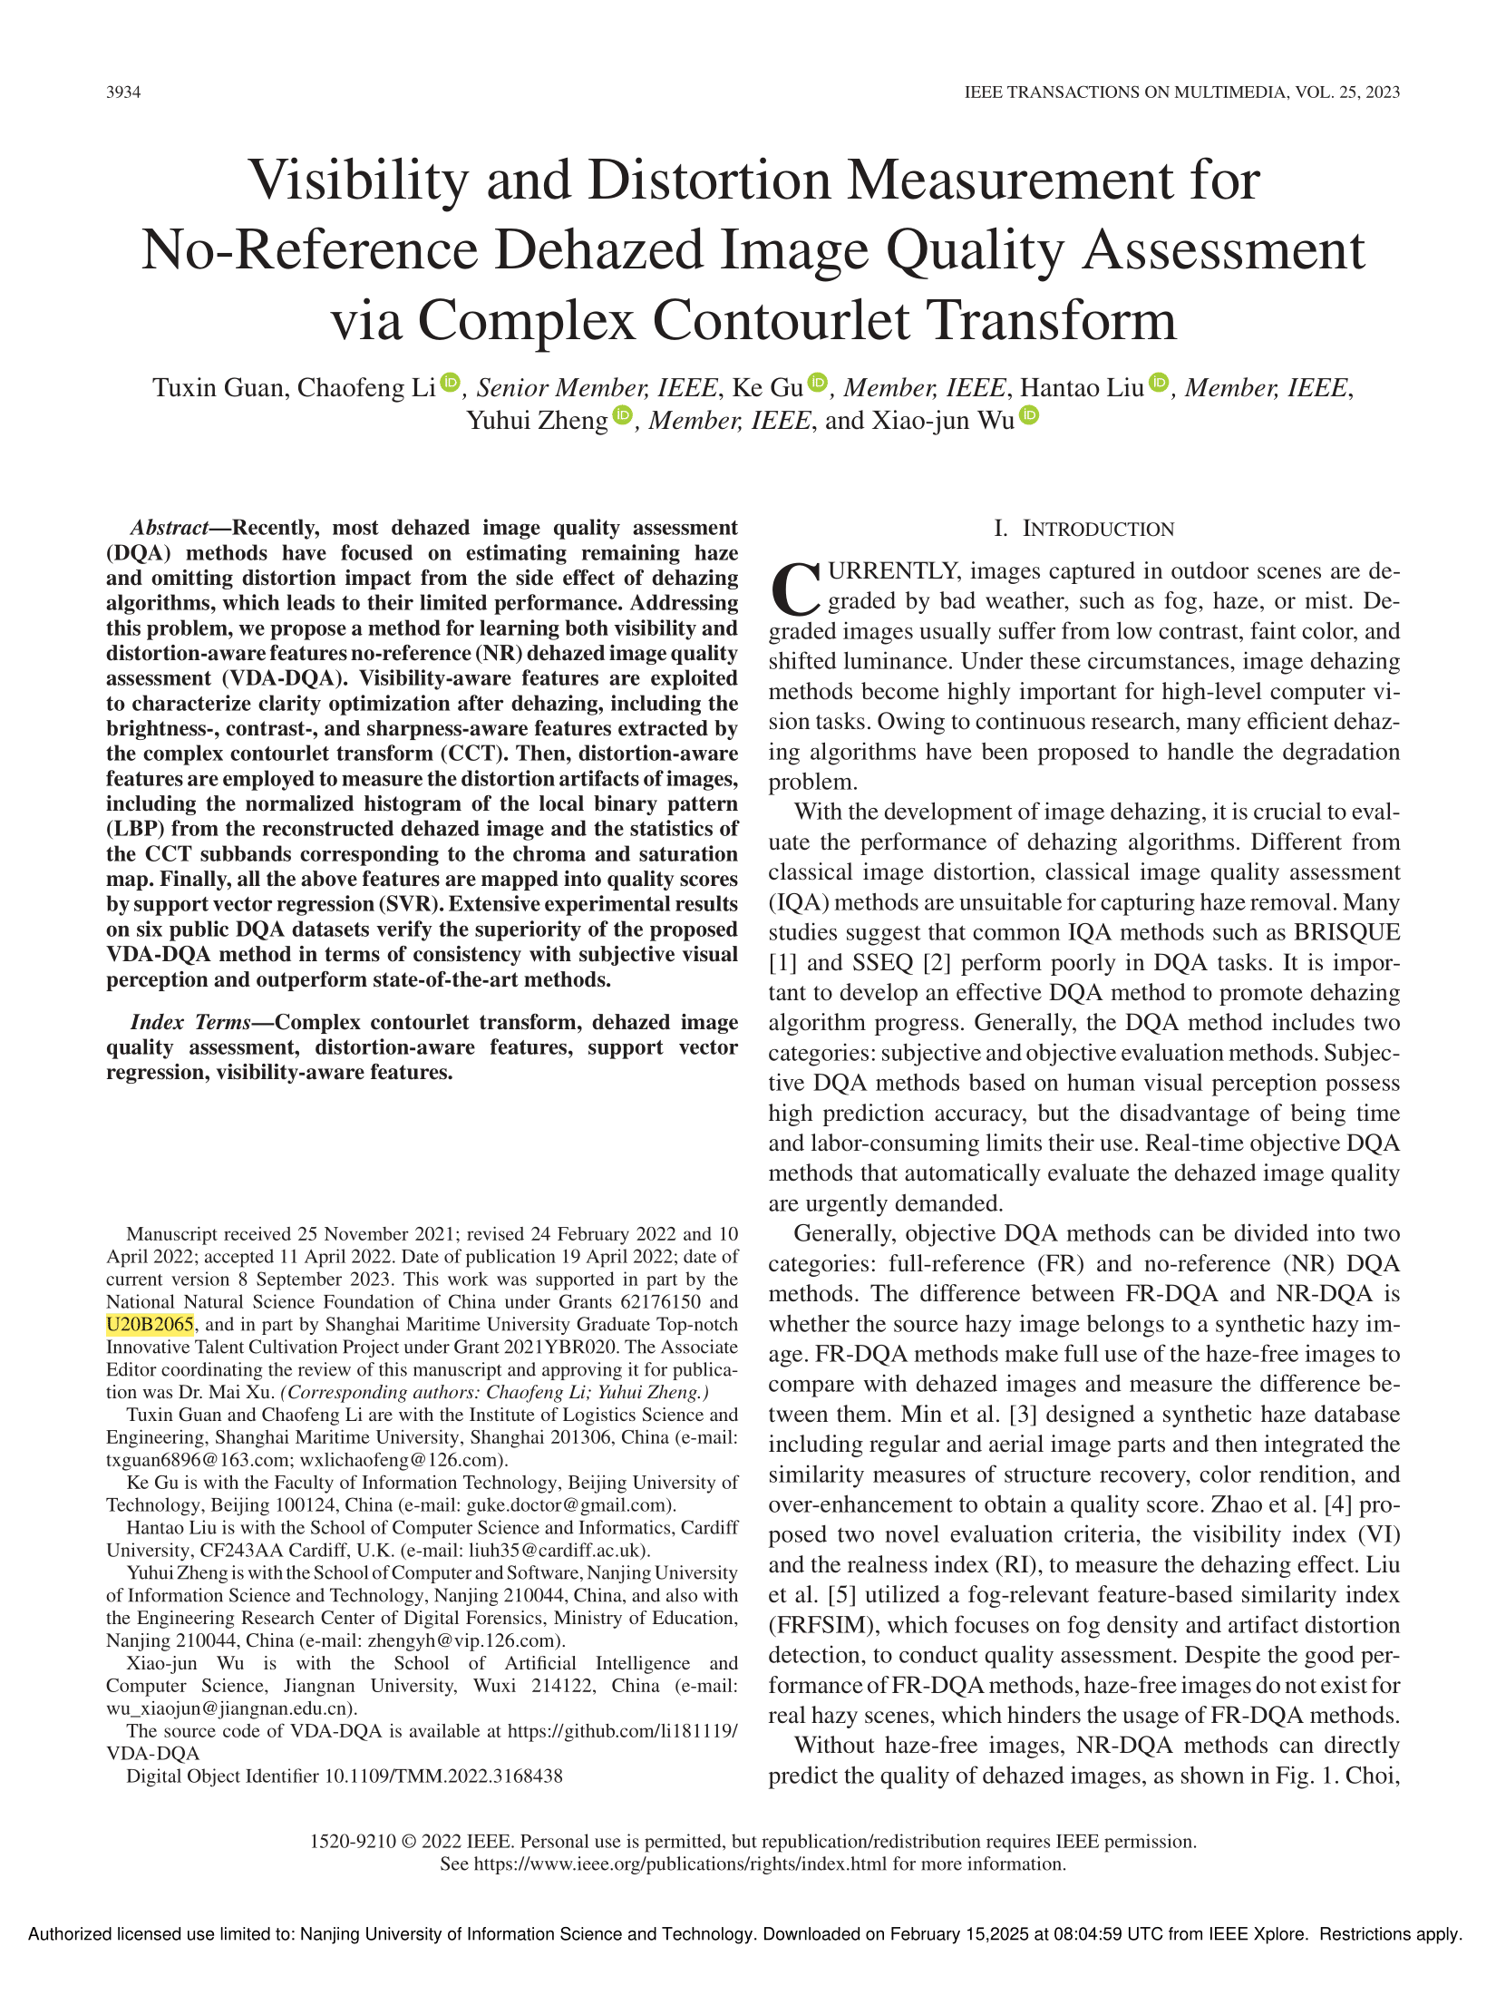

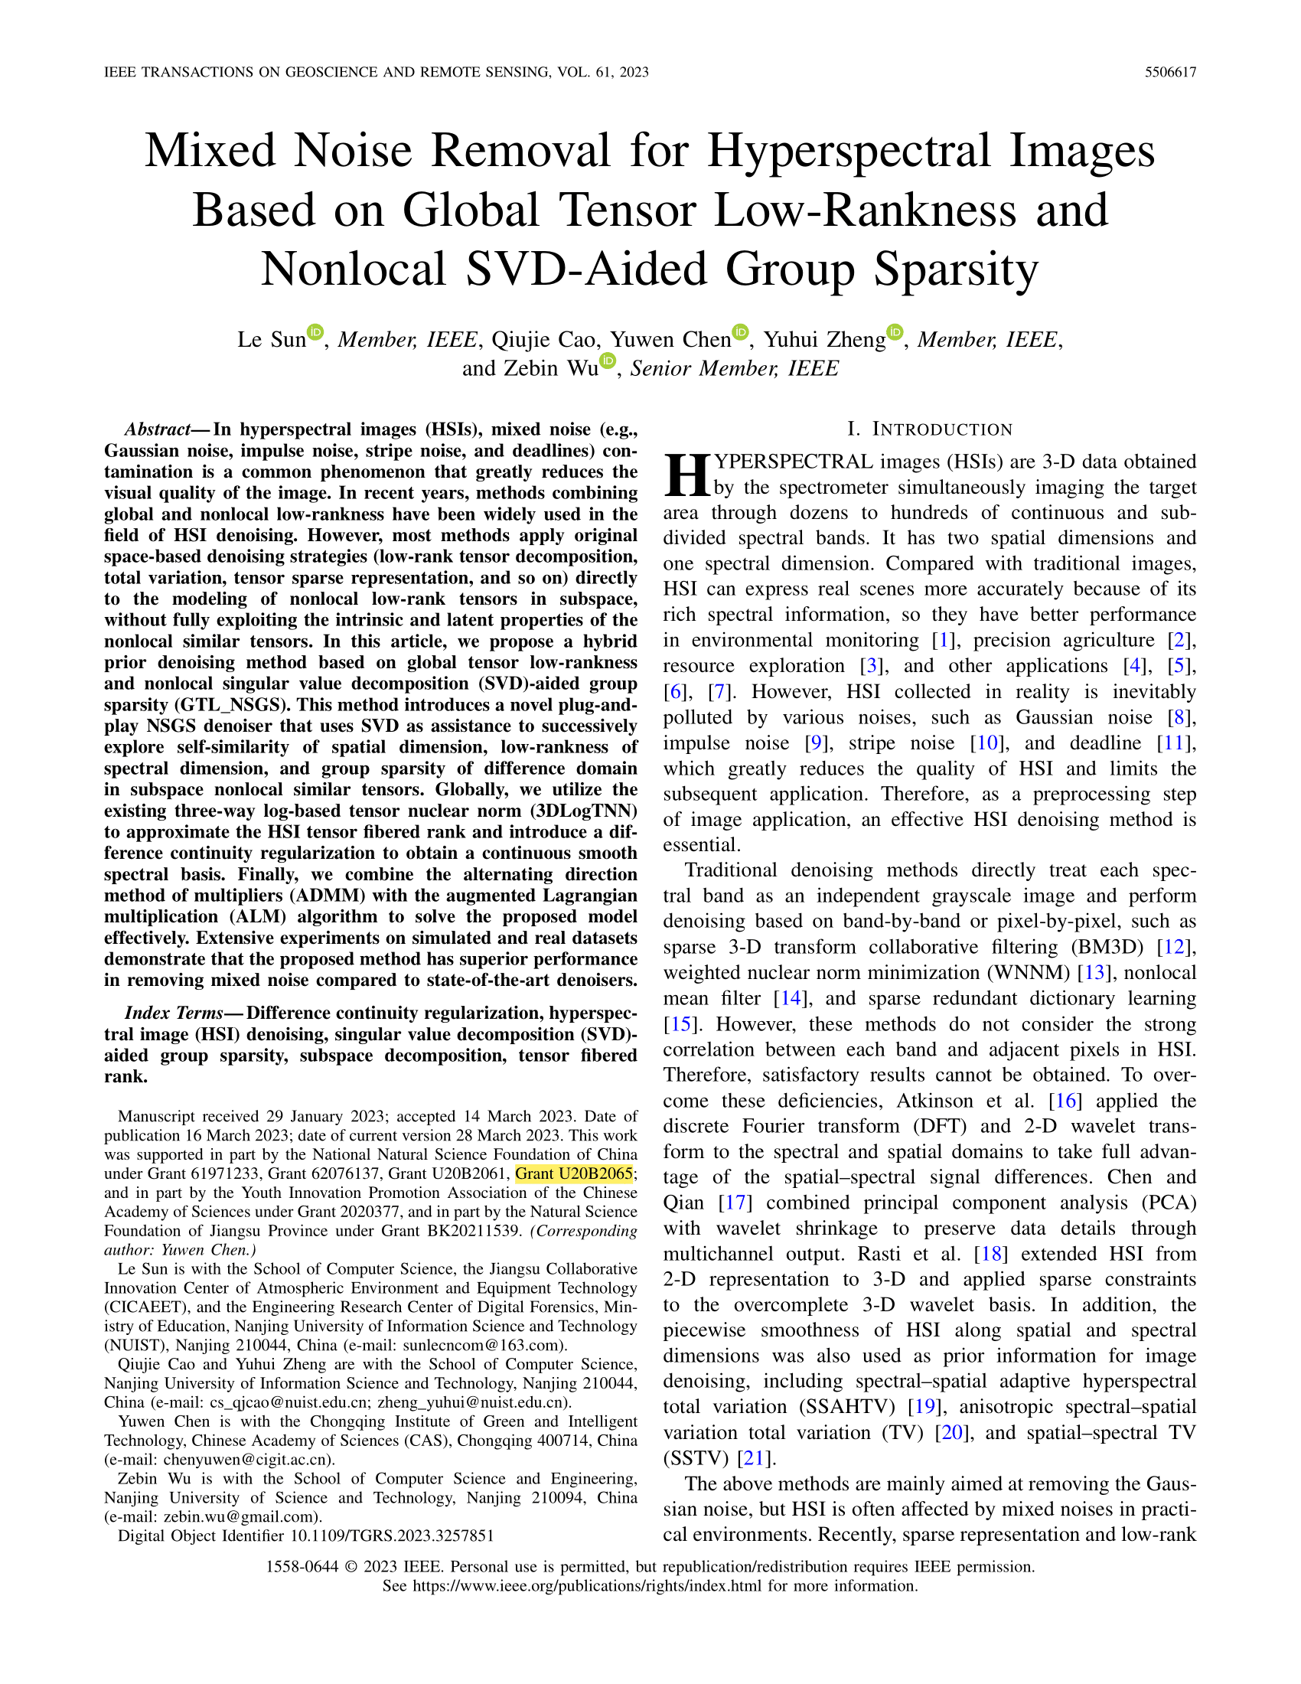

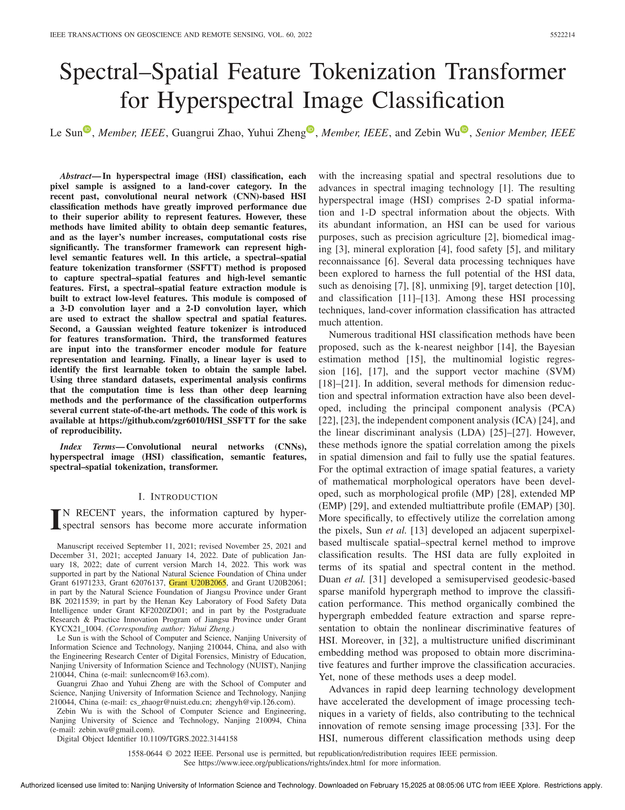

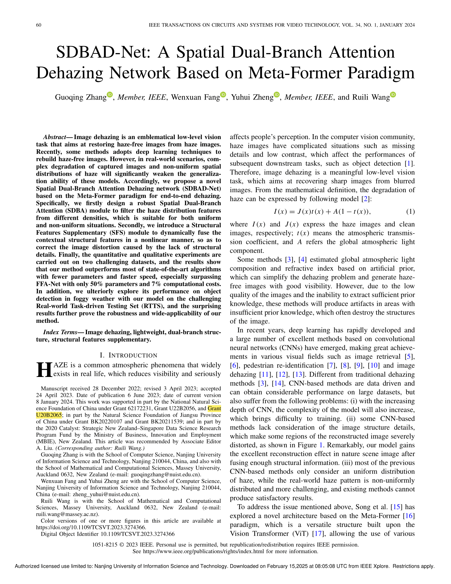

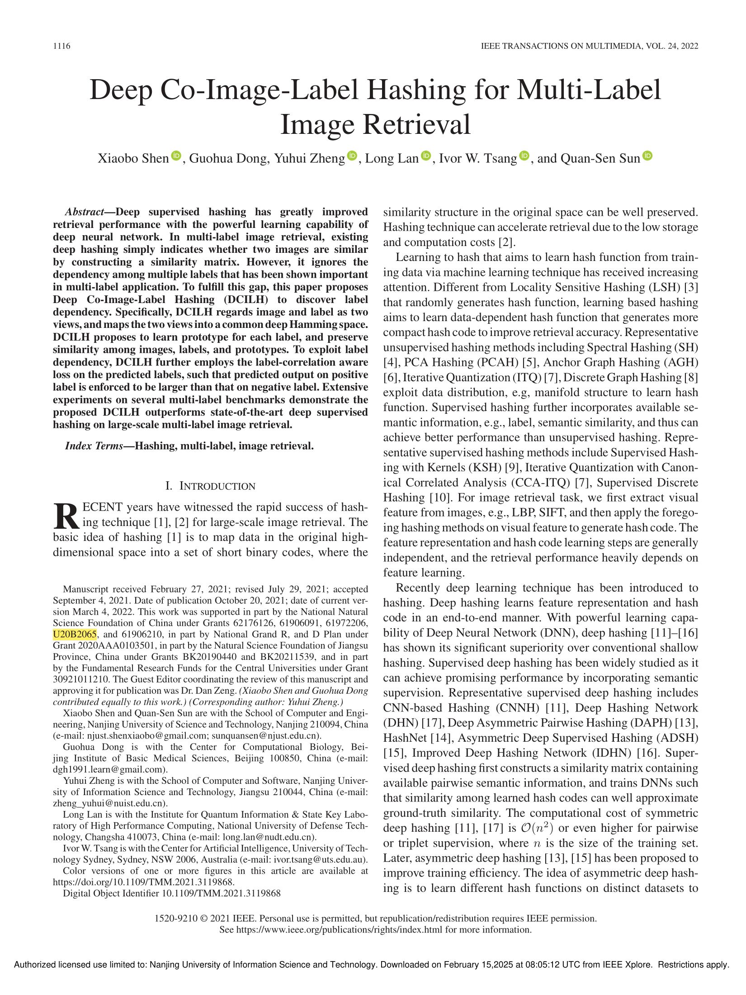

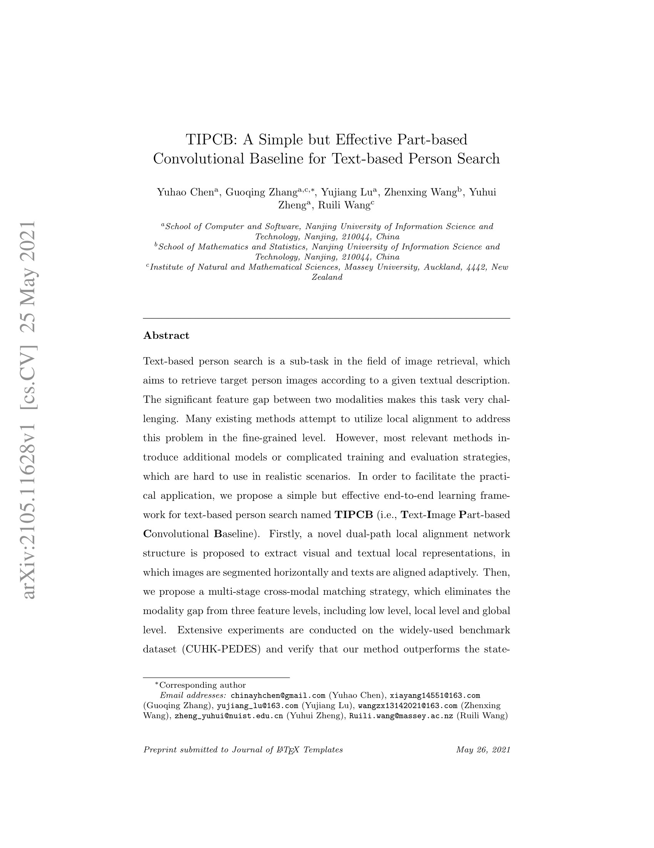 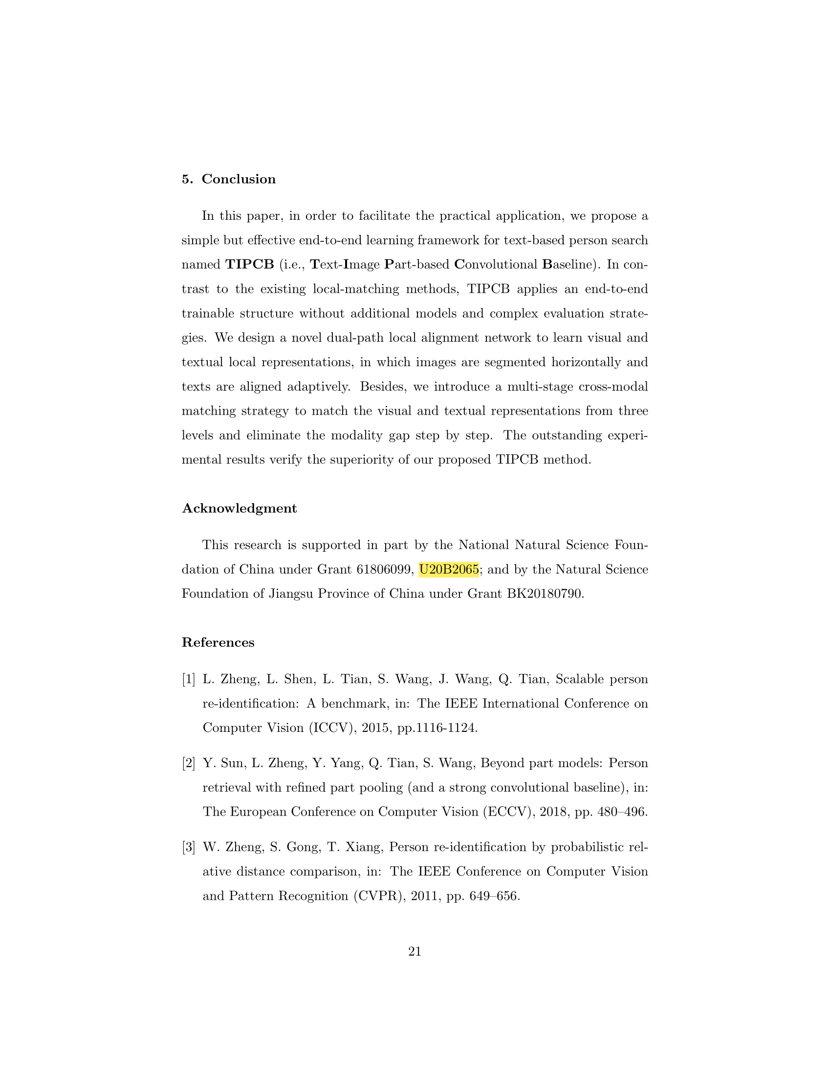

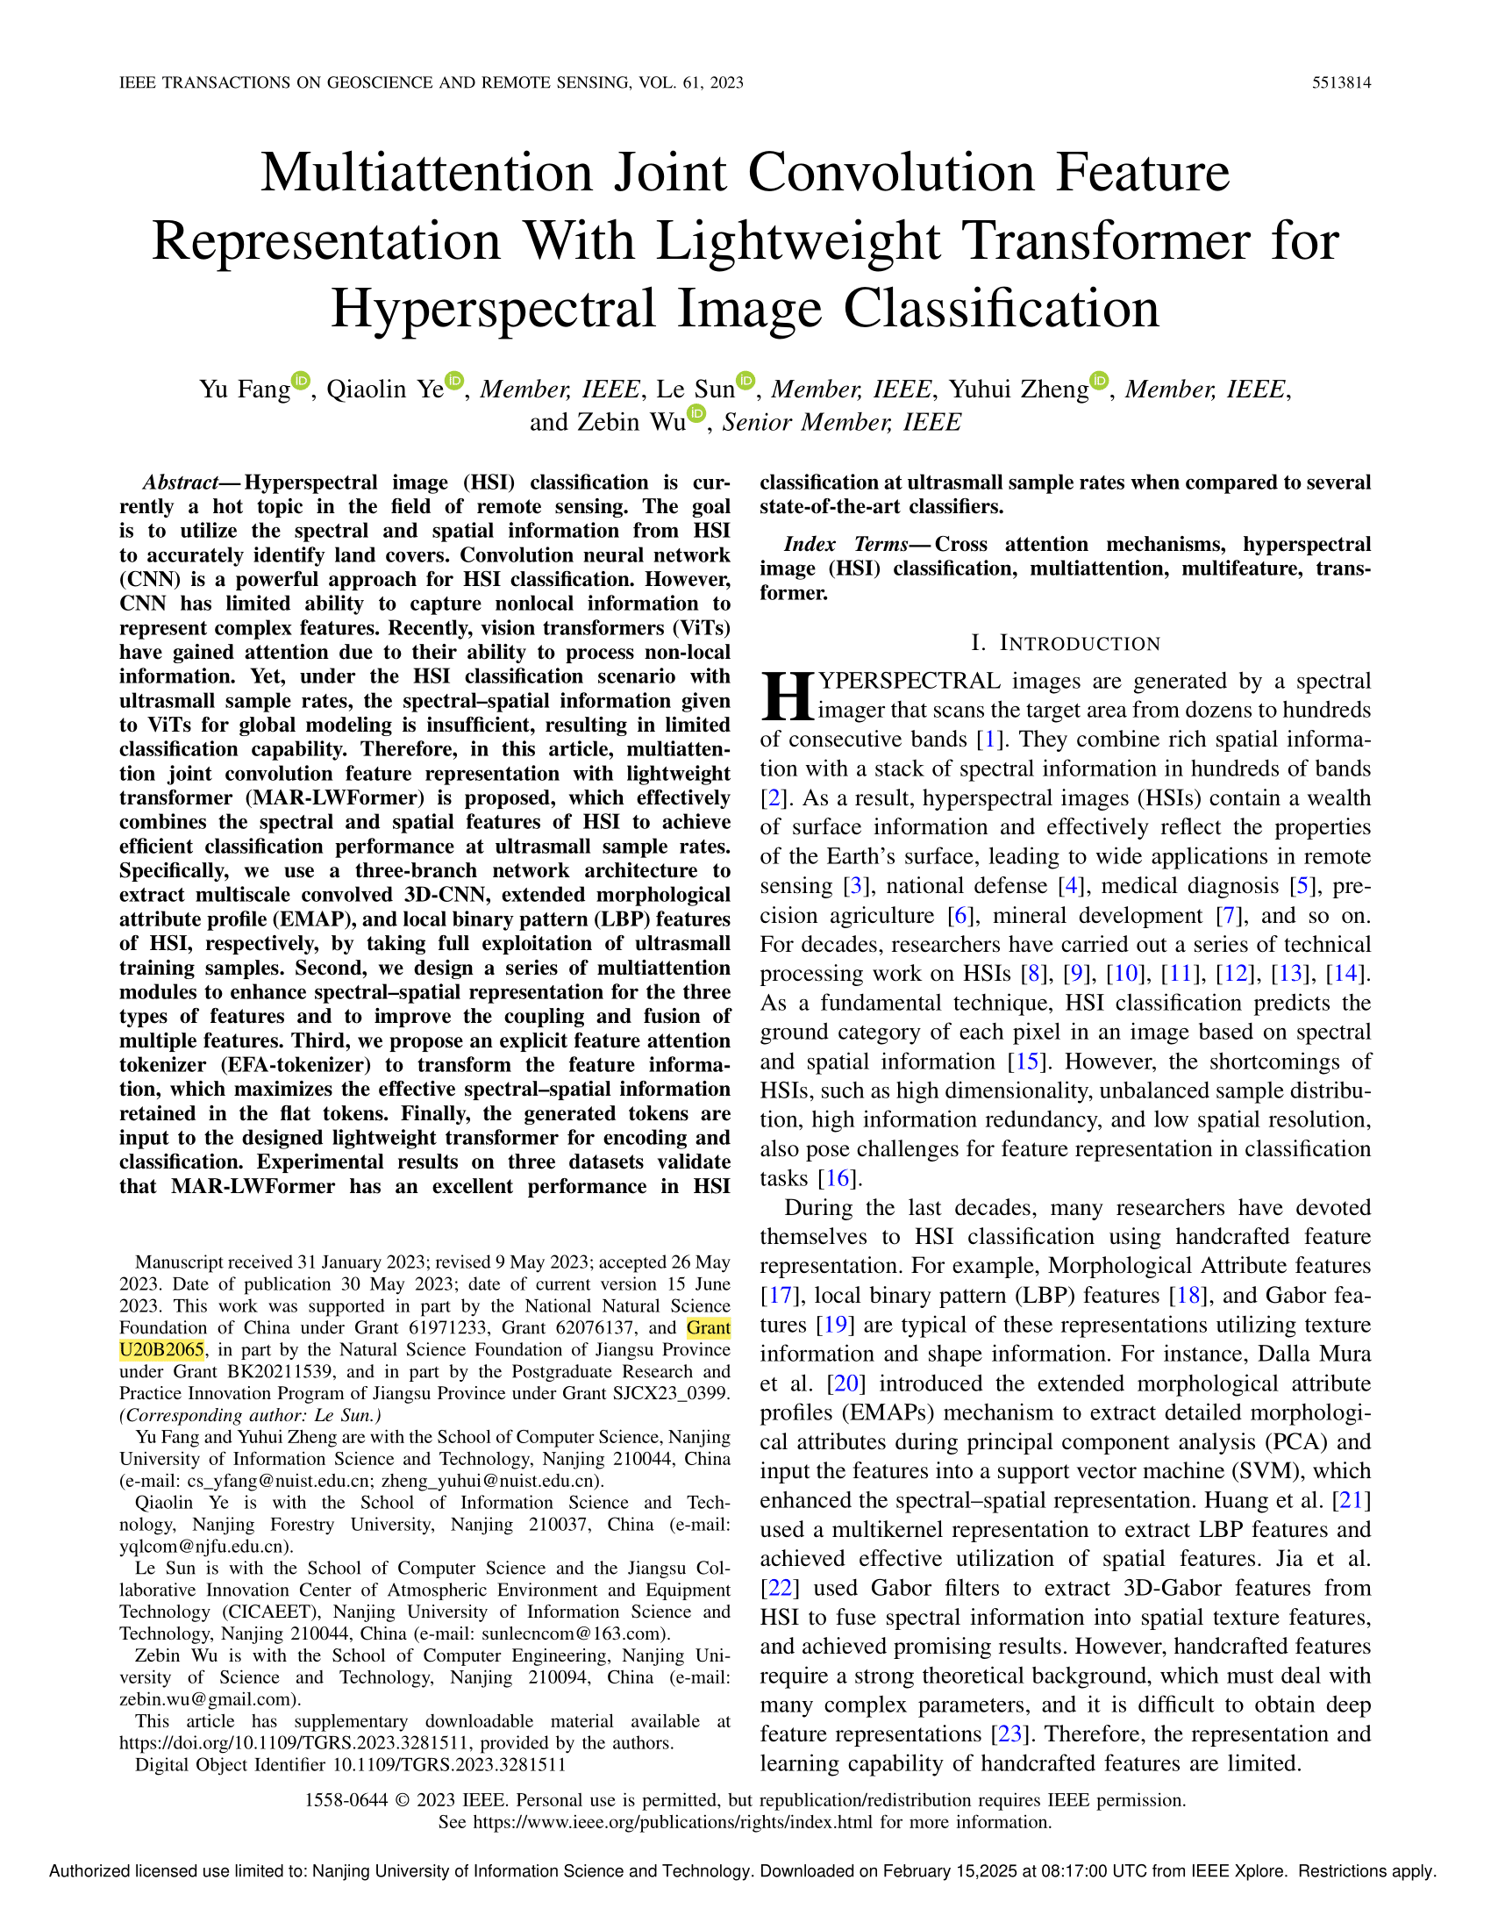

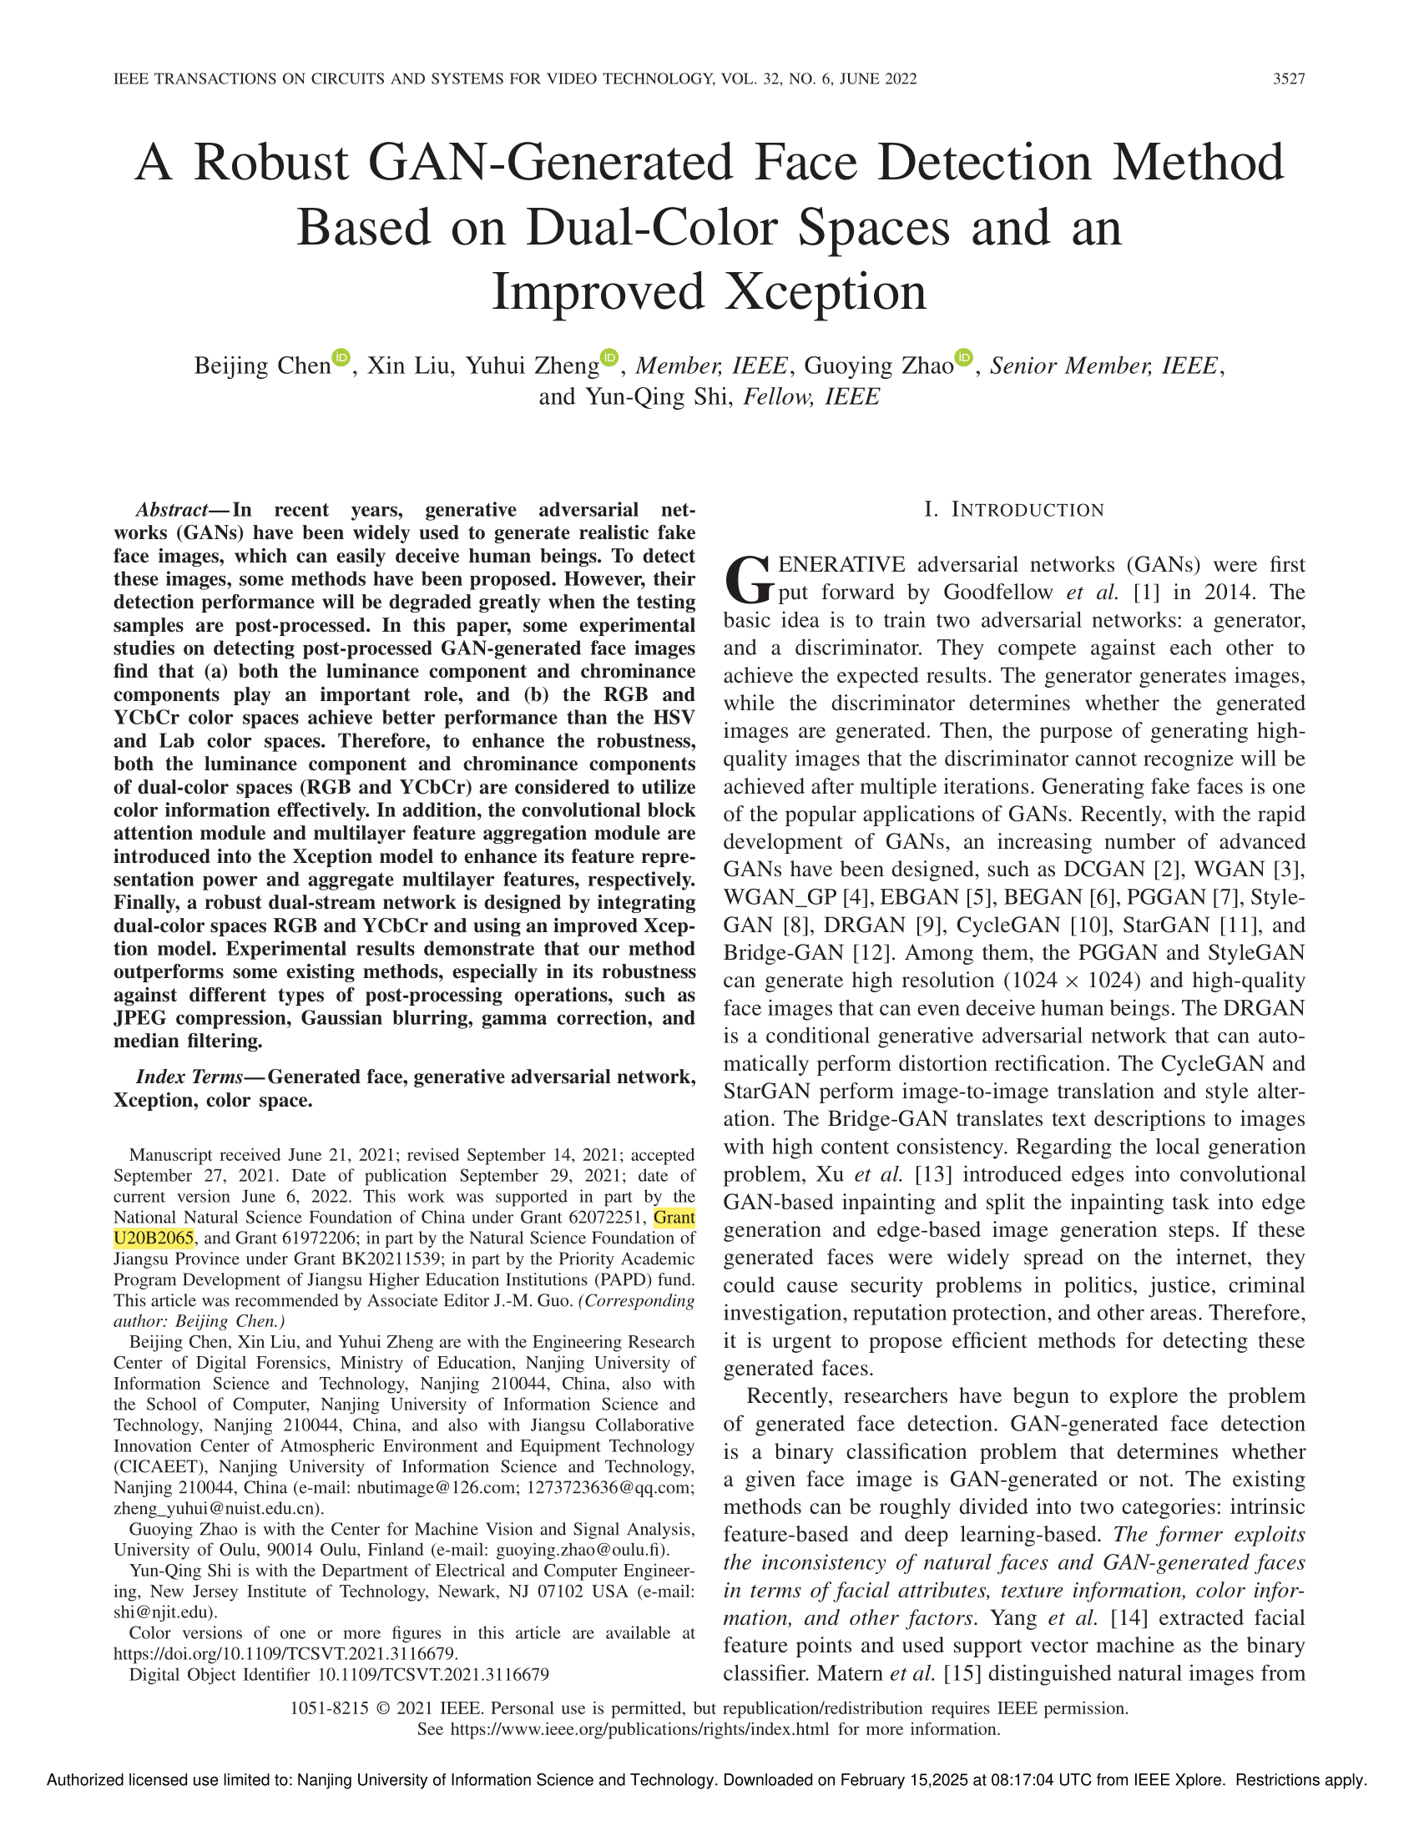

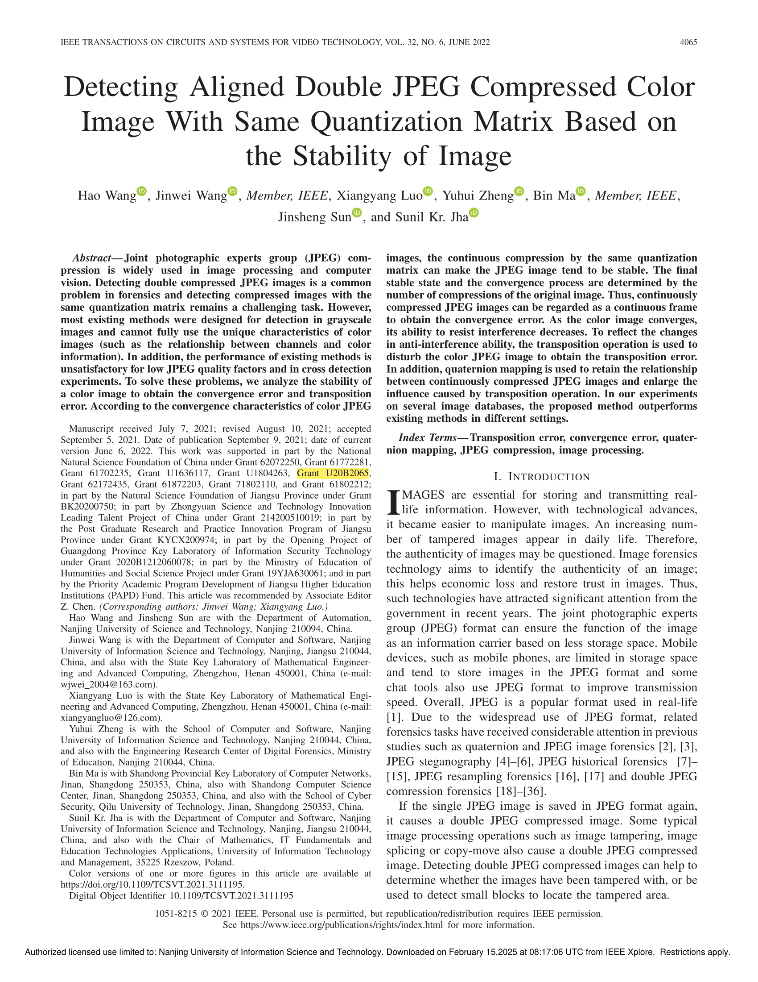

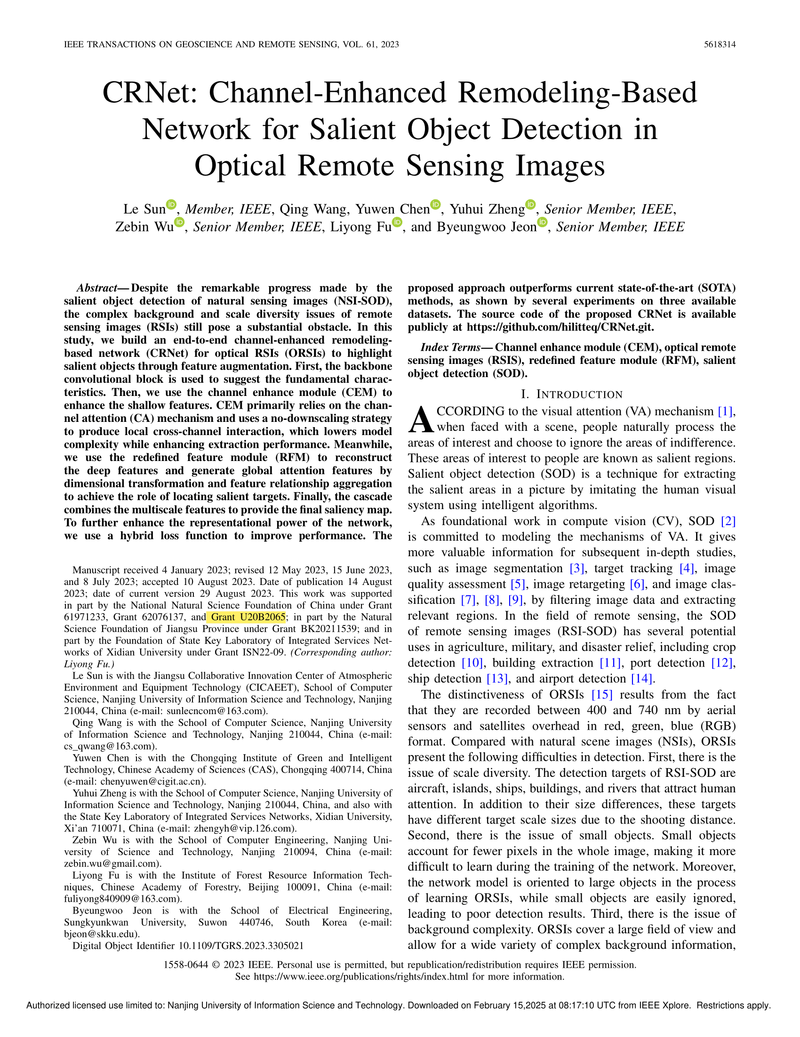

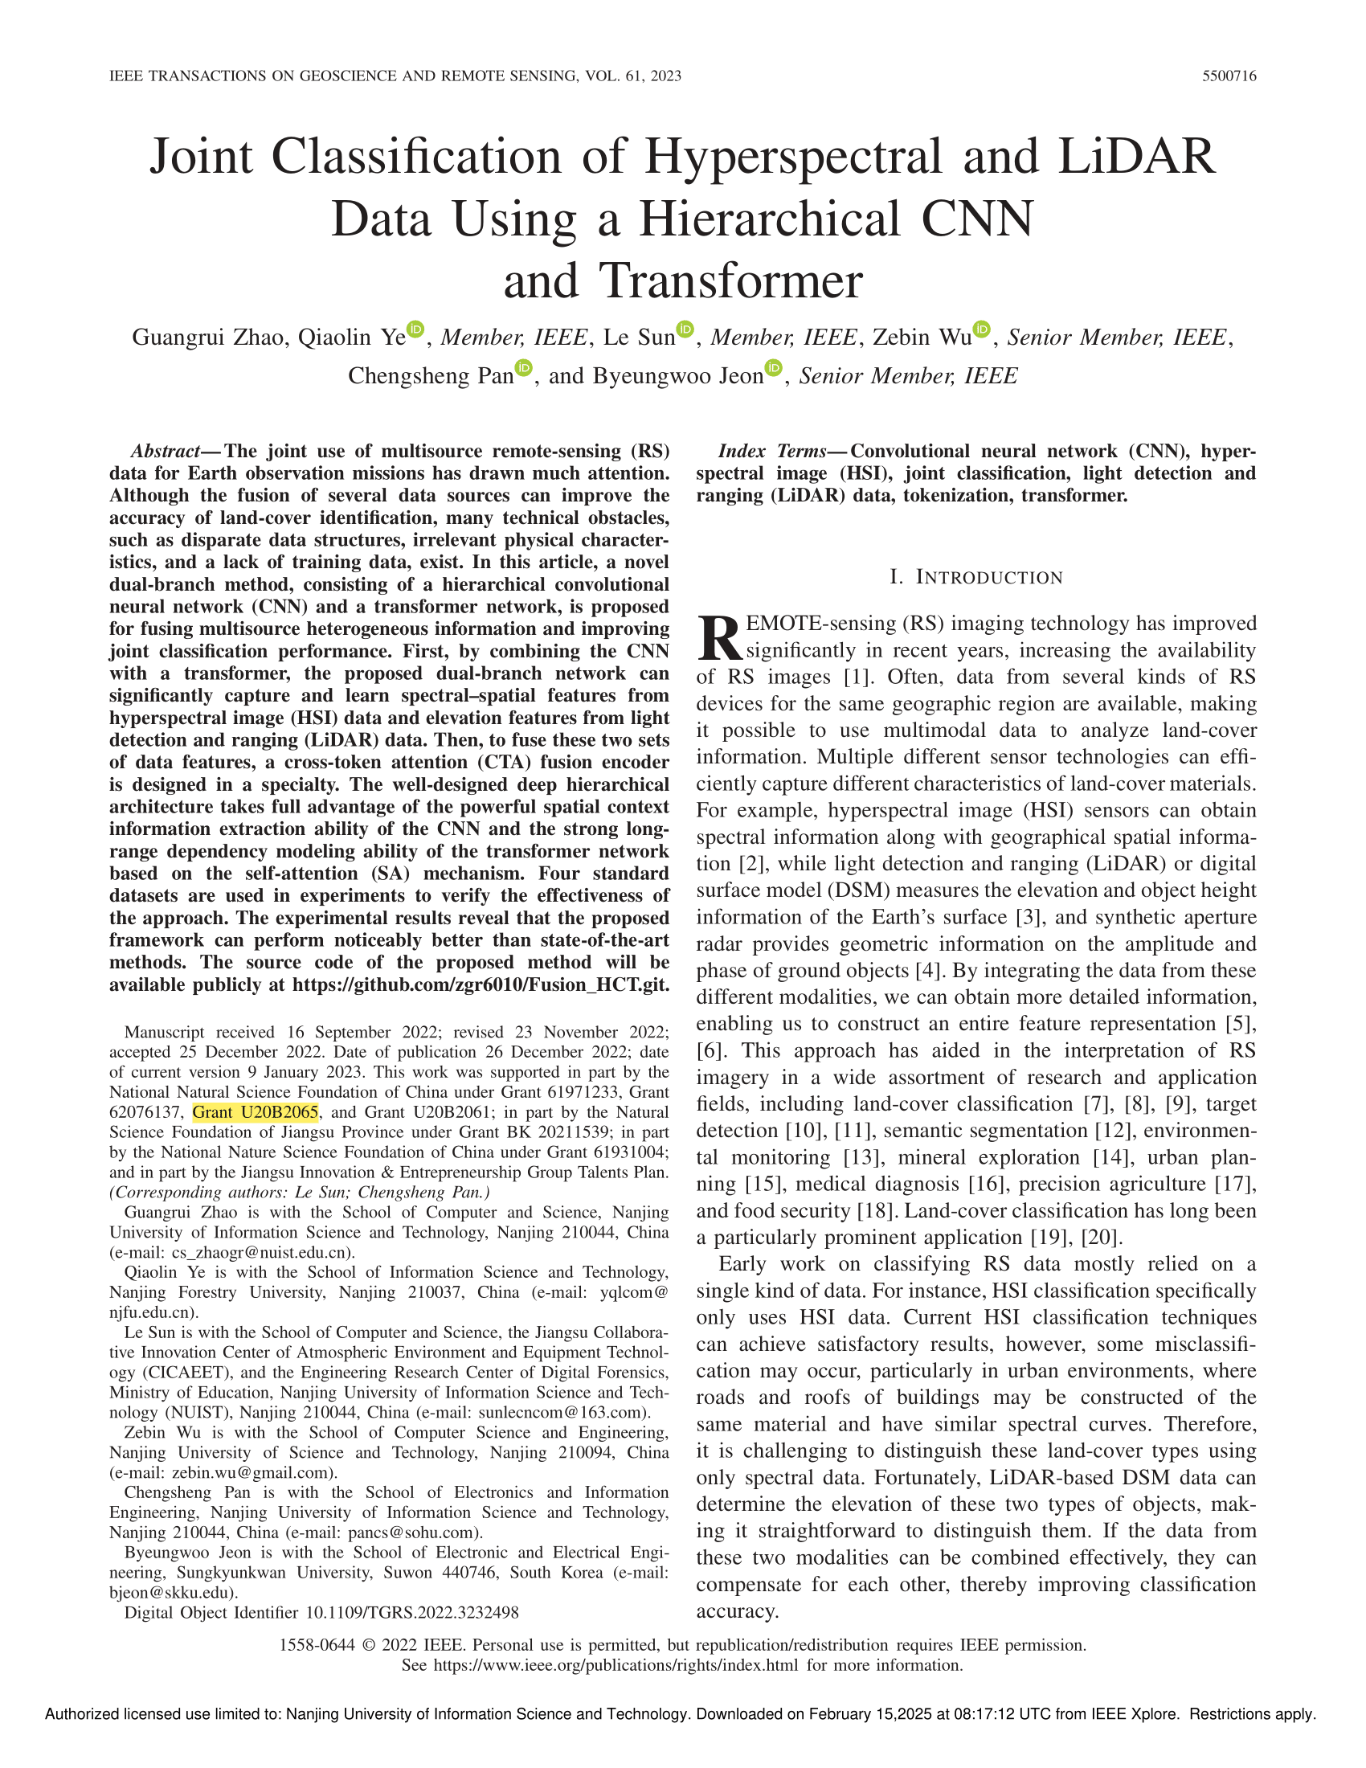

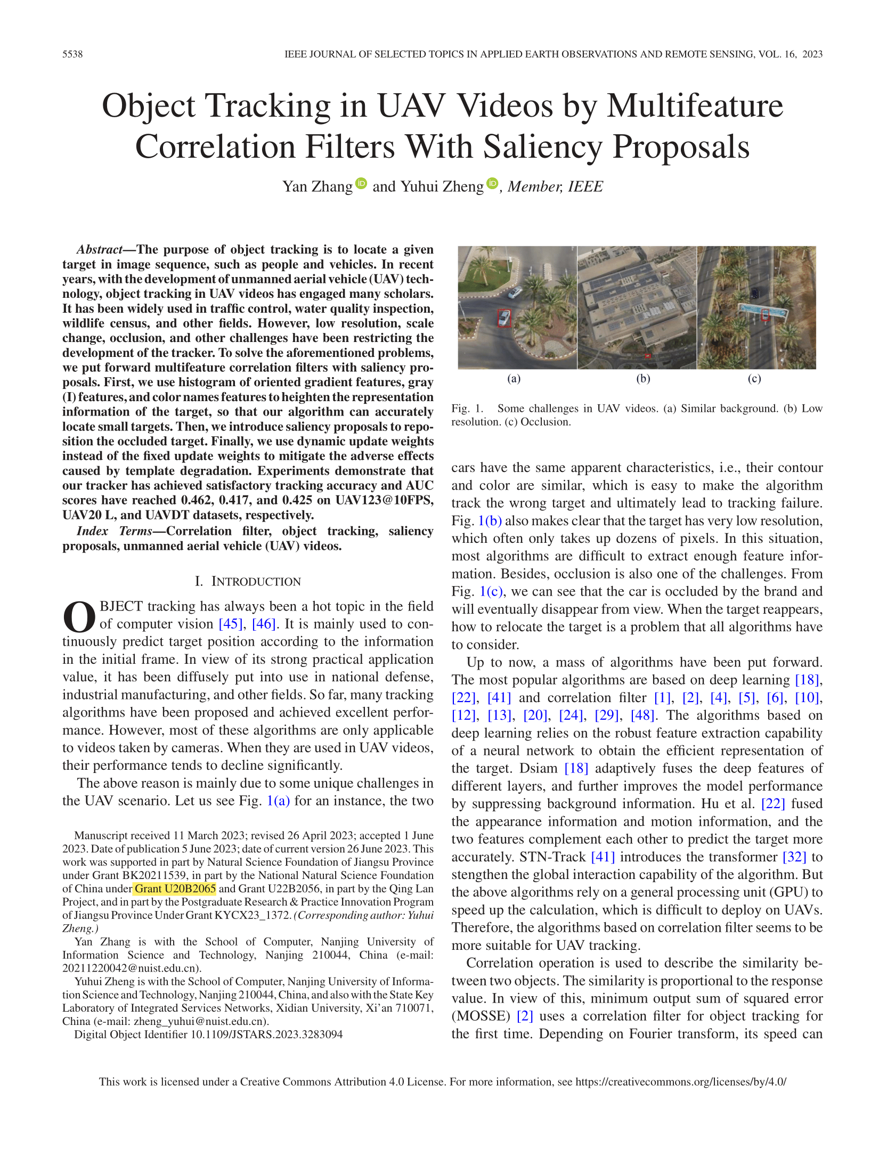

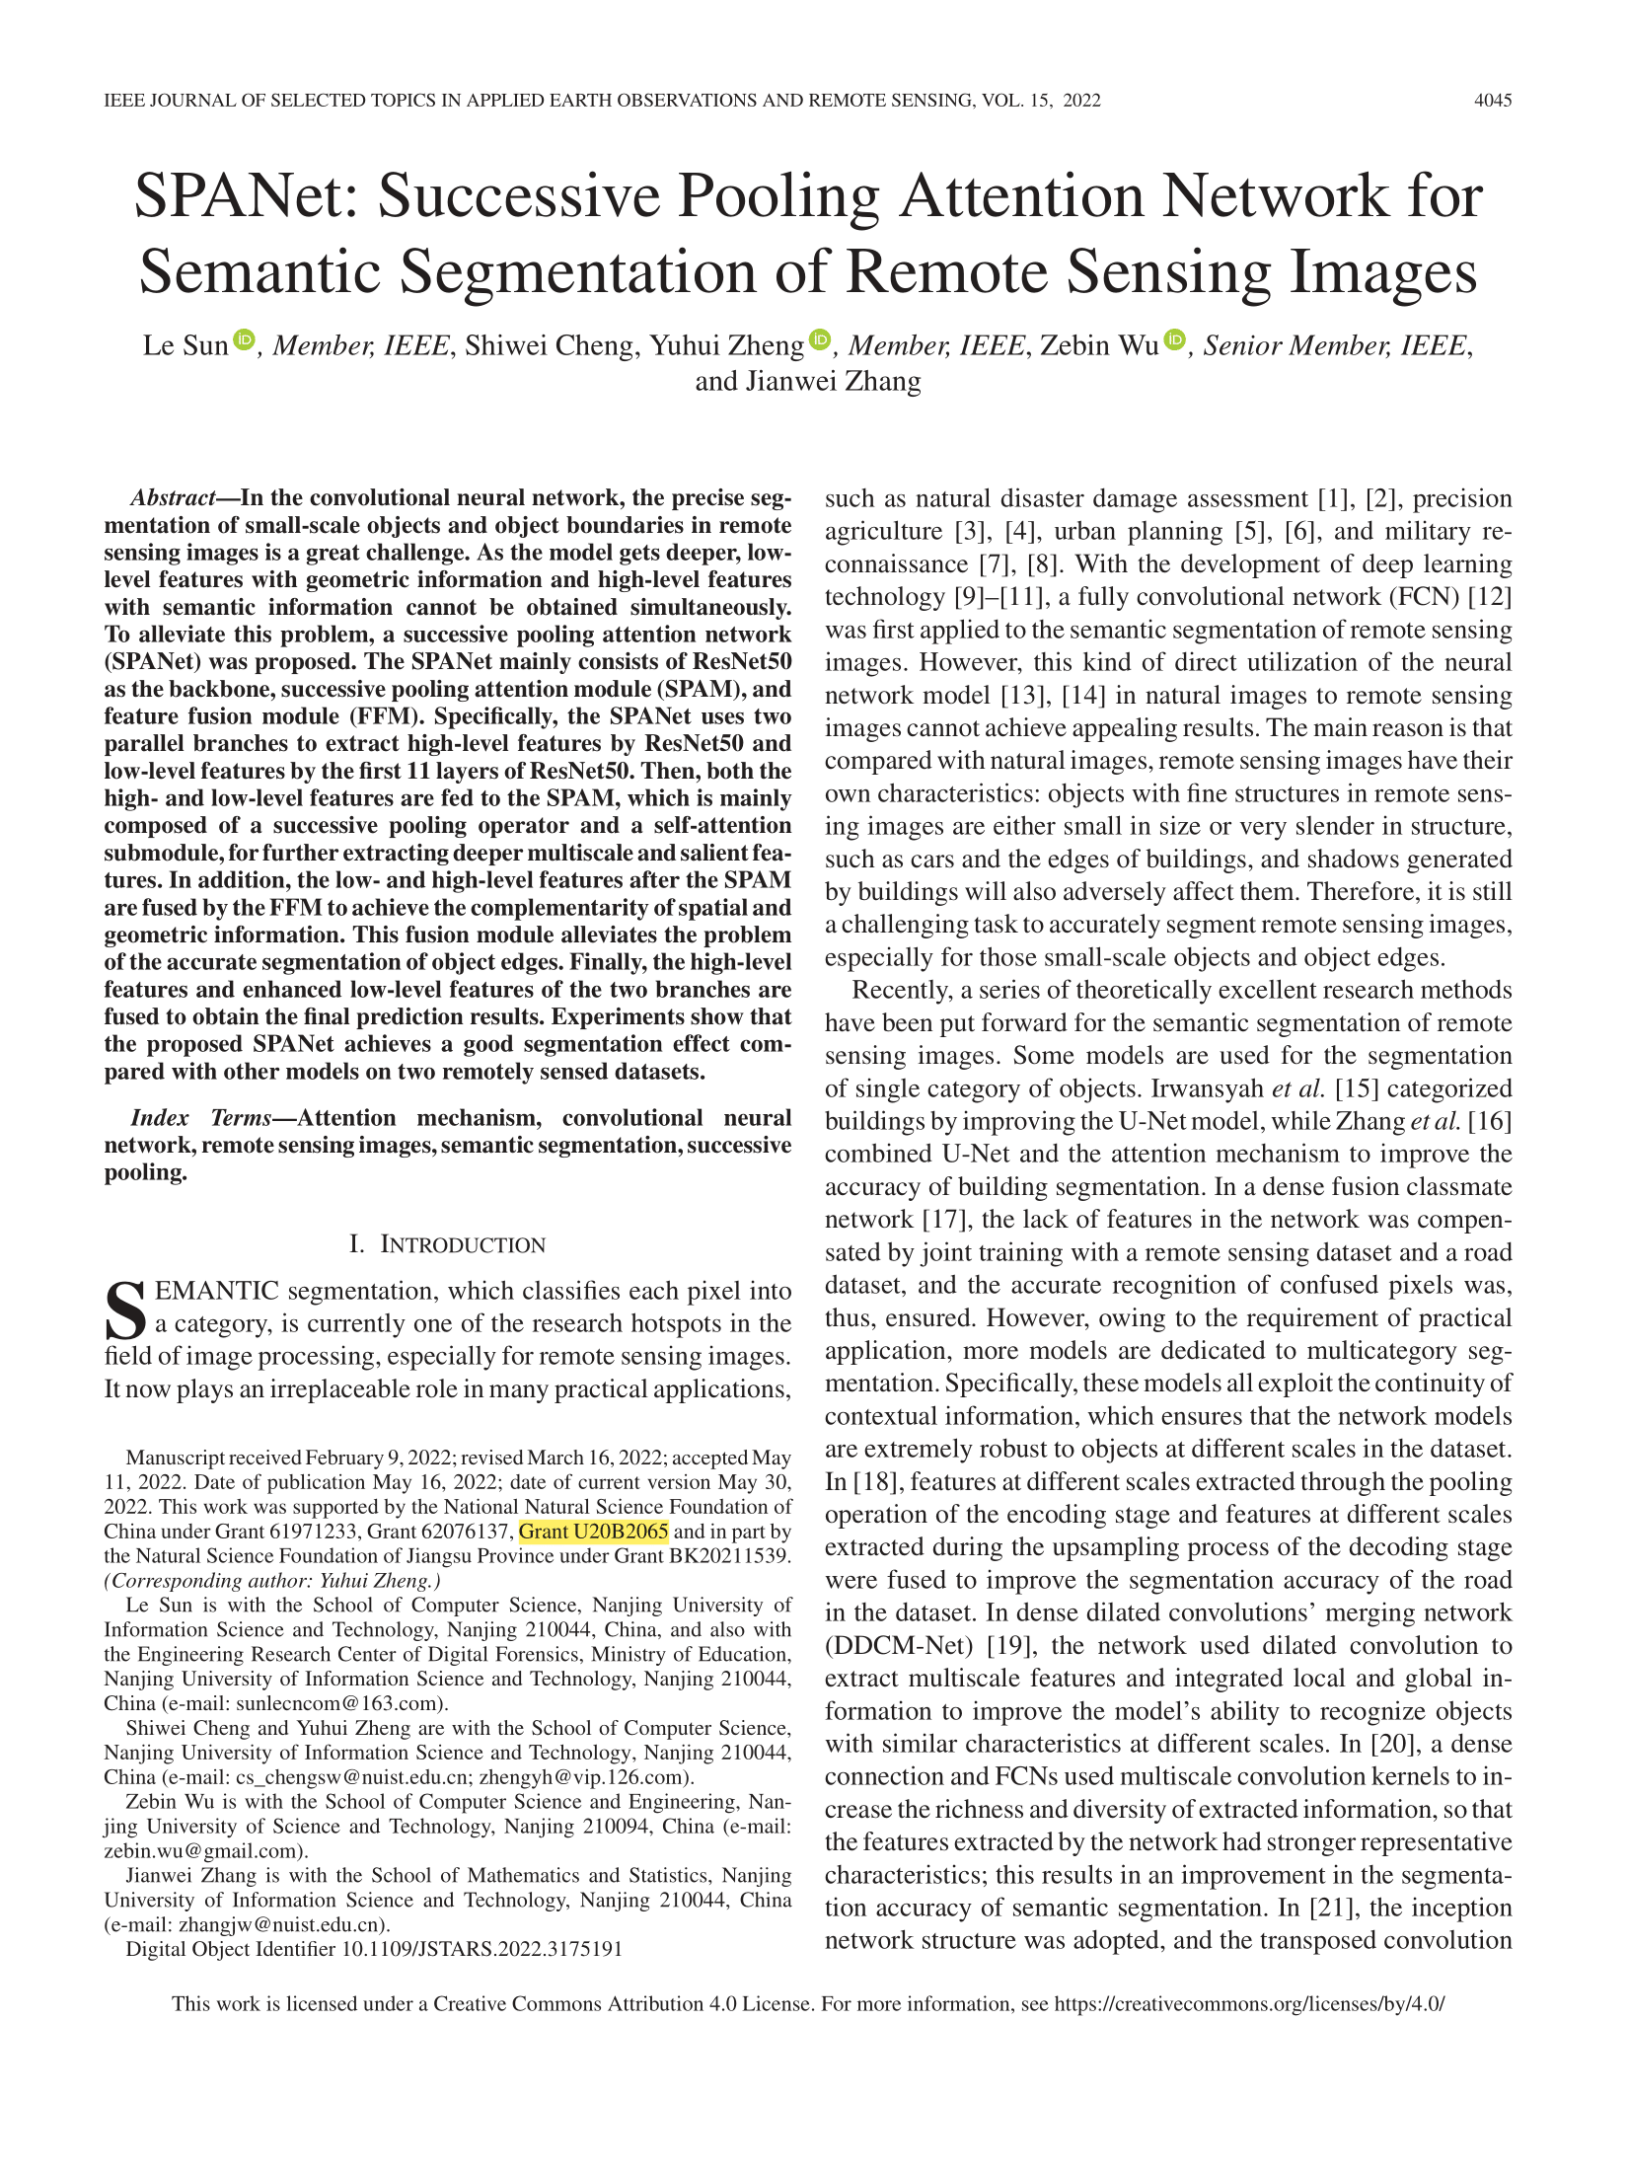

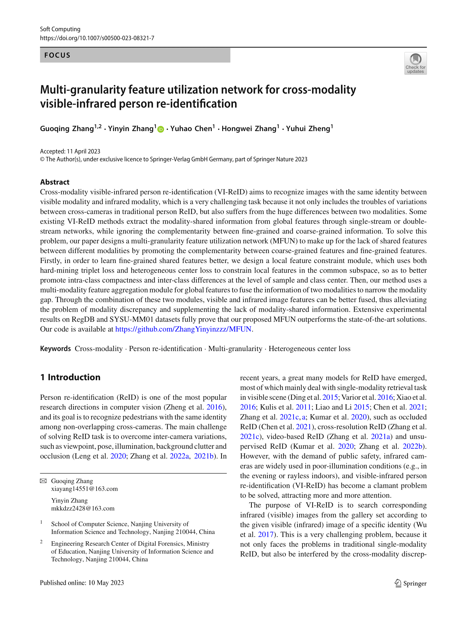 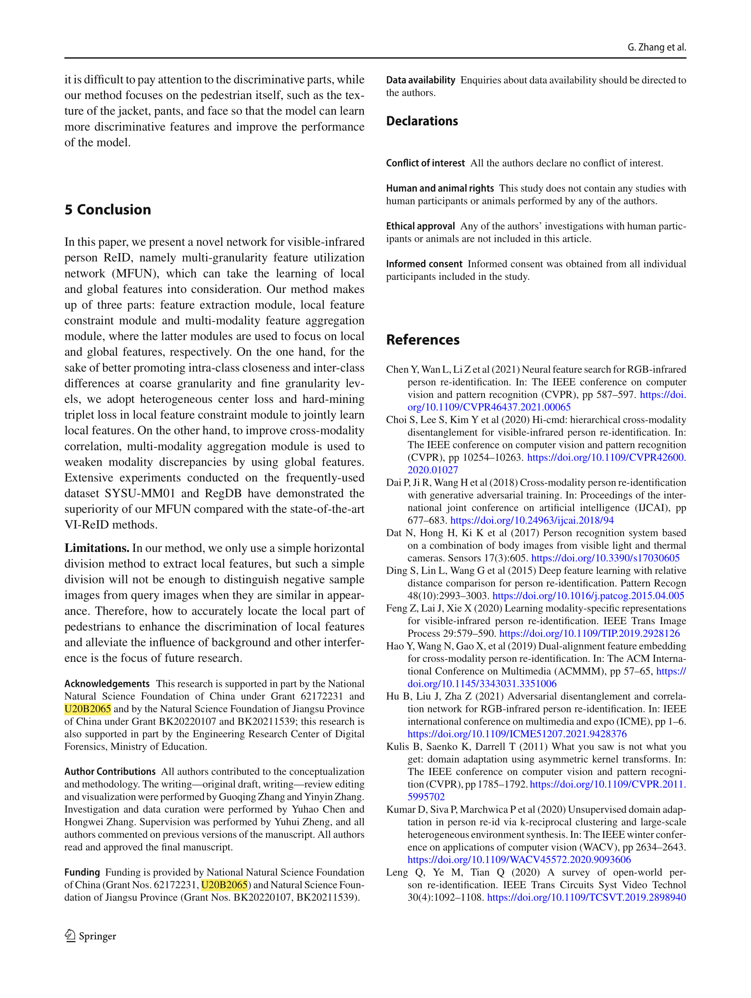

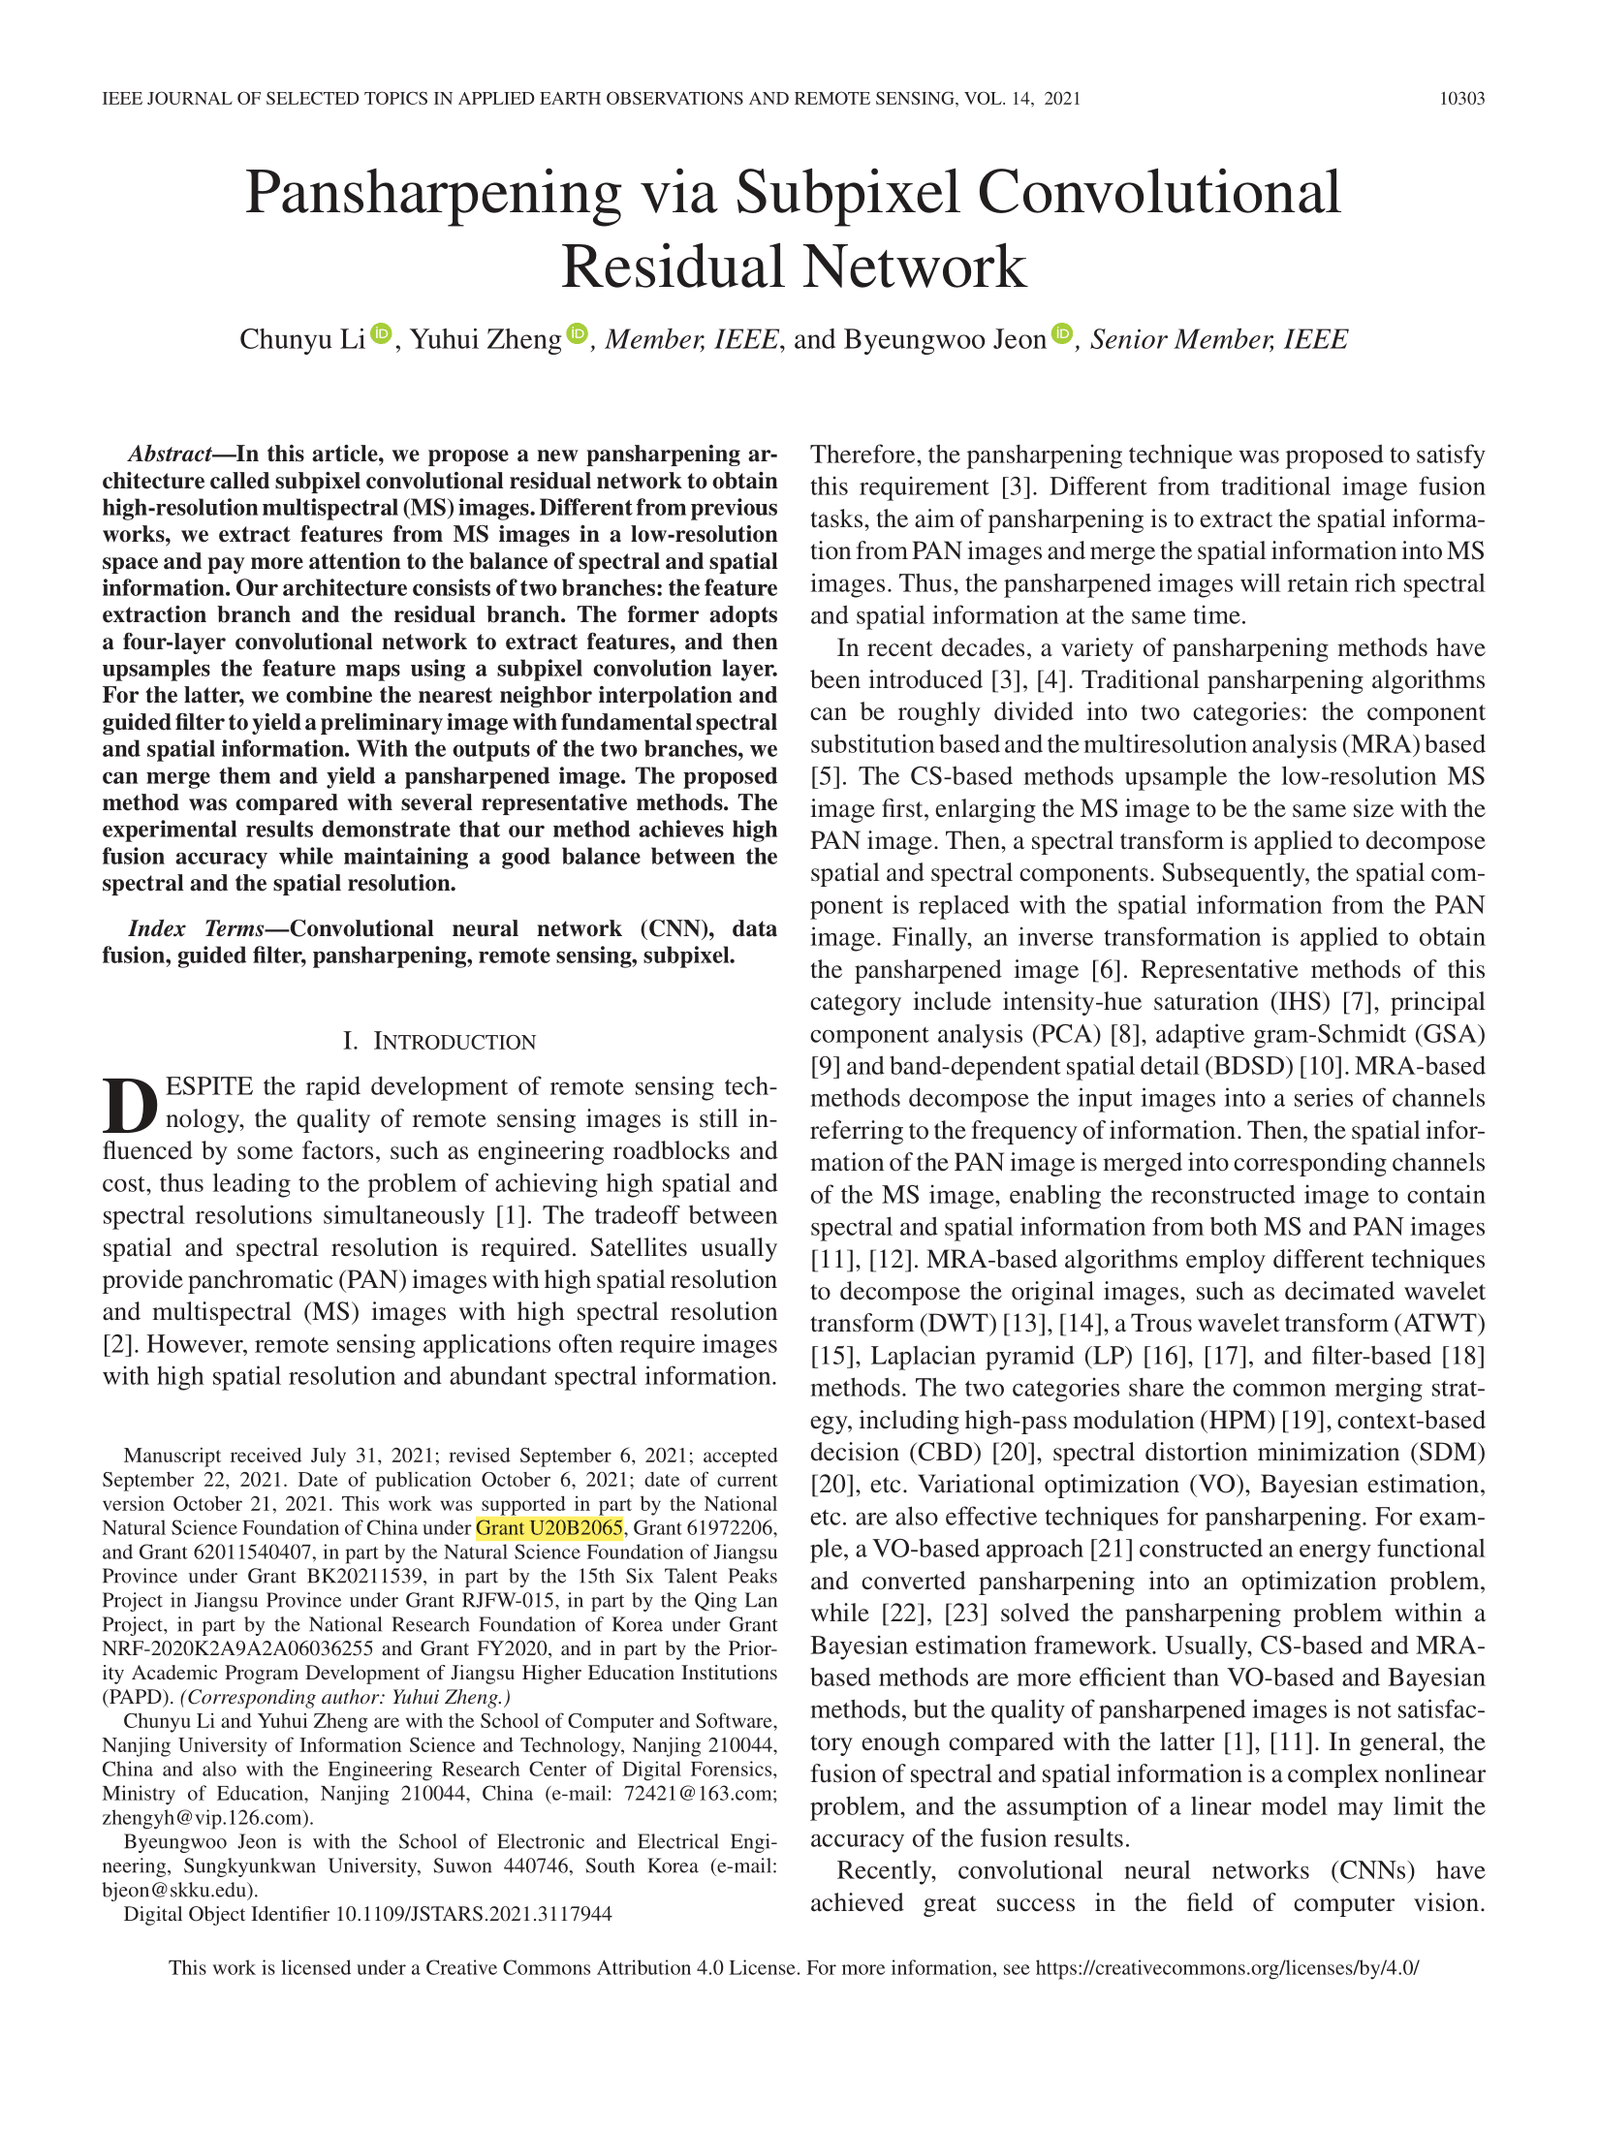

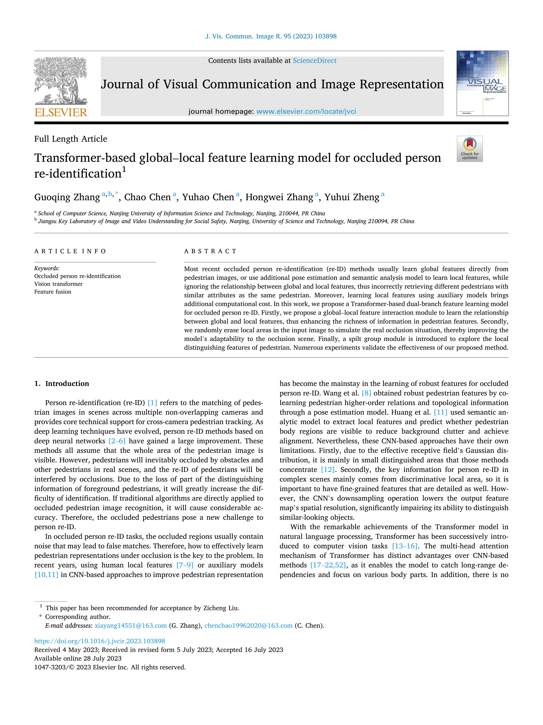 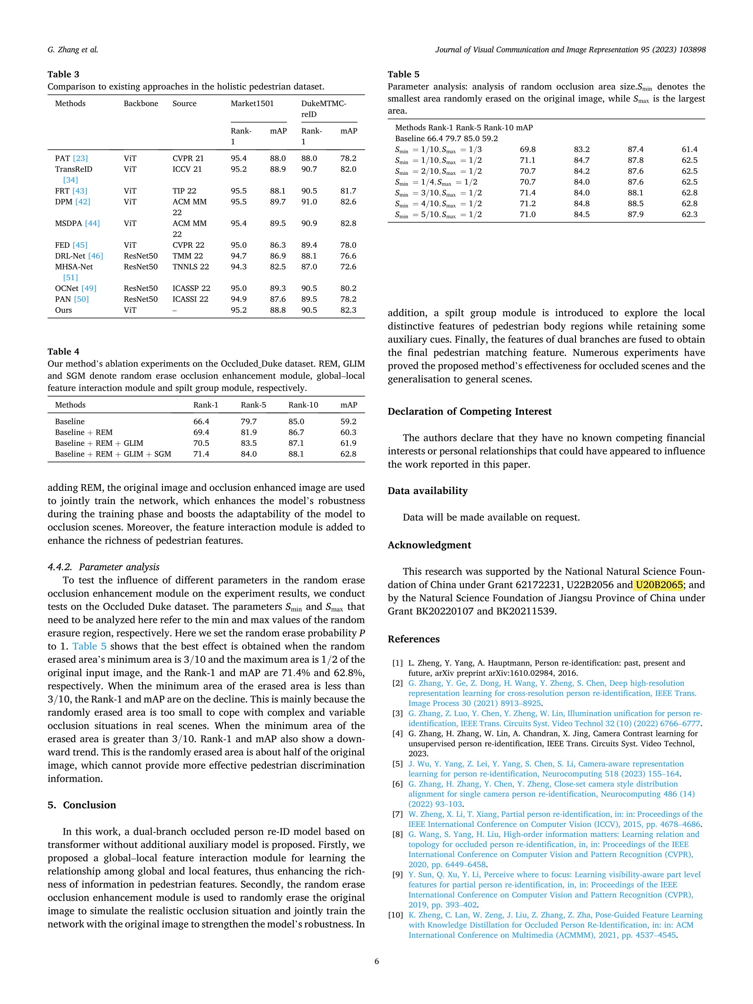

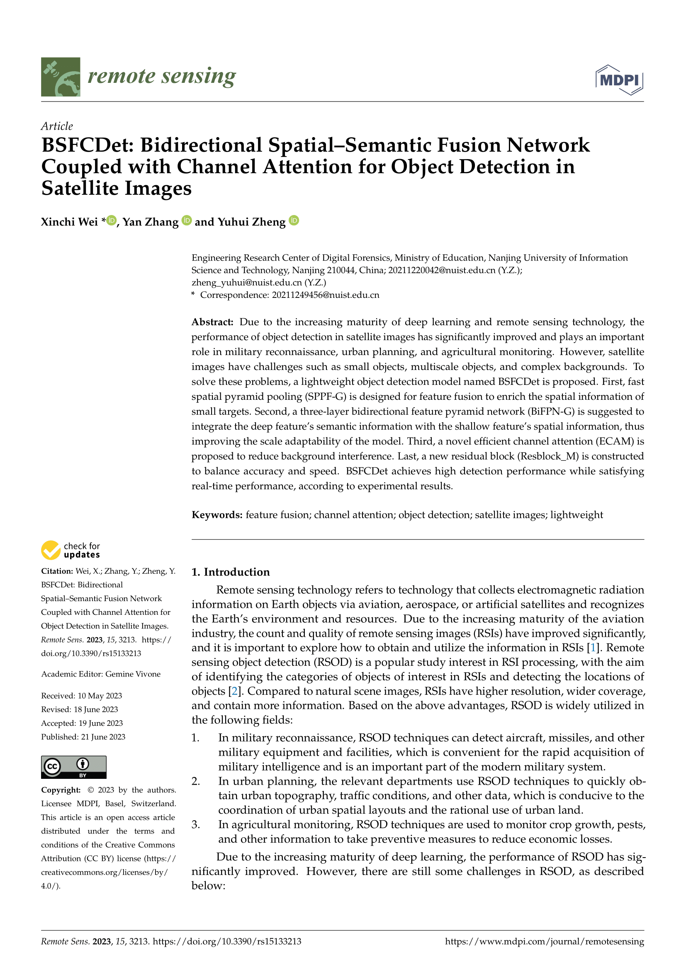

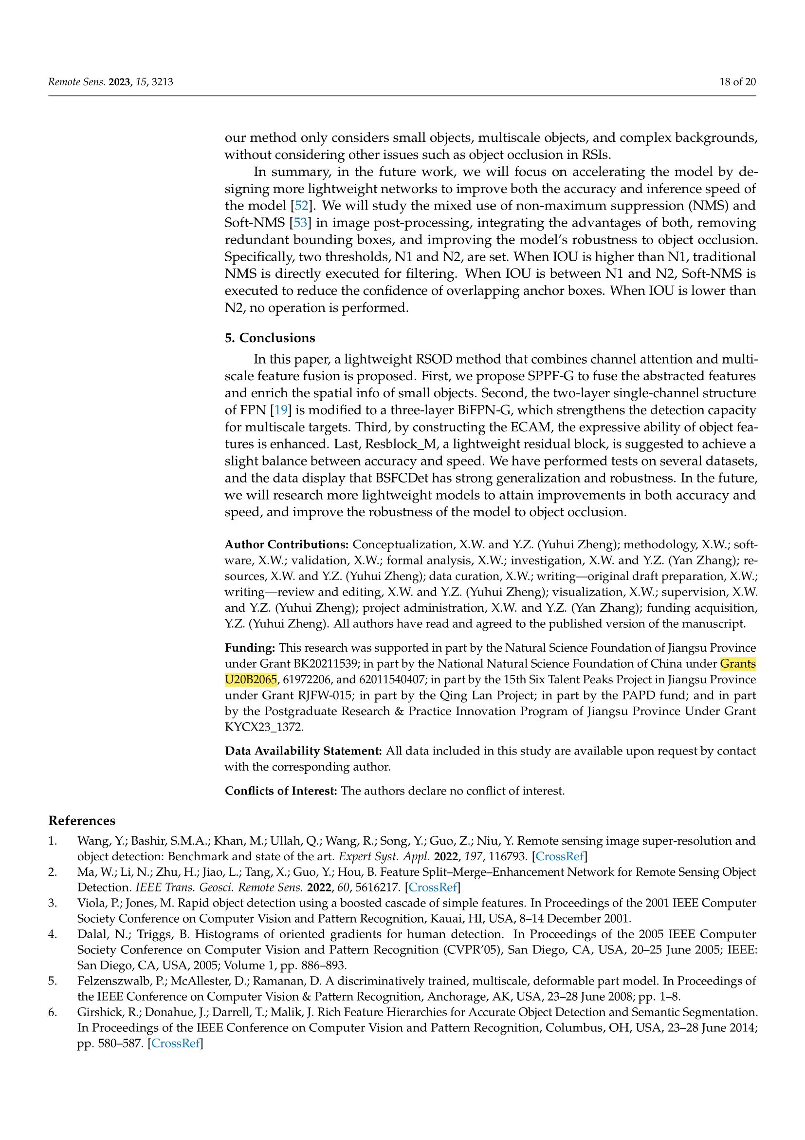

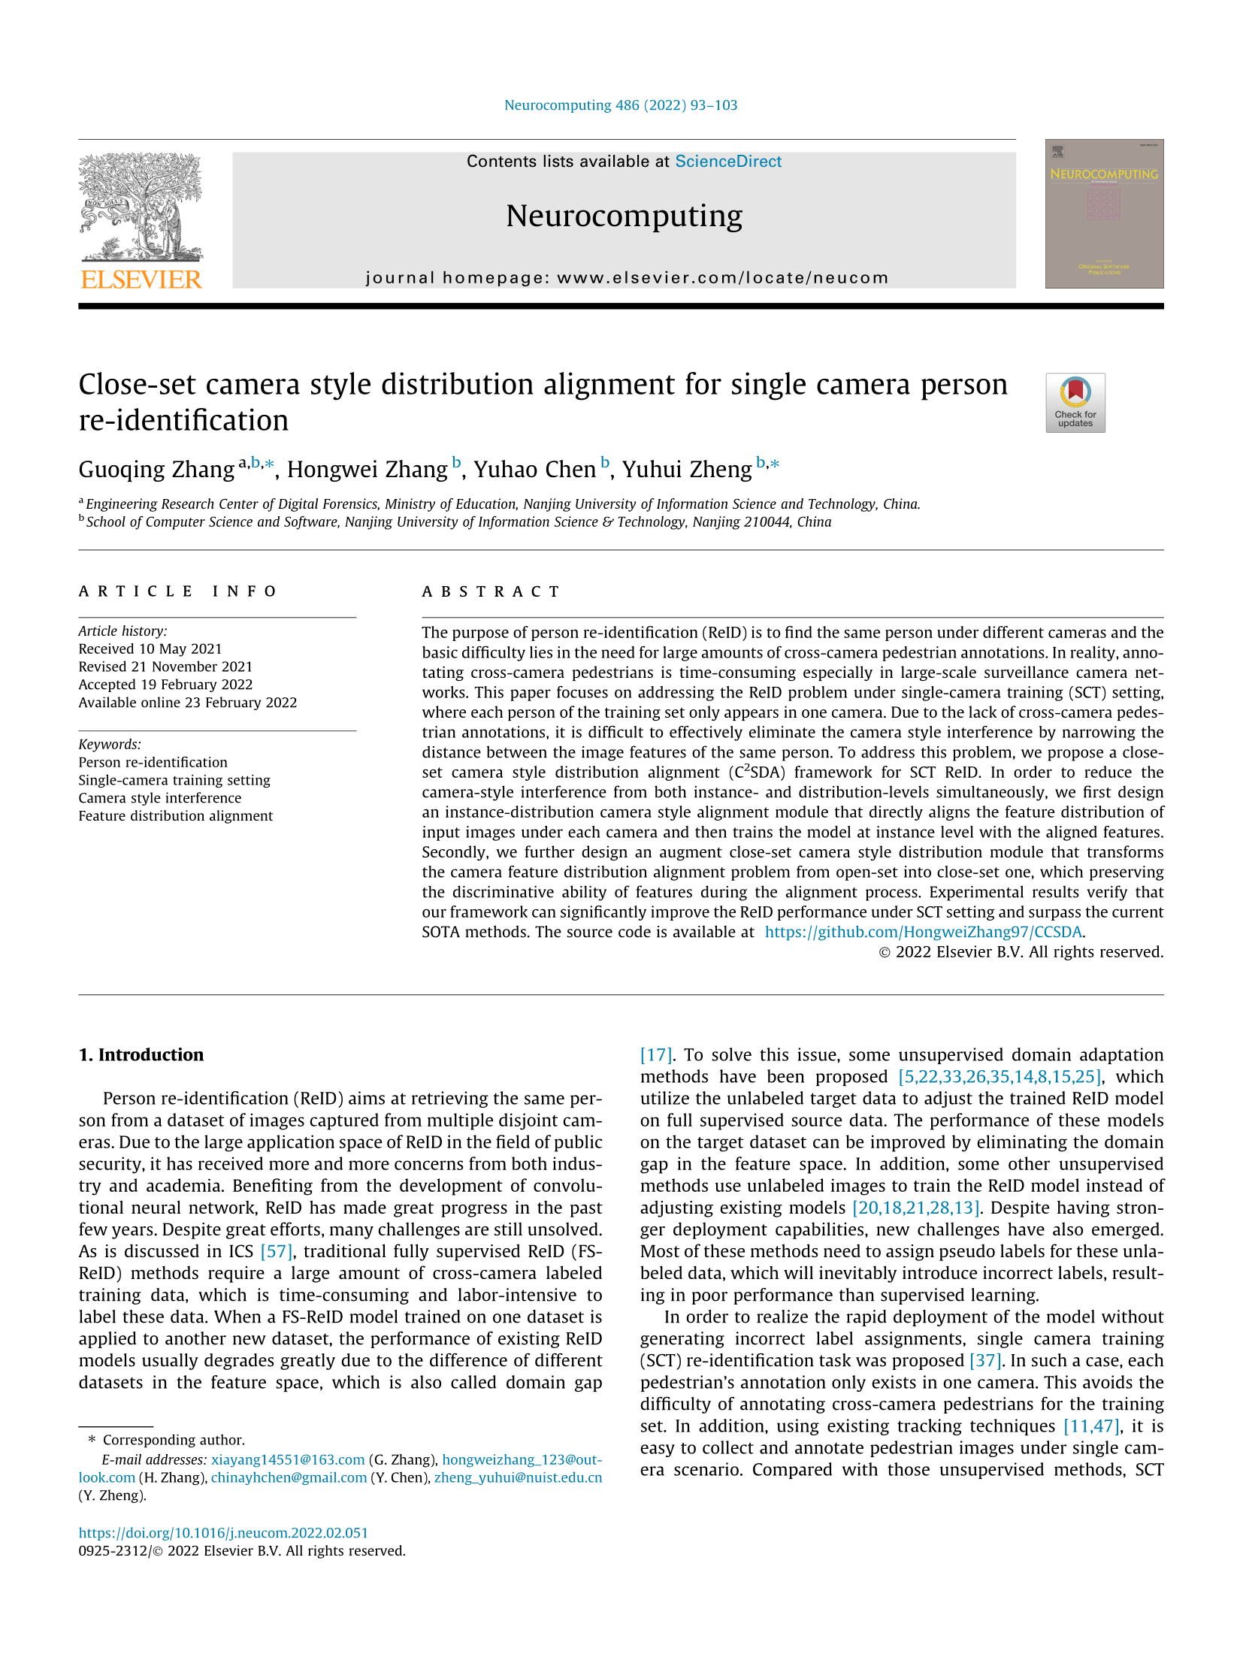

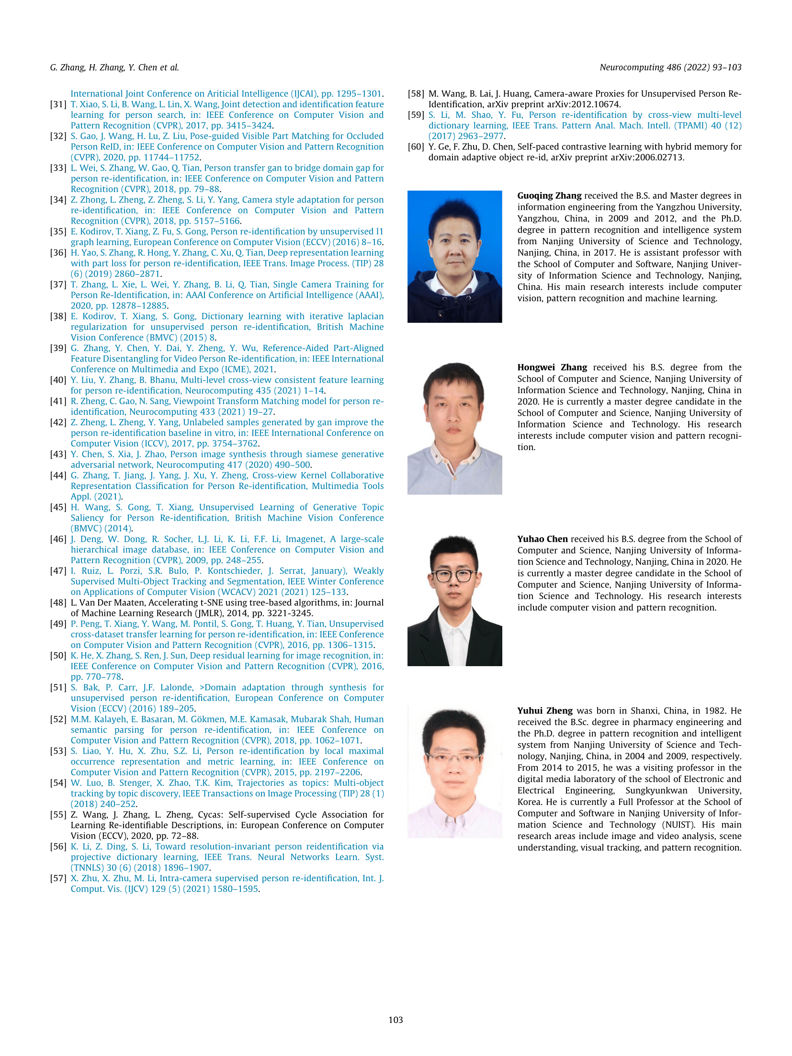

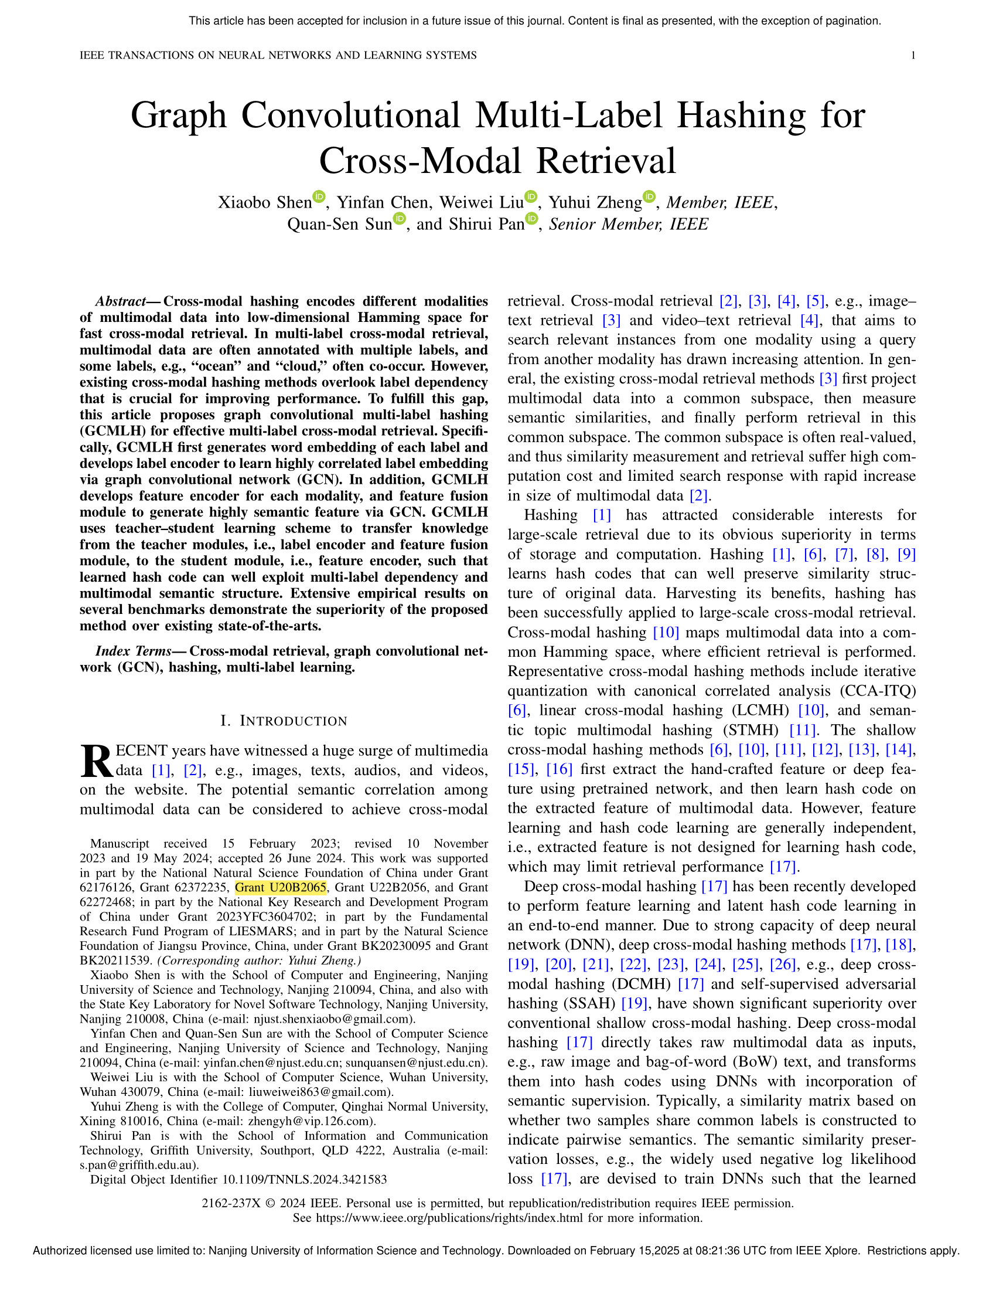

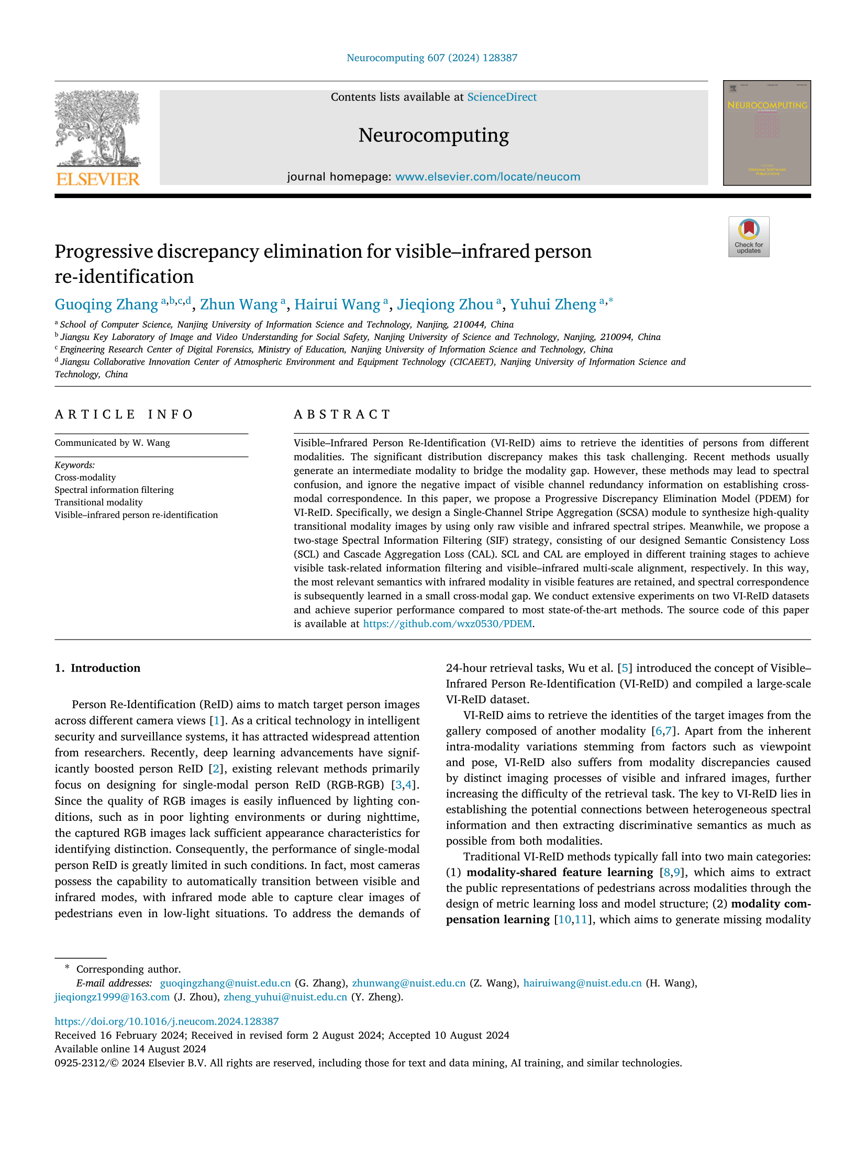 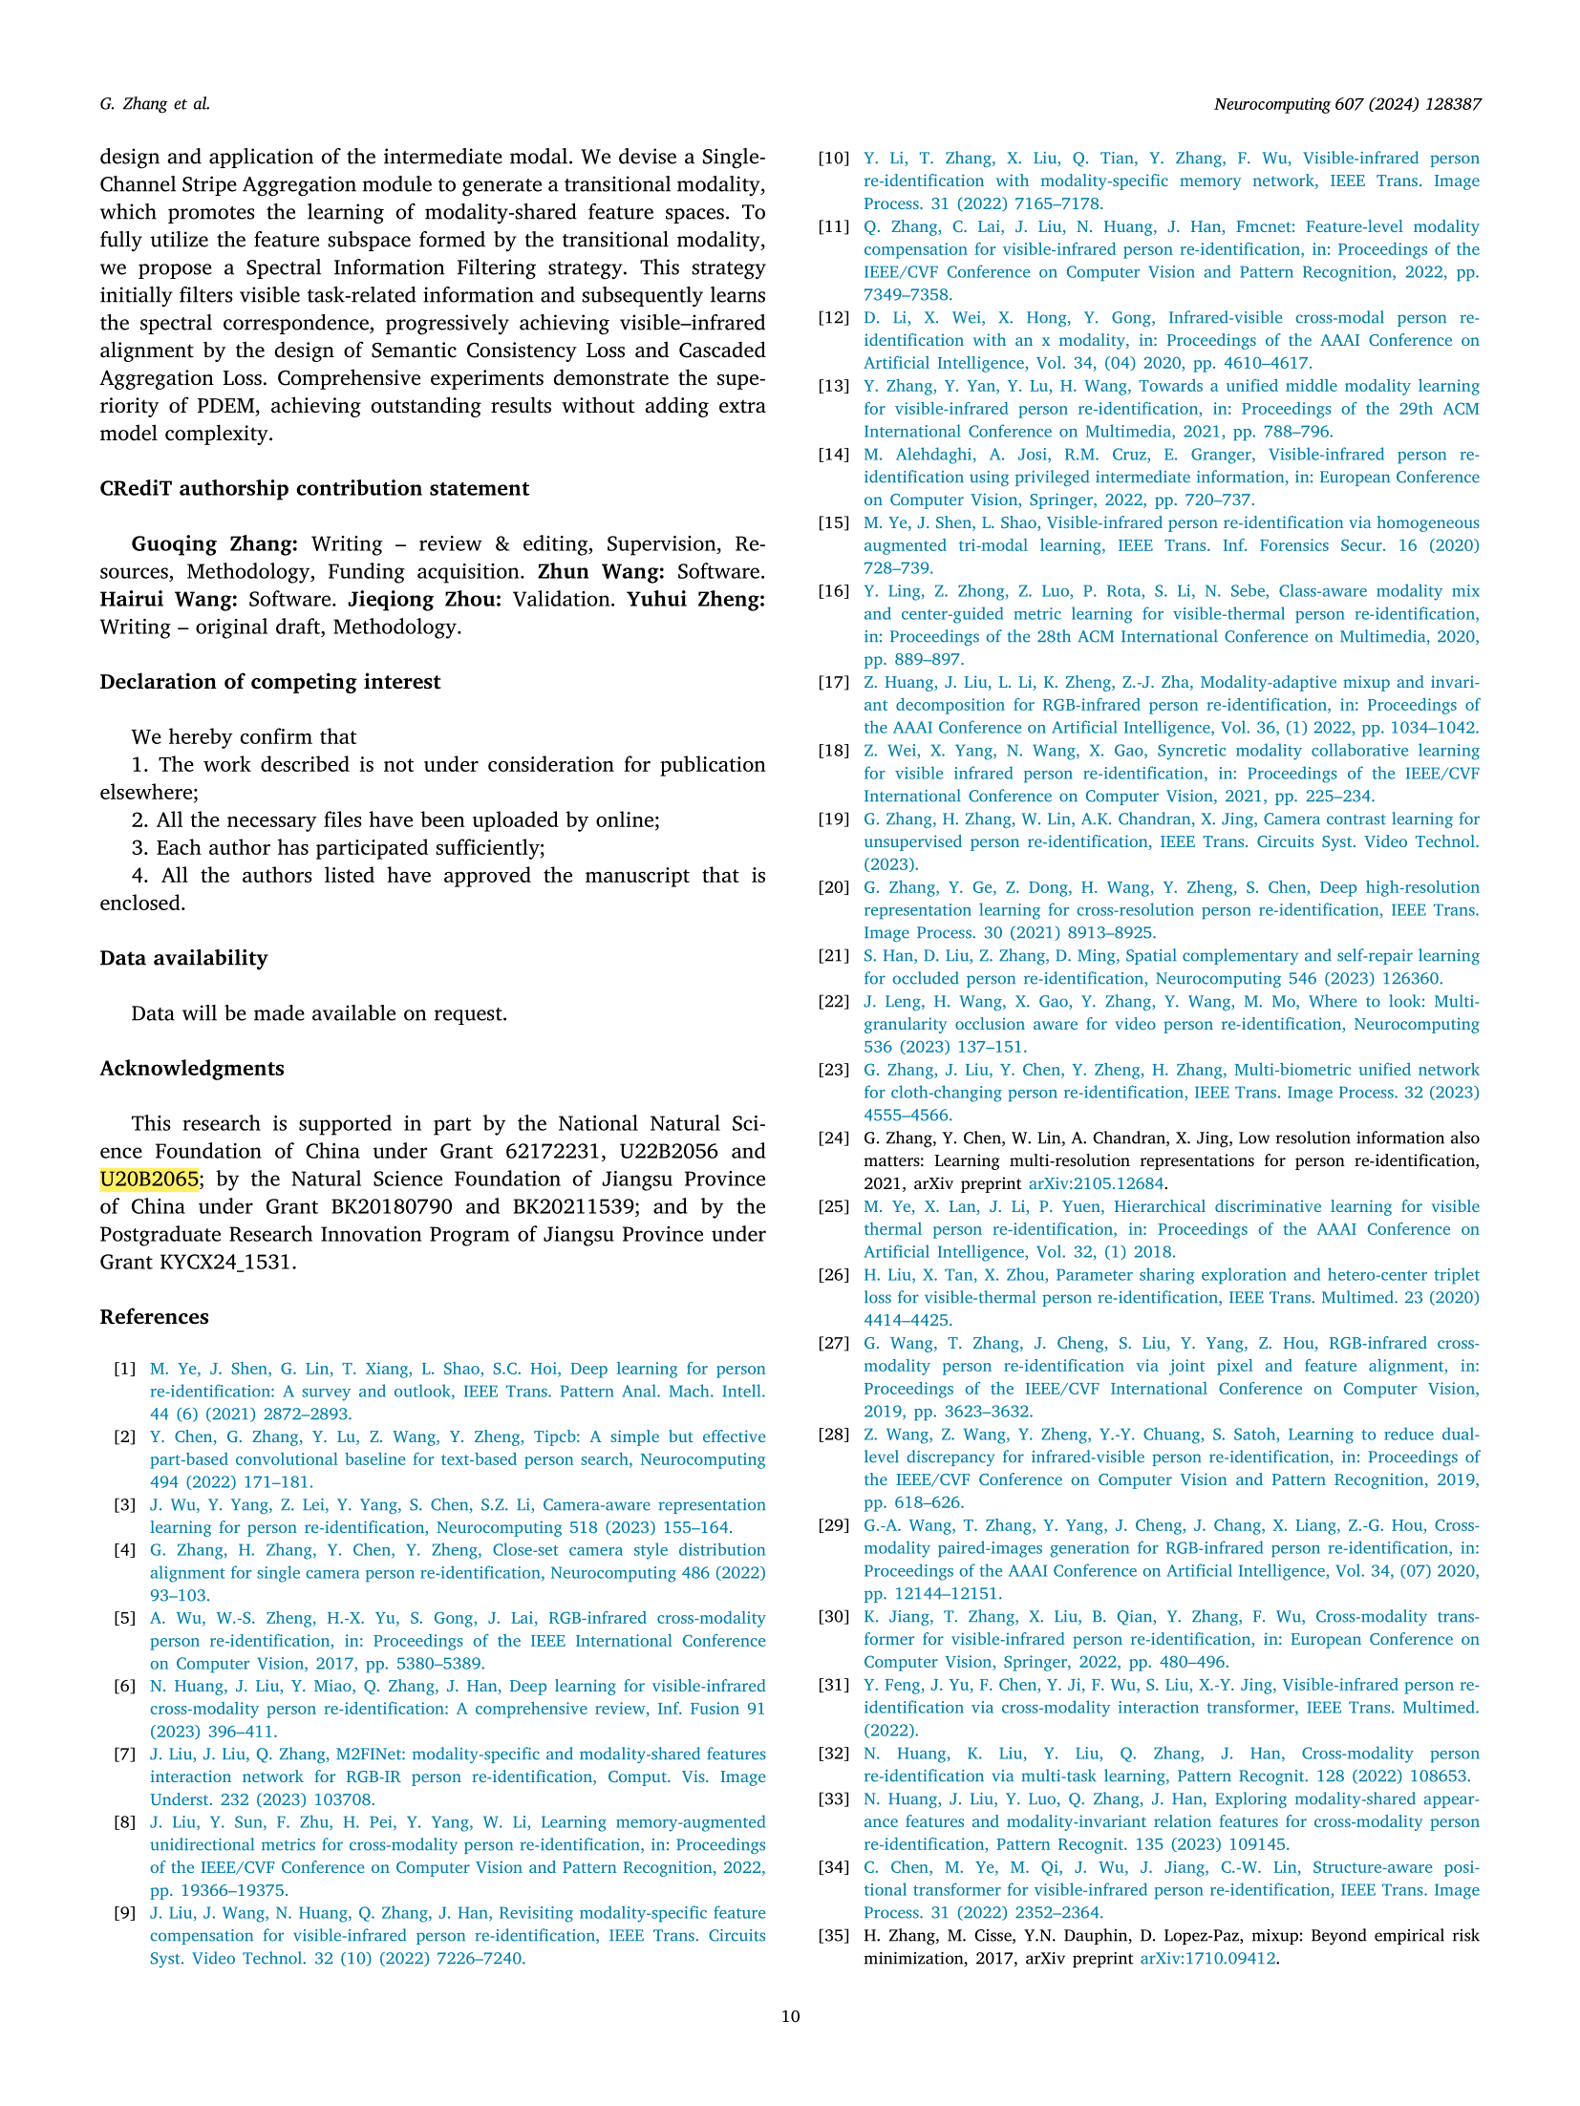

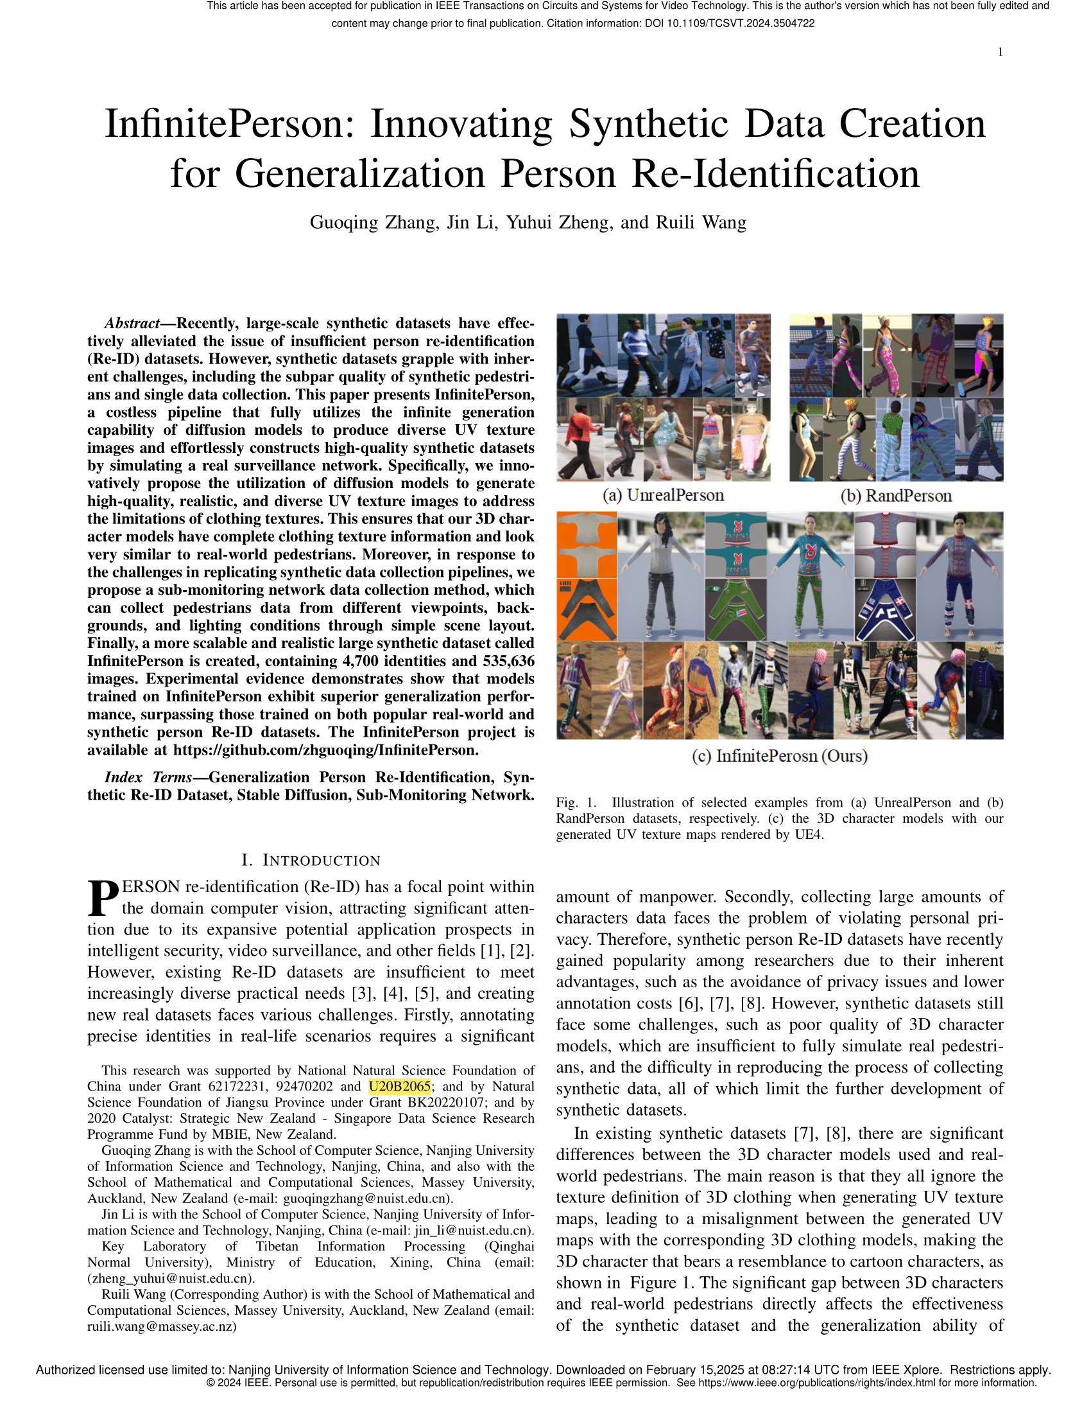

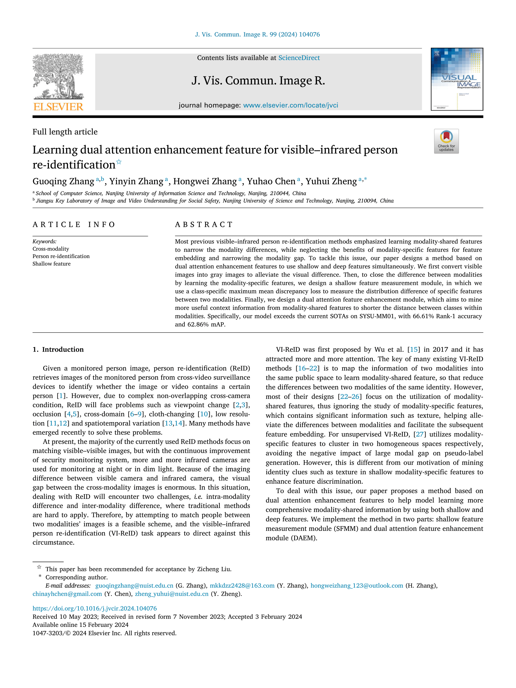

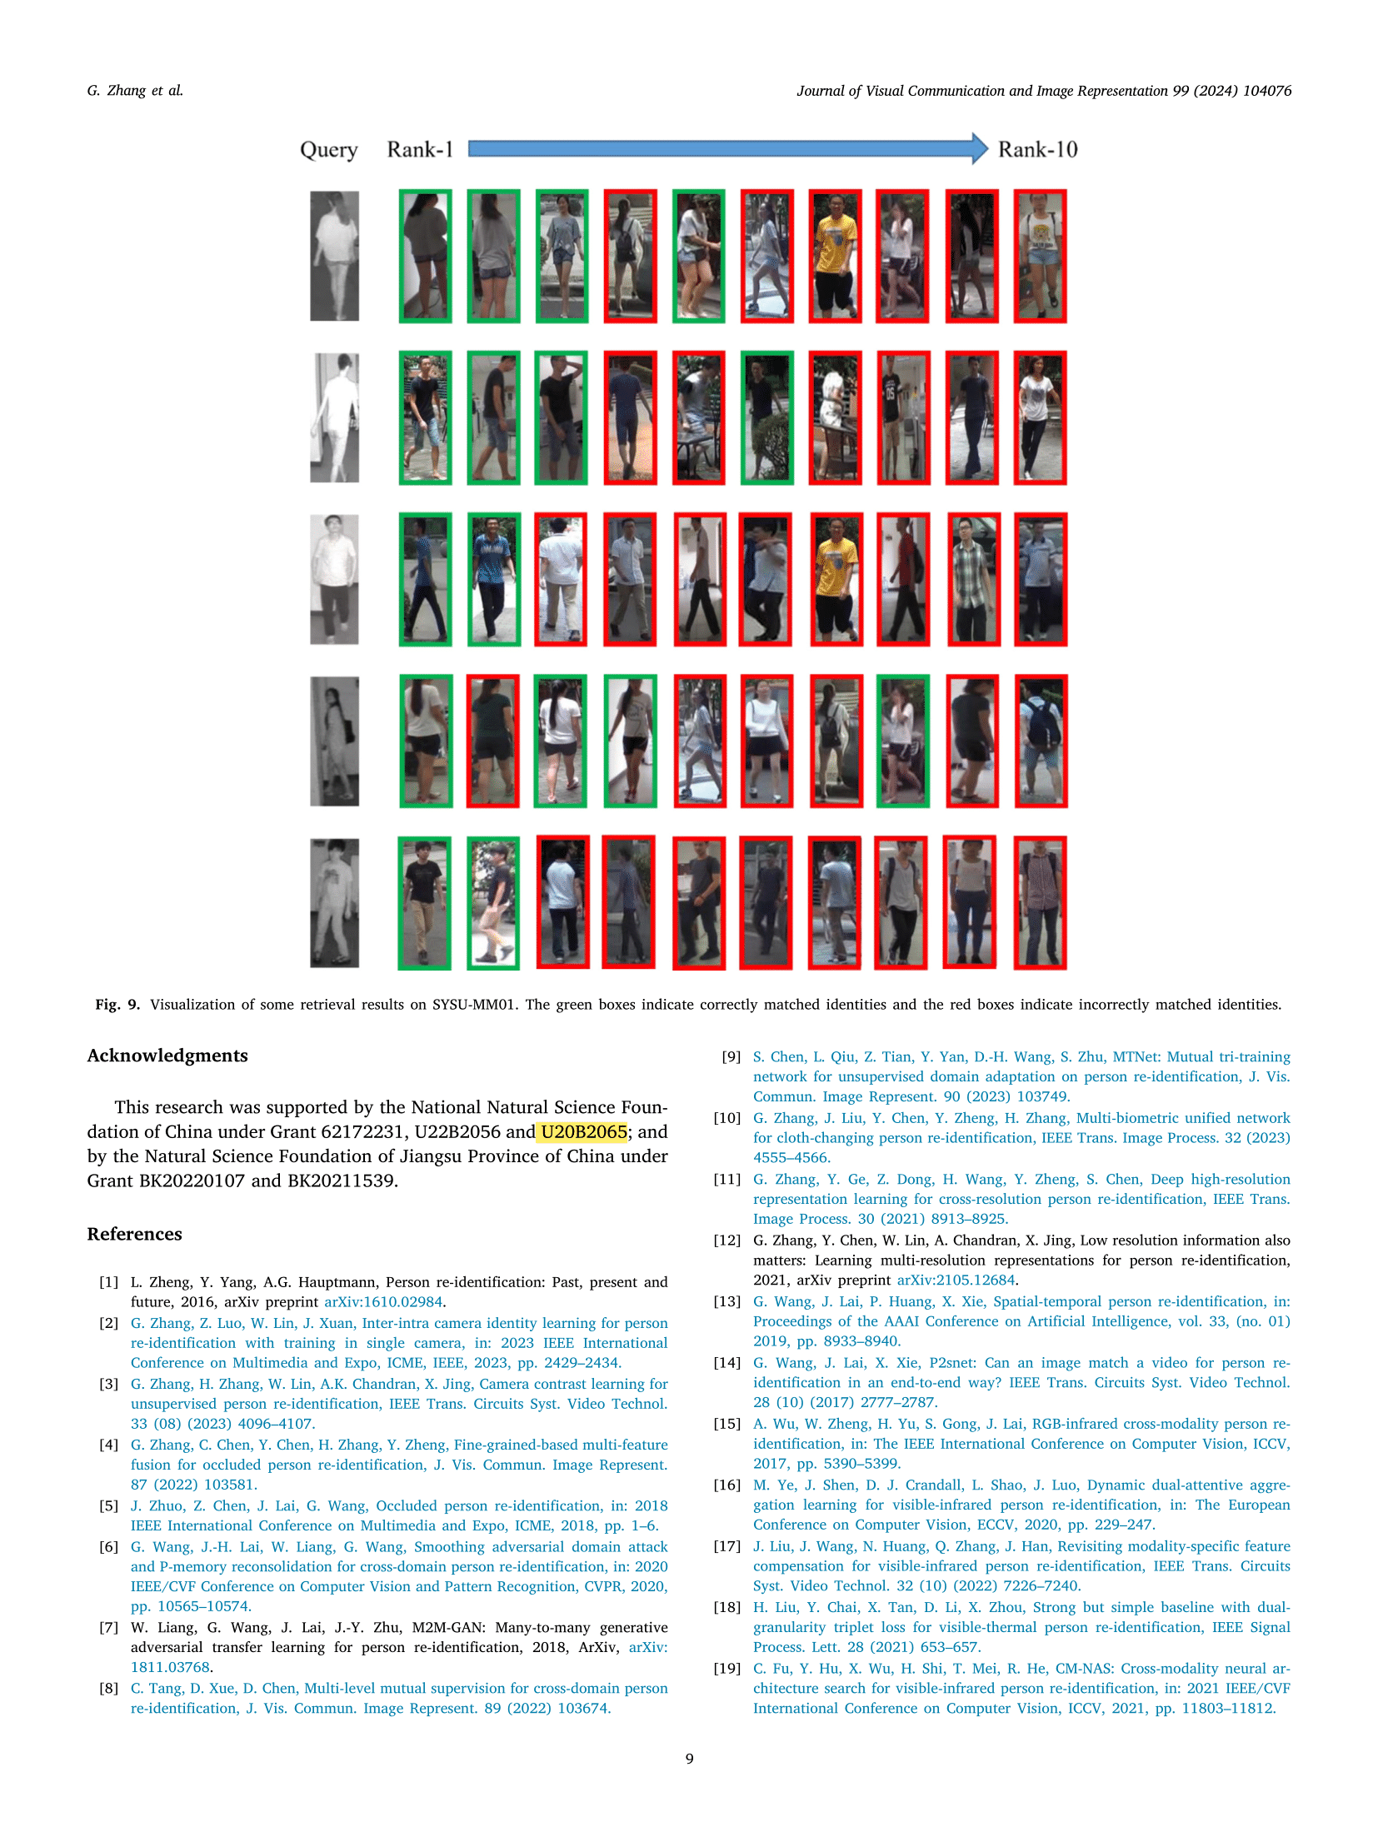



45没有基金号………………

